


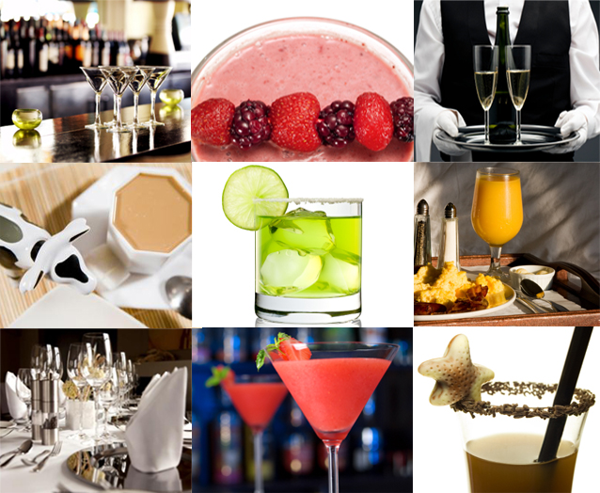



Prepare and serve non-alcoholic beverages
D1.HBS.CL5.07
Trainer Guide

Prepare and serve non-alcoholic beverages

D1.HBS.CL5.07

Trainer Guide




Project Base
William Angliss Institute of TAFE
555 La Trobe Street
Melbourne 3000 Victoria
Telephone: | (03) 9606 2111
Facsimile: | (03) 9670 1330
Acknowledgements
Project Director: | Wayne Crosbie
Chief Writer: | Alan Hickman
Subject Writer: | Alan Hickman
Project Manager/Editor: | Alan Maguire
DTP/Production: | Daniel Chee, Mai Vu, Kaly Quach

The Association of Southeast Asian Nations (ASEAN) was established on 8 August 1967. The Member States of the Association are Brunei Darussalam, Cambodia, Indonesia, Lao PDR, Malaysia, Myanmar, Philippines, Singapore, Thailand and Viet Nam.
The ASEAN Secretariat is based in Jakarta, Indonesia.
General Information on ASEAN appears online at the ASEAN Website: www.asean.org.
All text is produced by William Angliss Institute of TAFE for the ASEAN Project on “Toolbox Development for Front Office, Food and Beverage Services and Food Production Divisions”.
This publication is supported by the Australian Government’s aid program through the ASEAN-Australia Development Cooperation Program Phase II (AADCP II).
Copyright: Association of Southeast Asian Nations (ASEAN) 2013.
All rights reserved.
Disclaimer
Every effort has been made to ensure that this publication is free from errors or omissions. However, you should conduct your own enquiries and seek professional advice before relying on any fact, statement or matter contained in this book. The ASEAN Secretariat and William Angliss Institute of TAFE are not responsible for any injury, loss or damage as a result of material included or omitted from this course. Information in this module is current at the time of publication. Time of publication is indicated in the date stamp at the bottom of each page.
Some images appearing in this resource have been purchased from stock photography suppliers Shutterstock and iStockphoto and other third party copyright owners and as such are non-transferable and non-exclusive. Clip arts, font images and illustrations used are from the Microsoft Office Clip Art and Media Library. Some images have been provided by and are the property of William Angliss Institute.
Additional images have been sourced from Flickr and SXC and are used under Creative Commons licence: http://creativecommons.org/licenses/by/2.0/deed.en

File name: TG_Prepare_&_serve_non_alcoholic_bev_refined





Table of contents
Competency Based Training (CBT) and assessment - An introduction for trainers 1
Competency standard 11
Notes and PowerPoint slides 19
Recommended training equipment 141
Instructions for Trainers for using PowerPoint – Presenter View 143
Appendix – ASEAN acronyms 145

Competency Based Training (CBT) and assessment - An introduction for trainers

Competency
Competency refers to the ability to perform particular tasks and duties to the standard of performance expected in the workplace.
Competency requires the application of specified knowledge, skills and attitudes relevant to effective participation, consistently over time and in the workplace environment.
The essential skills and knowledge are either identified separately or combined.
Knowledge identifies what a person needs to know to perform the work in an informed and effective manner.
Skills describe the application of knowledge to situations where understanding is converted into a workplace outcome.
Attitude describes the founding reasons behind the need for certain knowledge or why skills are performed in a specified manner.
Competency covers all aspects of workplace performance and involves:
- Performing individual tasks
- Managing a range of different tasks
- Responding to contingencies or breakdowns
- Dealing with the responsibilities of the workplace
- Working with others.

Unit of Competency
Like with any training qualification or program, a range of subject topics are identified that focus on the ability in a certain work area, responsibility or function.
Each manual focuses on a specific unit of competency that applies in the hospitality workplace.
In this manual a unit of competency is identified as a ‘unit’.
Each unit of competency identifies a discrete workplace requirement and includes:
- Knowledge and skills that underpin competency
- Language, literacy and numeracy
- Occupational safety and health requirements.
Each unit of competency must be adhered to in training and assessment to ensure consistency of outcomes.

Element of Competency
An element of competency describes the essential outcomes within a unit of competency.
The elements of competency are the basic building blocks of the unit of competency. They describe in terms of outcomes the significant functions and tasks that make up the competency.
In this manual elements of competency are identified as an ‘element’.

Performance criteria
Performance criteria indicate the standard of performance that is required to demonstrate achievement within an element of competency. The standards reflect identified industry skill needs.
Performance criteria will be made up of certain specified skills, knowledge and attitudes.

Learning
For the purpose of this manual learning incorporates two key activities:
- Training
- Assessment.
Both of these activities will be discussed in detail in this introduction.
Today training and assessment can be delivered in a variety of ways. It may be provided to participants:
- On-the-job – in the workplace
- Off-the-job – at an educational institution or dedicated training environment
- As a combination of these two options.
No longer is it necessary for learners to be absent from the workplace for long periods of time in order to obtain recognised and accredited qualifications.

Learning Approaches
This manual will identify two avenues to facilitate learning:
Competency Based Training (CBT)
This is the strategy of developing a participant’s competency.
Educational institutions utilise a range of training strategies to ensure that participants are able to gain the knowledge and skills required for successful:
- Completion of the training program or qualification
- Implementation in the workplace.
The strategies selected should be chosen based on suitability and the learning styles of participants.

Competency Based Assessment (CBA)
This is the strategy of assessing competency of a participant.
Educational institutions utilise a range of assessment strategies to ensure that participants are assessed in a manner that demonstrates validity, fairness, reliability, flexibility and fairness of assessment processes.

Flexibility in Learning
It is important to note that flexibility in training and assessment strategies is required to meet the needs of participants who may have learning difficulties. The strategies used will vary, taking into account the needs of individual participants with learning difficulties. However they will be applied in a manner which does not discriminate against the participant or the participant body as a whole.
Catering for Participant Diversity
Participants have diverse backgrounds, needs and interests. When planning training and assessment activities to cater for individual differences, trainers and assessors should:
- Consider individuals’ experiences, learning styles and interests
- Develop questions and activities that are aimed at different levels of ability
- Modify the expectations for some participants
- Provide opportunities for a variety of forms of participation, such as individual, pair and small group activities
- Assess participants based on individual progress and outcomes.
The diversity among participants also provides a good reason for building up a learning community in which participants support each other’s learning.
Participant Centred Learning
This involves taking into account structuring training and assessment that:
- Builds on strengths – Training environments need to demonstrate the many positive features of local participants (such as the attribution of academic success to effort, and the social nature of achievement motivation) and of their trainers (such as a strong emphasis on subject disciplines and moral responsibility). These strengths and uniqueness of local participants and trainers should be acknowledged and treasured
- Acknowledges prior knowledge and experience – The learning activities should be planned with participants’ prior knowledge and experience in mind
- Understands learning objectives – Each learning activity should have clear learning objectives and participants should be informed of them at the outset. Trainers should also be clear about the purpose of assignments and explain their significance to participants
- Teaches for understanding – The pedagogies chosen should aim at enabling participants to act and think flexibly with what they know
- Teaches for independent learning – Generic skills and reflection should be nurtured through learning activities in appropriate contexts of the curriculum. Participants should be encouraged to take responsibility for their own learning
- Enhances motivation – Learning is most effective when participants are motivated. Various strategies should be used to arouse the interest of participants
- Makes effective use of resources – A variety of teaching resources can be employed as tools for learning
- Maximises engagement – In conducting learning activities, it is important for the minds of participants to be actively engaged
- Aligns assessment with learning and teaching – Feedback and assessment should be an integral part of learning and teaching
- Caters for learner diversity – Trainers should be aware that participants have different characteristics and strengths and try to nurture these rather than impose a standard set of expectations.
Active Learning
The goal of nurturing independent learning in participants does not imply that they always have to work in isolation or solely in a classroom. On the contrary, the construction of knowledge in tourism and hospitality studies can often best be carried out in collaboration with others in the field. Sharing experiences, insights and views on issues of common concern, and working together to collect information through conducting investigative studies in the field (active learning) can contribute a lot to their eventual success.
Active learning has an important part to play in fostering a sense of community in the class. First, to operate successfully, a learning community requires an ethos of acceptance and a sense of trust among participants, and between them and their trainers. Trainers can help to foster acceptance and trust through encouragement and personal example, and by allowing participants to take risks as they explore and articulate their views, however immature these may appear to be. Participants also come to realise that their classmates (and their trainers) are partners in learning and solving.
Trainers can also encourage cooperative learning by designing appropriate group learning tasks, which include, for example, collecting background information, conducting small-scale surveys, or producing media presentations on certain issues and themes. Participants need to be reminded that, while they should work towards successful completion of the field tasks, developing positive peer relationships in the process is an important objective of all group work.

Competency Based Training (CBT)
Principle of Competency Based Training
Competency based training is aimed at developing the knowledge, skills and attitudes of participants, through a variety of training tools.
Training Strategies
The aims of this curriculum are to enable participants to:
- Undertake a variety of subject courses that are relevant to industry in the current environment
- Learn current industry skills, information and trends relevant to industry
- Learn through a range of practical and theoretical approaches
- Be able to identify, explore and solve issues in a productive manner
- Be able to become confident, equipped and flexible managers of the future
- Be ‘job ready’ and a valuable employee in the industry upon graduation of any qualification level.
To ensure participants are able to gain the knowledge and skills required to meet competency in each unit of competency in the qualification, a range of training delivery modes are used.
Types of Training
In choosing learning and teaching strategies, trainers should take into account the practical, complex and multi-disciplinary nature of the subject area, as well as their participant’s prior knowledge, learning styles and abilities.
Training outcomes can be attained by utilising one or more delivery methods:
Lecture/Tutorial
This is a common method of training involving transfer of information from the trainer to the participants. It is an effective approach to introduce new concepts or information to the learners and also to build upon the existing knowledge. The listener is expected to reflect on the subject and seek clarifications on the doubts.
Demonstration
Demonstration is a very effective training method that involves a trainer showing a participant how to perform a task or activity. Through a visual demonstration, trainers may also explain reasoning behind certain actions or provide supplementary information to help facilitate understanding.
Group Discussions
Brainstorming in which all the members in a group express their ideas, views and opinions on a given topic, is a free flow and exchange of knowledge among the participants and the trainer. The discussion is carried out by the group on the basis of their own experience, perceptions and values. This will facilitate acquiring new knowledge. When everybody is expected to participate in the group discussion, even the introverted persons will also get stimulated and try to articulate their feelings.
The ideas that emerge in the discussions should be noted down and presentations are to be made by the groups. Sometimes consensus needs to be arrived at on a given topic. Group discussions are to be held under the moderation of a leader guided by the trainer. Group discussion technique triggers thinking process, encourages interactions and enhances communication skills.
Role Play
This is a common and very effective method of bringing into the classroom real life situations, which may not otherwise be possible. Participants are made to enact a particular role so as to give a real feel of the roles they may be called upon to play. This enables participants to understand the behaviour of others as well as their own emotions and feelings. The instructor must brief the role players on what is expected of them. The role player may either be given a ready-made script, which they can memorise and enact, or they may be required to develop their own scripts around a given situation. This technique is extremely useful in understanding creative selling techniques and human relations. It can be entertaining and energising and it helps the reserved and less literate to express their feelings.

Simulation Games
When trainees need to become aware of something that they have not been conscious of, simulations can be a useful mechanism. Simulation games are a method based on "here and now" experience shared by all the participants. The games focus on the participation of the trainees and their willingness to share their ideas with others. A "near real life" situation is created providing an opportunity to which they apply themselves by adopting certain behaviour. They then experience the impact of their behaviour on the situation. It is carried out to generate responses and reactions based on the real feelings of the participants, which are subsequently analysed by the trainer.
While use of simulation games can result in very effective learning, it needs considerable trainer competence to analyse the situations.
Individual /Group Exercises
Exercises are often introduced to find out how much the participant has assimilated. This method involves imparting instructions to participants on a particular subject through use of written exercises. In the group exercises, the entire class is divided into small groups, and members are asked to collaborate to arrive at a consensus or solution to a problem.
Case Study
This is a training method that enables the trainer and the participant to experience a real life situation. It may be on account of events in the past or situations in the present, in which there may be one or more problems to be solved and decisions to be taken. The basic objective of a case study is to help participants diagnose, analyse and/or solve a particular problem and to make them internalise the critical inputs delivered in the training. Questions are generally given at the end of the case study to direct the participants and to stimulate their thinking towards possible solutions. Studies may be presented in written or verbal form.
Field Visit
This involves a carefully planned visit or tour to a place of learning or interest. The idea is to give first-hand knowledge by personal observation of field situations, and to relate theory with practice. The emphasis is on observing, exploring, asking questions and understanding. The trainer should remember to brief the participants about what they should observe and about the customs and norms that need to be respected.
Group Presentation
The participants are asked to work in groups and produce the results and findings of their group work to the members of another sub-group. By this method participants get a good picture of each other's views and perceptions on the topic and they are able to compare them with their own point of view. The pooling and sharing of findings enriches the discussion and learning process.
Practice Sessions
This method is of paramount importance for skills training. Participants are provided with an opportunity to practice in a controlled situation what they have learnt. It could be real life or through a make-believe situation.

Games
This is a group process and includes those methods that involve usually fun-based activity, aimed at conveying feelings and experiences, which are everyday in nature, and applying them within the game being played. A game has set rules and regulations, and may or may not include a competitive element. After the game is played, it is essential that the participants be debriefed and their lessons and experiences consolidated by the trainer.
Research
Trainers may require learners to undertake research activities, including online research, to gather information or further understanding about a specific subject area.

Competency Based Assessment (CBA)
Principle of Competency Based Assessment
Competency based assessment is aimed at compiling a list of evidence that shows that a person is competent in a particular unit of competency.
Competencies are gained through a multitude of ways including:
- Training and development programs
- Formal education
- Life experience
- Apprenticeships
- On-the-job experience
- Self-help programs.
All of these together contribute to job competence in a person. Ultimately, assessors and participants work together, through the ‘collection of evidence’ in determining overall competence.
This evidence can be collected:
- Using different formats
- Using different people
- Collected over a period of time.
The assessor, who is ideally someone with considerable experience in the area being assessed, reviews the evidence and verifies the person as being competent or not.
Flexibility in Assessment
Whilst allocated assessment tools have been identified for this subject, all attempts are made to determine competency and suitable alternate assessment tools may be used, according to the requirements of the participant.
The assessment needs to be equitable for all participants, taking into account their cultural and linguistic needs.
Competency must be proven regardless of:
- Language
- Delivery Method
- Assessment Method.
Assessment Objectives
The assessment tools used for subjects are designed to determine competency against the ‘elements of competency’ and their associated ‘performance criteria’.
The assessment tools are used to identify sufficient:
- Knowledge, including underpinning knowledge
- Skills
- Attitudes
Assessment tools are activities that trainees are required to undertake to prove participant competency in this subject.
All assessments must be completed satisfactorily for participants to obtain competence in this subject. There are no exceptions to this requirement, however, it is possible that in some cases several assessment items may be combined and assessed together.
Types of Assessment
Allocated Assessment Tools
There are a number of assessment tools that are used to determine competency in this subject:
- Work projects
- Written questions
- Oral questions
- Third Party Report
- Observation Checklist.
Instructions on how assessors should conduct these assessment methods are explained in the Assessment Manuals.
Alternative Assessment Tools
Whilst this subject has identified assessment tools, as indicated above, this does not restrict the assessor from using different assessment methods to measure the competency of a participant.
Evidence is simply proof that the assessor gathers to show participants can actually do what they are required to do.
Whilst there is a distinct requirement for participants to demonstrate competency, there are many and diverse sources of evidence available to the assessor.
Ongoing performance at work, as verified by a supervisor or physical evidence, can count towards assessment. Additionally, the assessor can talk to customers or work colleagues to gather evidence about performance.
A range of assessment methods to assess competency include:
- Practical demonstrations
- Practical demonstrations in simulated work conditions
- Problem solving
- Portfolios of evidence
- Critical incident reports
- Journals
- Oral presentations
- Interviews
- Videos
- Visuals: slides, audio tapes
- Case studies
- Log books
- Projects
- Role plays
- Group projects
- Group discussions
- Examinations.
Recognition of Prior Learning
Recognition of Prior Learning is the process that gives current industry professionals who do not have a formal qualification, the opportunity to benchmark their extensive skills and experience against the standards set out in each unit of competency/subject.
Also known as a Skills Recognition Audit (SRA), this process is a learning and assessment pathway which encompasses:
- Recognition of Current Competencies (RCC)
- Skills auditing
- Gap analysis and training
- Credit transfer.
Assessing competency
As mentioned, assessment is the process of identifying a participant’s current knowledge, skills and attitudes sets against all elements of competency within a unit of competency. Traditionally in education, grades or marks were given to participants, dependent on how many questions the participant successfully answered in an assessment tool.
Competency based assessment does not award grades, but simply identifies if the participant has the knowledge, skills and attitudes to undertake the required task to the specified standard.
Therefore, when assessing competency, an assessor has two possible results that can be awarded:
- Pass Competent (PC)
- Not Yet Competent (NYC).
Pass Competent (PC)
If the participant is able to successfully answer or demonstrate what is required, to the expected standards of the performance criteria, they will be deemed as ‘Pass Competent’ (PC).
The assessor will award a ‘Pass Competent’ (PC) if they feel the participant has the necessary knowledge, skills and attitudes in all assessment tasks for a unit.
Not Yet Competent’ (NYC)
If the participant is unable to answer or demonstrate competency to the desired standard, they will be deemed to be ‘Not Yet Competent’ (NYC).
This does not mean the participant will need to complete all the assessment tasks again. The focus will be on the specific assessment tasks that were not performed to the expected standards.
The participant may be required to:
a) Undertake further training or instruction
b) Undertake the assessment task again until they are deemed to be ‘Pass Competent’.

Competency standard
UNIT TITLE: PREPARE AND SERVE NON-ALCOHOLIC BEVERAGES |  |  |  | NOMINAL HOURS: 25
UNIT NUMBER: D1.HBS.CL5.07
UNIT DESCRIPTOR: This unit deals with the skills and knowledge required to prepare and serve non-alcoholic beverages in a range of settings within the hotel industries workplace context
ELEMENTS AND PERFORMANCE CRITERIA | UNIT VARIABLE AND ASSESSMENT GUIDE
Element 1: Prepare and serve a range of teas and coffees  - Select ingredients, tea/coffee making equipment and crockery/glassware to prepare tea/coffee  - Prepare drinks using appropriate method in accordance with customer requests and required timeframe  - Evaluate drink before presenting to customer  Element 2: Prepare and serve cold drinks  - Select ingredients, equipment and glassware  - Prepare drink in accordance with standard recipes or to customer requests  - Serve garnishes and accompaniments with drinks | Unit Variables  The Unit Variables provide advice to interpret the scope and context of this unit of competence, allowing for differences between enterprises and workplaces. It relates to the unit as a whole and facilitates holistic assessment  This unit applies to all industry sectors that require to prepare and serve non-alcoholic beverages within the labour divisions of the hotel and travel industries and may include:  - Food and Beverage Service  Ingredients might include:  Traditional teas  Specialty teas  Herbal teas  Specialty coffee  Special blends.
Element 3: Use, clean and maintain equipment and machinery for non-alcoholic drinks  - Use machinery and equipment safely in accordance with manufacturer's specifications and hygiene/safety requirements  - Clean and maintain machinery and equipment regularly in accordance with manufacturer's specifications and enterprise cleaning and maintenance schedules  - Identify problems promptly and report to the appropriate person | Equipment might include:  Espresso machines  Grinders  Percolators/urns  Drip filter systems  Tea pots  Plungers.
Crockery/glassware might include:
Plungers
Teapots
Creamers
Milk jugs
Tea strainers
Mugs, cups, coffee glasses.
Appropriate method might include:
Filter
Plunger
Iced
Espresso
Greek/Turkish.
Evaluate should relate to:
Strength of coffee or tea in accordance with customer requirements/requests
Taste
Temperature
Presentation.
Cold drinks might include:
Shakes
Flavoured milks
Smoothies
Hot/iced chocolate/coffee
Juices
Water
Soft drinks
Non-alcoholic cocktails.
Ingredients may include:
Juices
Cream
Mixers
Cordials.
Equipment may include:
Bottle openers
Measures
Blenders
Knives and chopping boards
Ice containers
Tongs and scoops
Coasters.
Glassware may include:
Old-fashioned glass
Highball glass
Irish coffee glass.
Garnishes and accompaniments may include:
Coasters
Edible and non-edible garnishes.
Assessment Guide
The following skills and knowledge must be assessed as part of this unit:
Knowledge of origins and characteristics of a range of different types of coffees and teas
Knowledge of processes involved in the preparation of teas and coffees
Knowledge of a range of the most popular/traditional non-alcoholic beverages
Knowledge of the range and variety of presentation methods
Ability to demonstrate preparation and serving techniques for a range of non-alcoholic beverages.
Linkages To Other Units
Comply with workplace hygiene procedures
Provide food and beverage services.
Critical Aspects of Assessment
Evidence of the following is essential:
Demonstrate ability to set up and operate coffee-making equipment, ingredients and accompaniments in accordance with enterprise procedures and systems
Demonstrate ability to set up and operate tea-making equipment, ingredients and accompaniments in accordance with enterprise procedures and systems
Demonstrate ability to prepare and serve a range of non-alcoholic beverages in accordance with enterprise procedures and accepted timelines.
Context of Assessment
This unit may be assessed on or off the job
Assessment should include practical demonstration of the ability to prepare and serve non-alcoholic beverages either in the workplace or through a simulation activity, supported by a range of methods to assess underpinning knowledge
Assessment must relate to the individual’s work area, job role and area of responsibility
Assessment must include project or work activities that allow the candidate to respond to multiple and varying customer requests that require the candidate to prepare and serve a range of non-alcoholic beverages.
Resource Implications
Training and assessment to include access to a real or simulated workplace; and access to workplace standards, procedures, policies, guidelines, tools and equipment.
Assessment Methods
The following methods may be used to assess competency for this unit:
Case studies
Observation of practical candidate performance
Oral and written questions
Portfolio evidence
Problem solving
Role plays
Third party reports completed by a supervisor
Project and assignment work.
Key Competencies in this Unit
Level 1 = competence to undertake tasks effectively
Level 2 = competence to manage tasks
Level 3 = competence to use concepts for evaluating
 | Key Competencies | Level | Examples
 | Collecting, organising and analysing information | 0
 | Communicating ideas and information | 2 | Us positive communication and customer service skills to promote non-alcoholic beverages to customers
 | Planning and organising activities | 2 | Undertake set up activities prior to service
 | Working with others and in teams | 1 | Share relevant information with staff members
 | Using mathematical ideas and techniques | 0
 | Solving problems | 1 | Handle customer complaints
 | Using technology | 0

Notes and PowerPoint slides
Slide
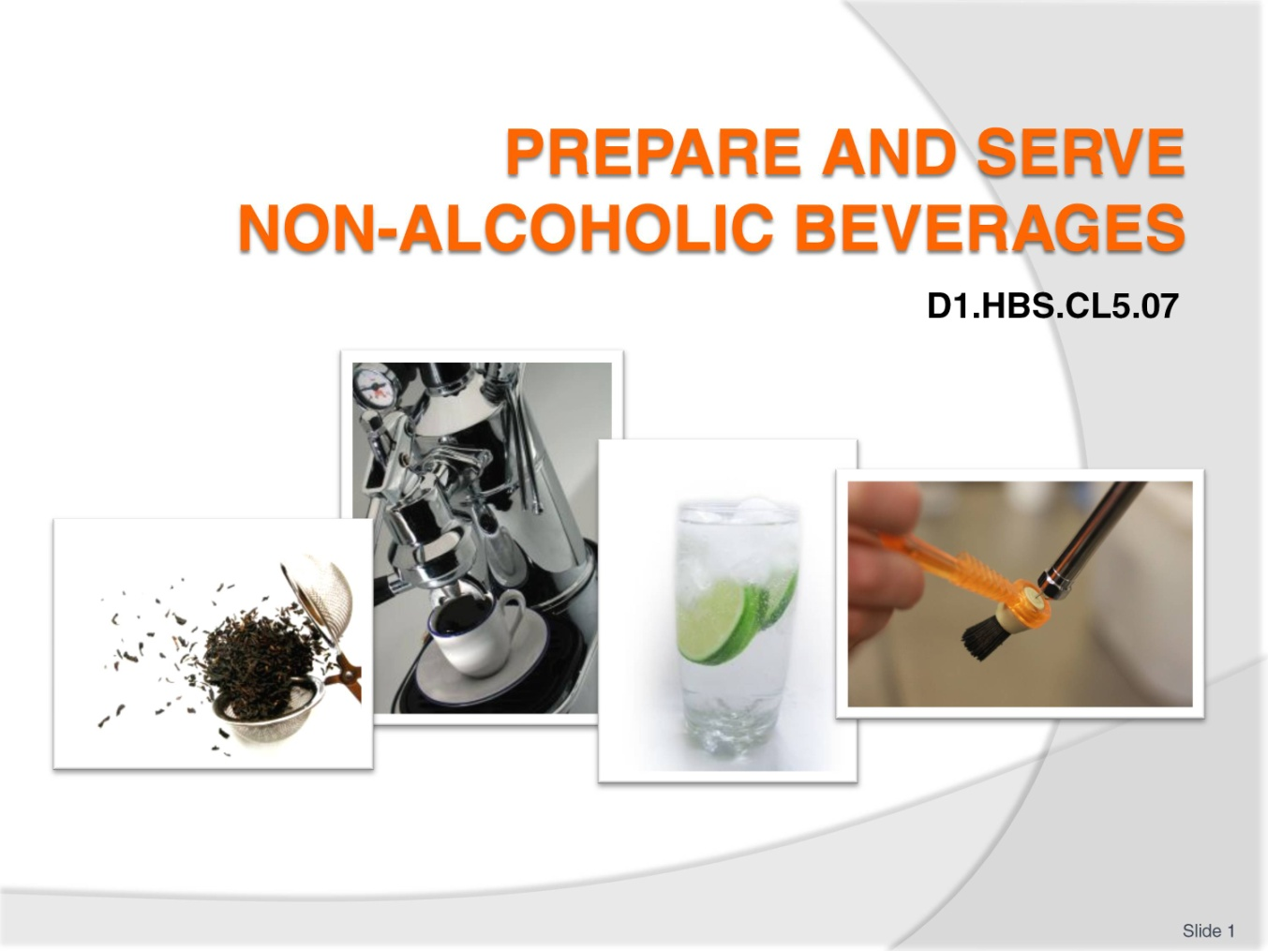
Slide No | Trainer Notes
 | Trainer welcomes trainees to class.

Slide
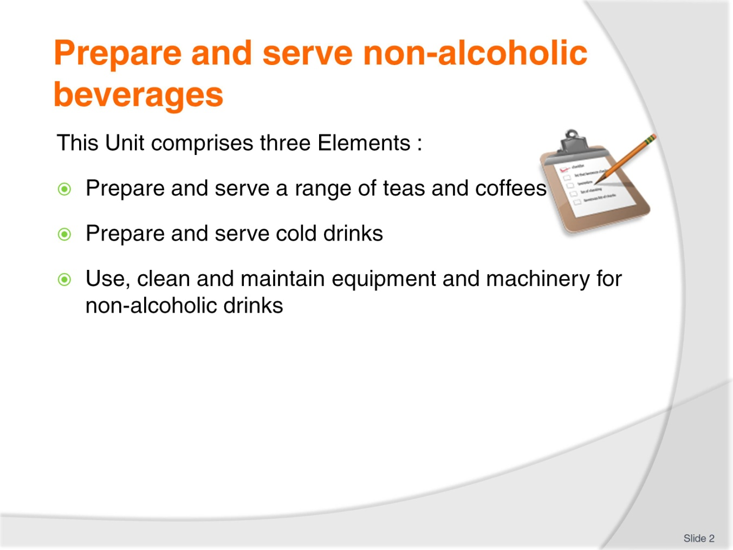
Slide No | Trainer Notes
Trainer advises trainees this Unit comprises three Elements, as listed on the slide explaining:
Each Element comprises a number of Performance Criteria which will be identified throughout the class and explained in detail
Trainees can obtain more detail from their Trainee Manual
At times the course presents advice and information about various protocols but where their workplace requirements differ to what is presented, the workplace practices and standards, as well as policies and procedures must be observed.

Slide
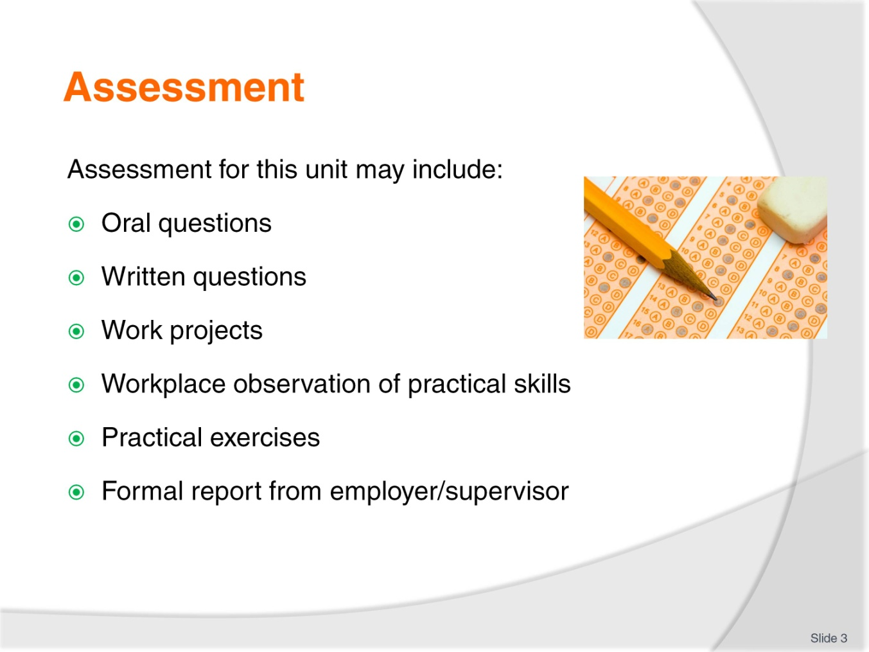
Slide No | Trainer Notes
Trainer advises trainees that assessment for this Unit may take several forms, all of which are aimed at verifying they have achieved competency for the Unit as required.
Trainer indicates to trainees the methods of assessment that will be applied to them for this Unit.

Slide
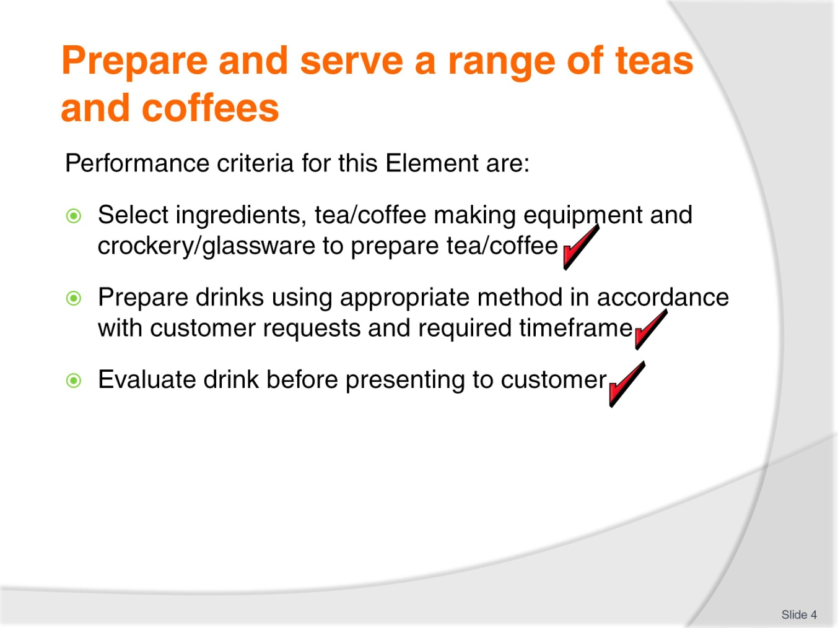
Slide No | Trainer Notes
Trainer identifies for trainees the Performance Criteria for this Element, as listed on the slide.
Class Activity – General Discussion
Trainer leads a general class discussion on preparing and serving tea and coffee by asking questions such as:
What experience have you had in making coffees and teas?
What do you think is involved in preparing and serving tea and coffee?
What teas and coffees have you had in a commercial outlet and how were they served, what did they taste like?
What ingredients and equipment do you think is used to prepare tea and coffee in a commercial setting?
What special requests do you think customers might have for teas and coffees they order?

Slide
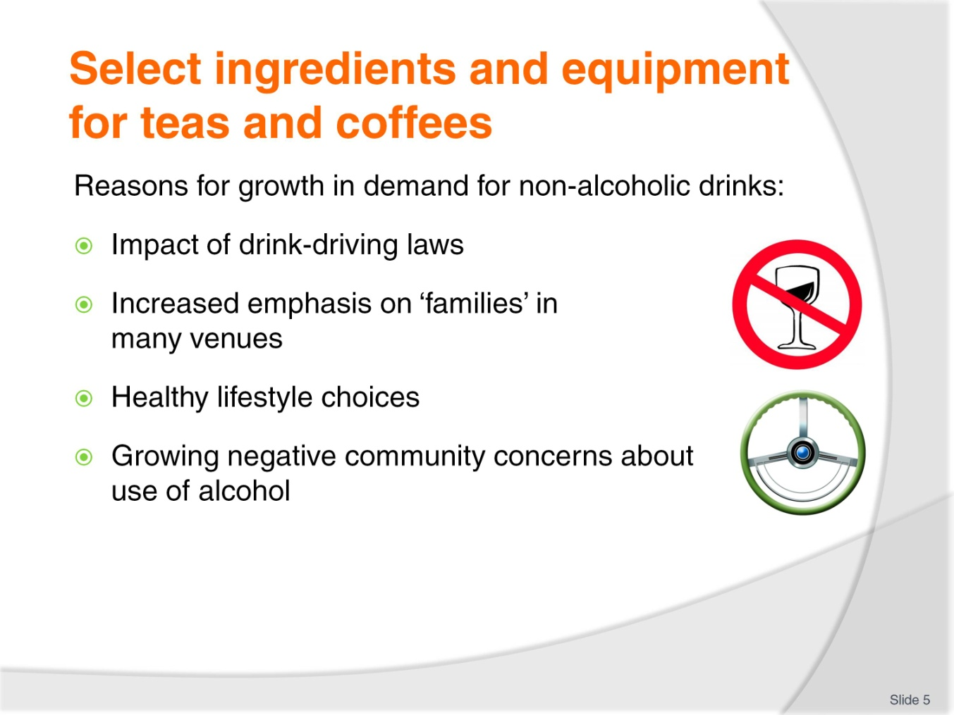
Slide No | Trainer Notes
Trainer explains there has been a growth in the demand for non-alcoholic drinks for the following reasons:
The impact of drink-driving laws. More people are now aware they have a moral, social and legal responsibility not to drink alcohol and drive
The increasing emphasis on ‘the family’ in many licensed premises. Many venues now target the entire family unit, and provide food, facilities and entertainment that will satisfy all age levels. It therefore follows naturally that beverages must also cater for all ages
A renewed interest in a healthy lifestyle. Some people have medical conditions which do not allow them to drink alcohol, and others simply want to remain as healthy as they can, believing the consumption of alcohol runs contrary to their efforts
A general community feeling that overindulging in liquor is no longer as acceptable as it once was. Employers and work colleagues will not tolerate drunkenness in the workplace. Many employers now have a ‘zero tolerance’ policy as far as alcohol is concerned. There is no doubt employers also have a common law duty of care towards both customers and staff in relation to alcohol.

Slide
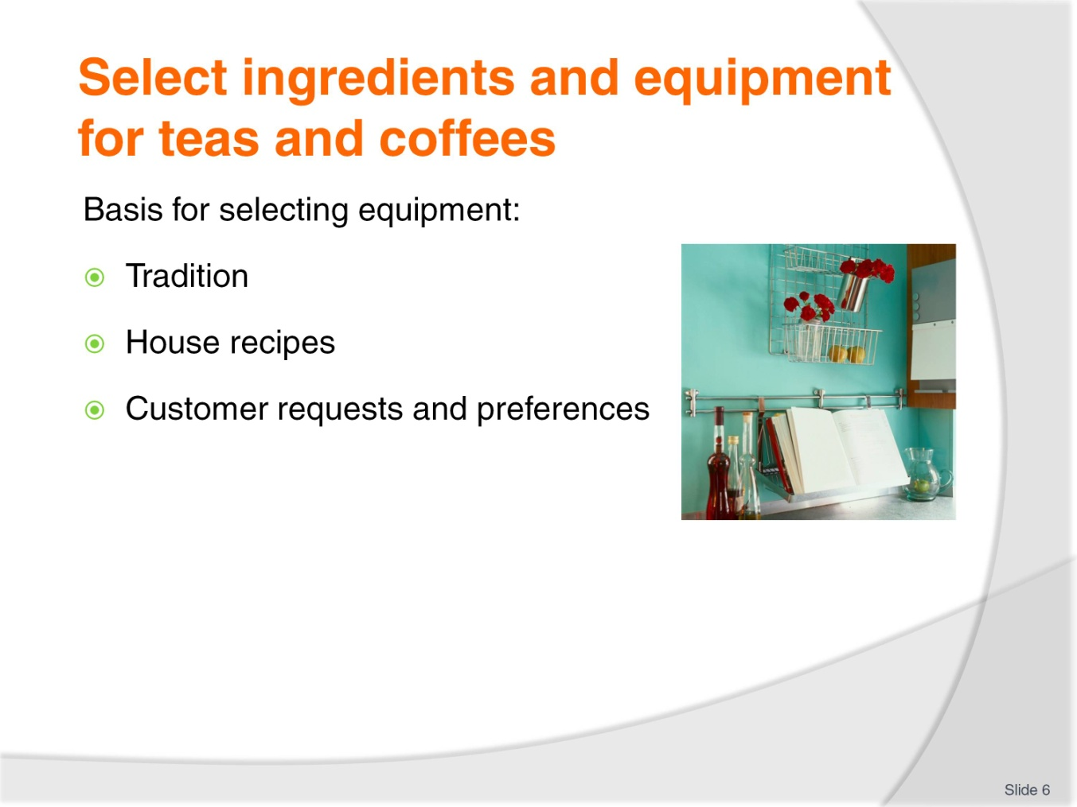
Slide No | Trainer Notes
Trainer identifies basis for selecting items for making tea, coffee and/or cold drinks are:
Tradition:
- There are traditional ways of making and serving many drinks.
- For example, demi-tasse for short blacks, glasses for lattes and iced tea.
- These traditional methods of making drinks and service protocols create customer expectations we must meet
House recipes – see next slide
Customer requests and preferences – see following slide.

Slide
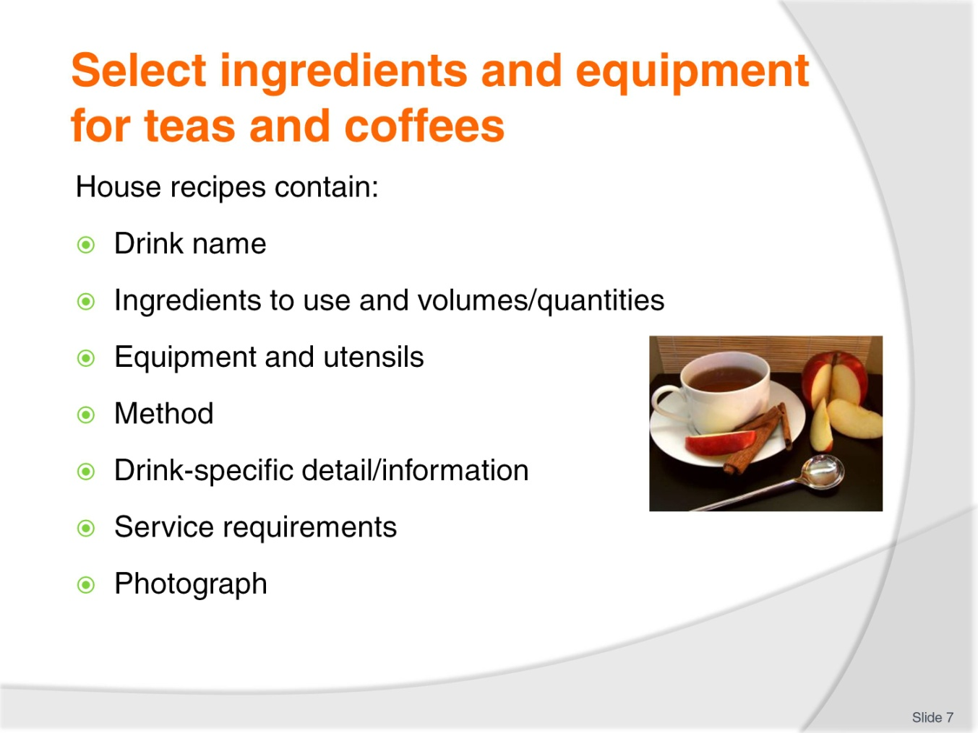
Slide No | Trainer Notes
Trainer states ‘House recipes’ are also known as ‘Standard recipes’ and they contain information and directions on how to prepare drinks setting out:
Name of drink
Ingredients to use
Quantities
Equipment and utensils required to make the drink
Procedure to follow
Relevant details regarding the individual drink which may mention drink-specific information such as temperature/s and type of milk to use
Service requirements including the crockery (or take away container) to be used, and garnishes, decorations and/or accompaniments required
A photograph of the finished product.
Class Activity – Handout
Trainer distributes and discusses sample house recipes.

Slide
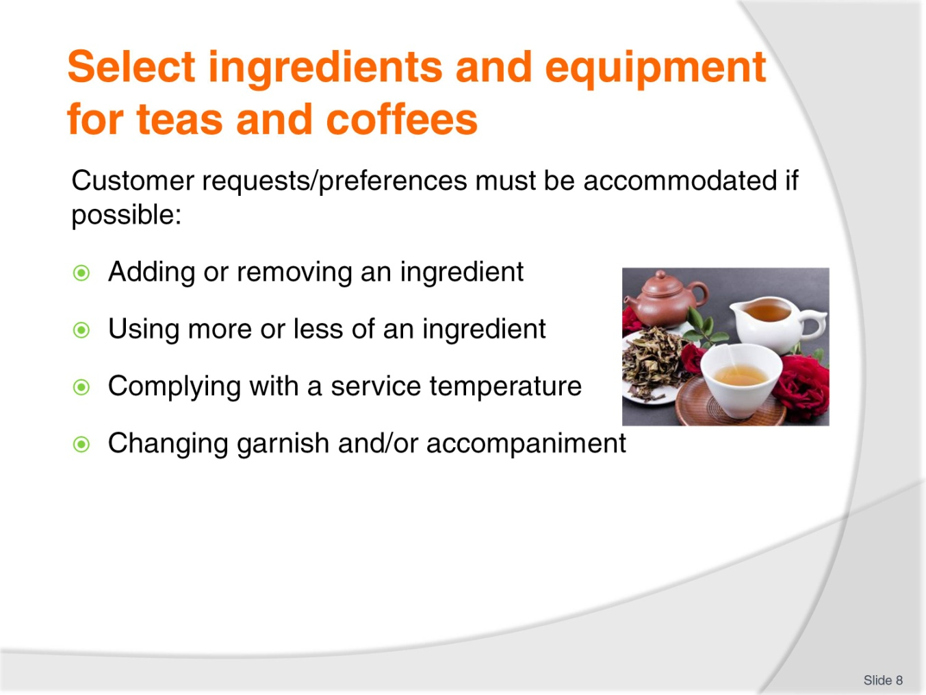
Slide No | Trainer Notes
Trainer highlights that individual requests and preferences should be accommodated when making beverages, where possible, indicating this can mean:
Adding or removing an ingredient – no sugar, no ice, no milk, extra cream
Adding more or less of an ingredient – extra syrup, double shot of coffee, just a splash of milk, really strong tea
Using a different type and or size of cup, mug or glass – “served in a mug rather than a cup”
Stipulating a service temperature – such as “Really cold, lots of ice”, “Warm but not hot”, “Boiling hot”
Differences to garnishes and/or accompaniments – “extra mints”, “no lemon”, no straws”.

Slide
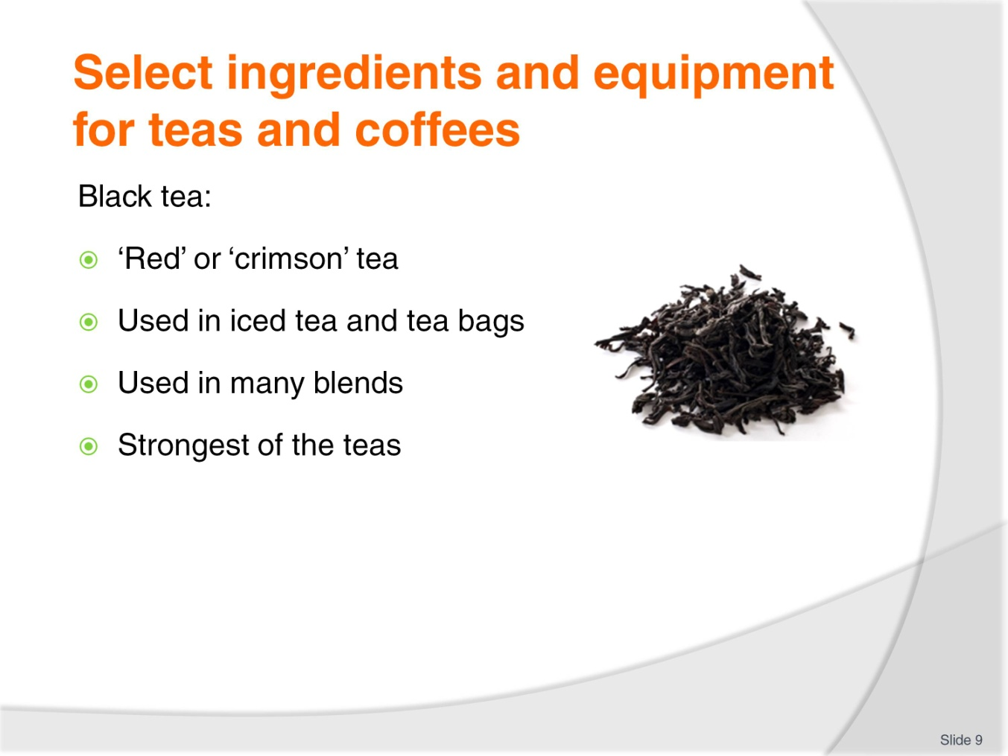
Slide No | Trainer Notes
Trainer explains there are over 3,000 types of tea across the world.
Black tea
Black tea is referred to as ‘red (or ‘crimson’) tea’ by the Chinese because of its colour, and is the most popular tea in the world
It comes from the fully oxidised leaves of the ‘tea plant’ called Camella Sinensis
It is the tea commonly used for making iced tea and owes its popularity to tea bags where it made its debut to most of the world
It is also popular with tea producers for blending with other ingredients (such as flowers, herbs, citrus, fruit) to produce an increasing range of tea-based drinks. Black tea is also mixed with other teas to make certain blended teas – see below
Black tea is usually the strongest of all teas in terms of taste and contains the most caffeine
It is available in tea bags and as loose leaf tea.
Class Activity 1 – Online video
Trainer arranges for students to view and discuss video at
http://video.about.com/coffeetea/Overview-of-Black-Tea.htm.
Class Activity 2 – Sample
Trainer arranges for students to:
See sample of tea as identified on slide
Taste tea as identified on slide.
Slide
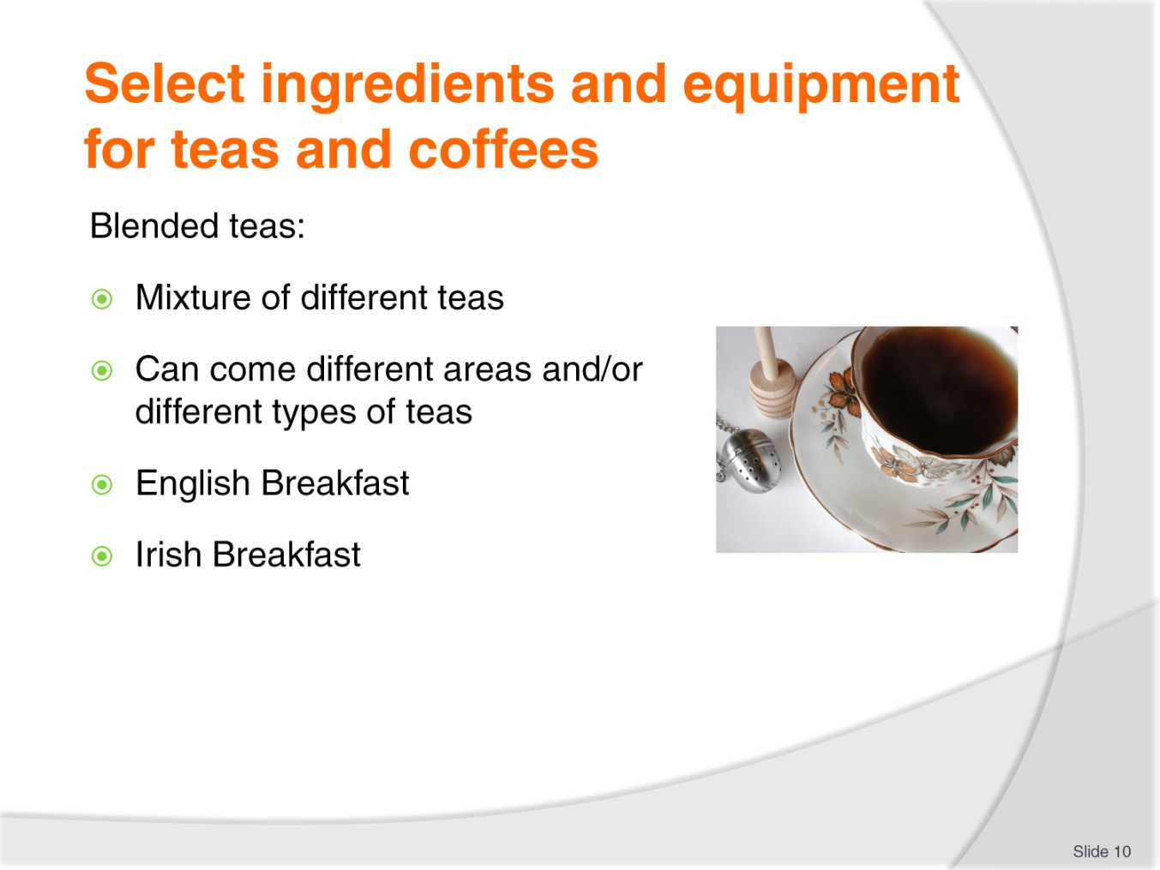
Slide No | Trainer Notes
Trainer continues providing information on teas:
Blended teas
These teas result from mixing different teas together with a view to creating a consistent final product
Teas blended together can come from different geographical regions or be different types of teas
English Breakfast is the most popular blend – Irish Breakfast is also a blend.
Class Activity – Sample
Trainer arranges for students to:
See sample of tea as identified on slide
Taste tea as identified on slide.

Slide
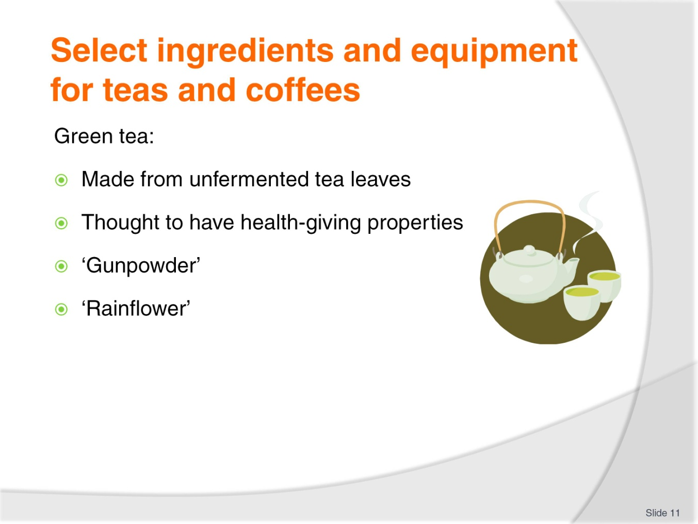
Slide No | Trainer Notes
Trainer continues providing information on teas:
Green tea
Green tea is made from unfermented (hence, green) tea leaves and is very popular in Japan and China
Green tea has recently been associated with having health benefits which are making it increasingly popular: nearly all teas are enjoying a surge in popularity for health-related reasons
Green tea has fairly popular versions known as ‘Gunpowder’ and ‘Rainflower’.
Class Activity – Sample
Trainer arranges for students to:
See sample of tea as identified on slide
Taste tea as identified on slide.

Slide
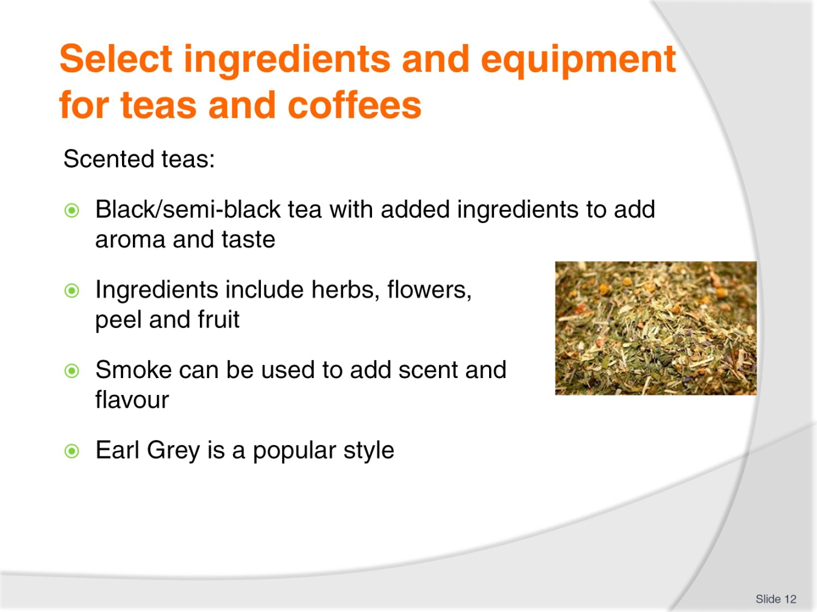
Slide No | Trainer Notes
Trainer continues providing information on teas:
Scented teas
Scented teas are usually made by taking a black tea or a semi-black tea and adding ingredients to introduce a specific aroma and taste
It is believed many of these teas originally evolved as manufacturers tried to mask the shortcomings of inferior quality teas, but today many of the scented teas are deliberate marketing ploys by producers seeking new niche markets for their products
Ingredients added to the base tea may include herbs, flower blossoms or fruit/fruit peel
Well-known scented teas include Earl Grey (which has oil from the bergamot citrus plant added to it) and Jasmine (jasmine flowers) but there has been a big growth in this area with scents also including apple, lychee, mango, strawberry, rose, lavender, mint, caramel etc
Smoke is used to scent and flavour some teas, burning pine needles under the tea while the leaves are drying. Lapsong Souchong is a well-known tea made using a smoking process.
Class Activity – Sample
Trainer arranges for students to:
See sample of tea as identified on slide
Taste tea as identified on slide.
Slide
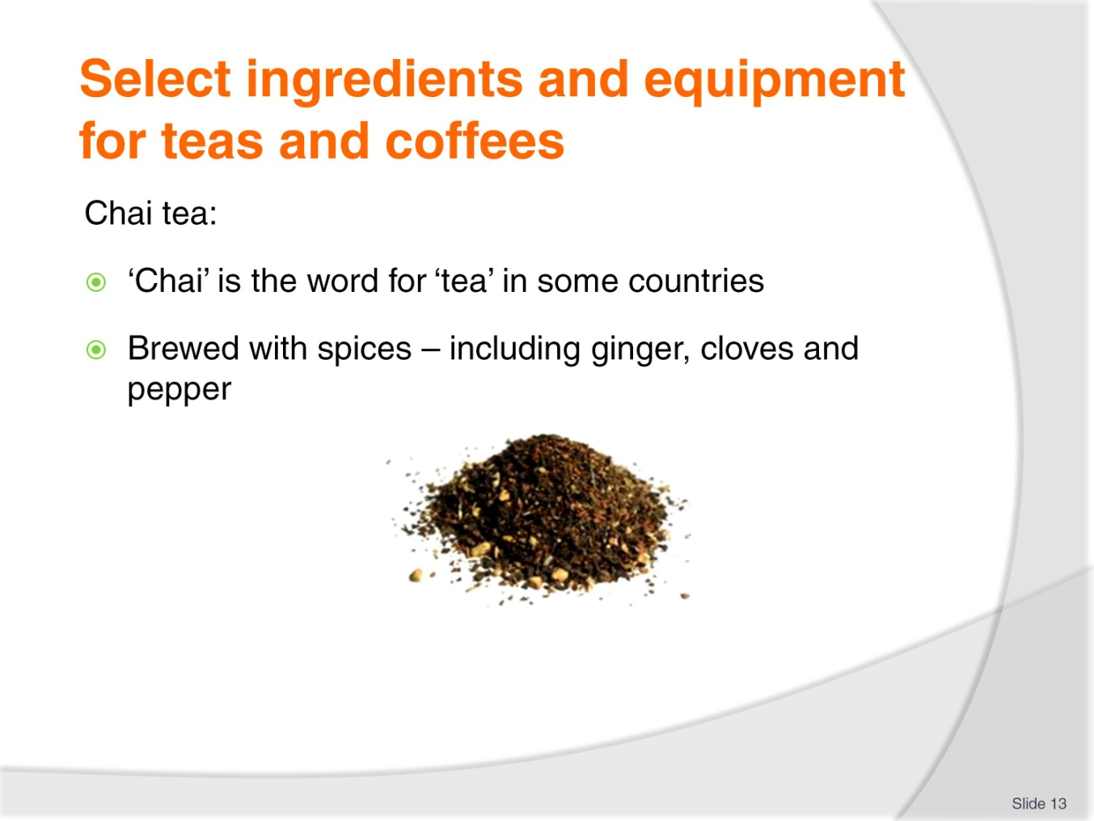
Slide No | Trainer Notes
Trainer continues providing information on teas:
Chai tea
Chai is the word for ‘tea’ in some countries
It is brewed with a variety of spices (such as ginger, cloves and pepper) which vary between different blends/recipes.
Class Activity 1 – Sample
Trainer arranges for students to:
See sample of tea as identified on slide
Taste tea as identified on slide.
Class Activity – Tea Websites
Trainer arranges for students to view and discuss websites such as:
http://www.2basnob.com/chai-tea.html
http://www.teavana.com/special-teas
http://www.tenren.com/index.html
http://coffeetea.about.com/od/typesoftea/Types_of_Tea.htm
http://www.twinings.com.au/
http://www.lipton.com.au/home/
http://www.bushells.com.au/
http://www.dilmah.com.au/.

Slide
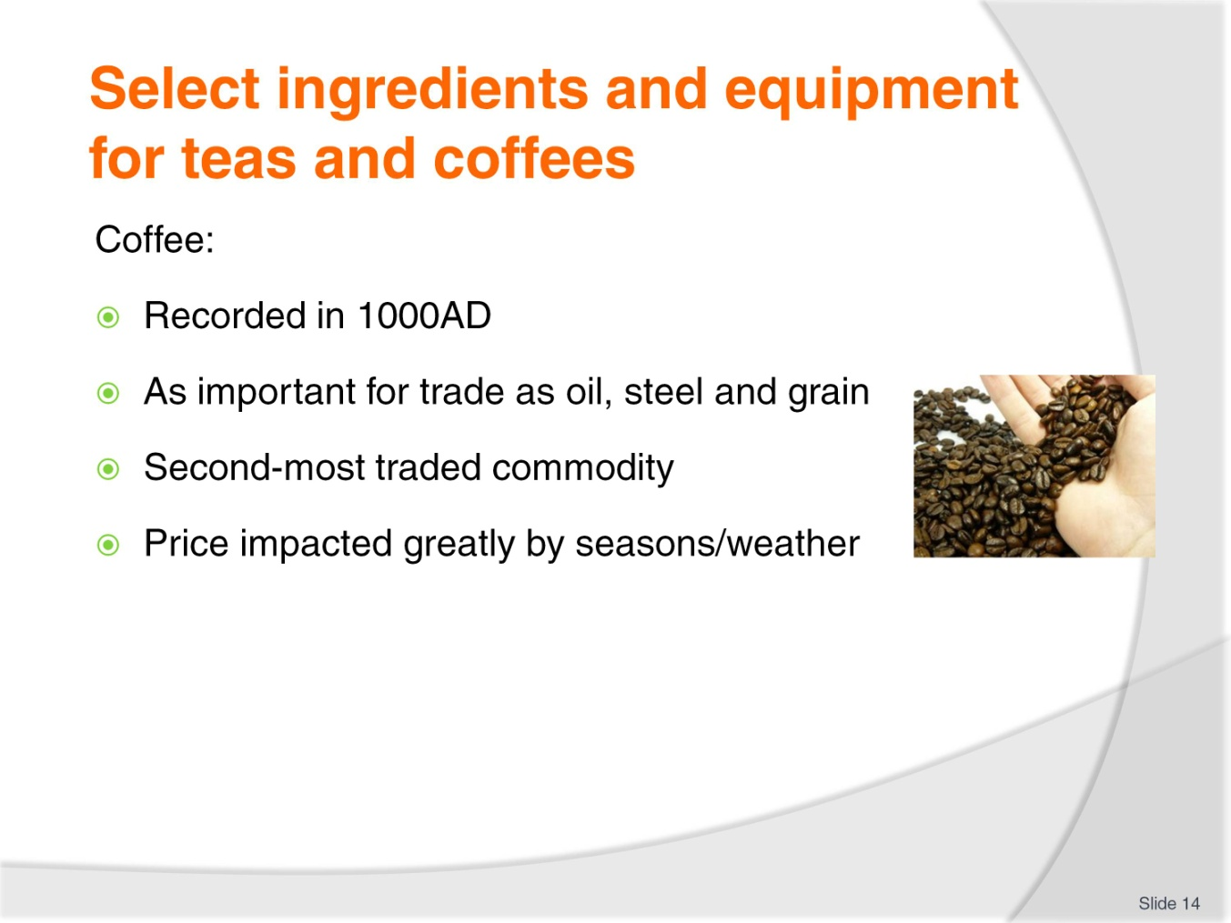
Slide No | Trainer Notes
Trainer provides background information on coffee:
The history of coffee has been recorded from about 1000 AD onwards
From about 1400 AD Europe began drinking coffee and its use exploded, with many innovations in its preparation and consumption being introduced
In the world marketplace, coffee ranks alongside oil, steel and grain as an exportable raw material of the highest value. Coffee is the second most-traded commodity in the world, indeed the economies of many of the prime coffee-producing countries are almost entirely dependent on the export of coffee for their natural wealth
When there is a bad coffee crop, the price increases and the supply and quality of the coffee is reduced.

Slide
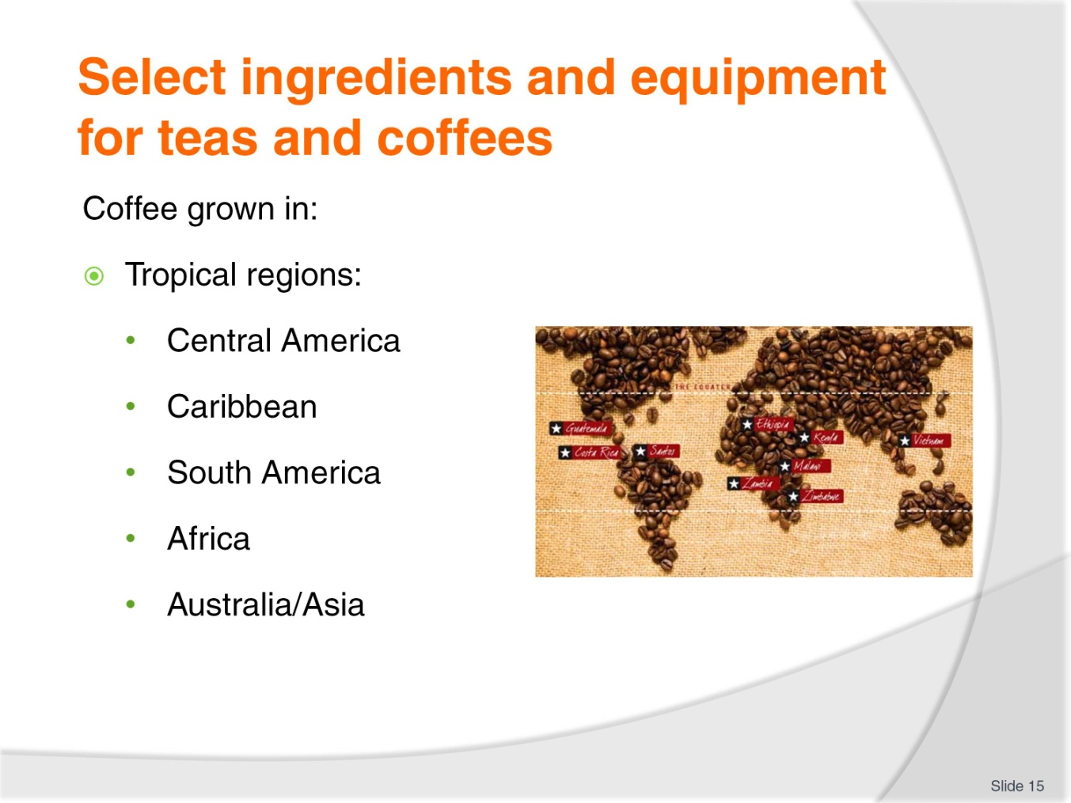
Slide No | Trainer Notes
Trainer talks about origins of coffee stating:
Coffee grows only in tropical regions. It is intolerant to frost and requires moderate rainfall, warm temperatures year-round and plenty of sunshine. The main coffee growing countries can be grouped into the following regions:
- Central America and the Caribbean – Mexico, Panama, Caribbean Islands
- South America – Brazil, Colombia, Ecuador, Peru
- Africa – Kenya, Tanzania, Cameroon
- Australia/Asia – India, Indonesia, Vietnam, New Guinea.

Slide
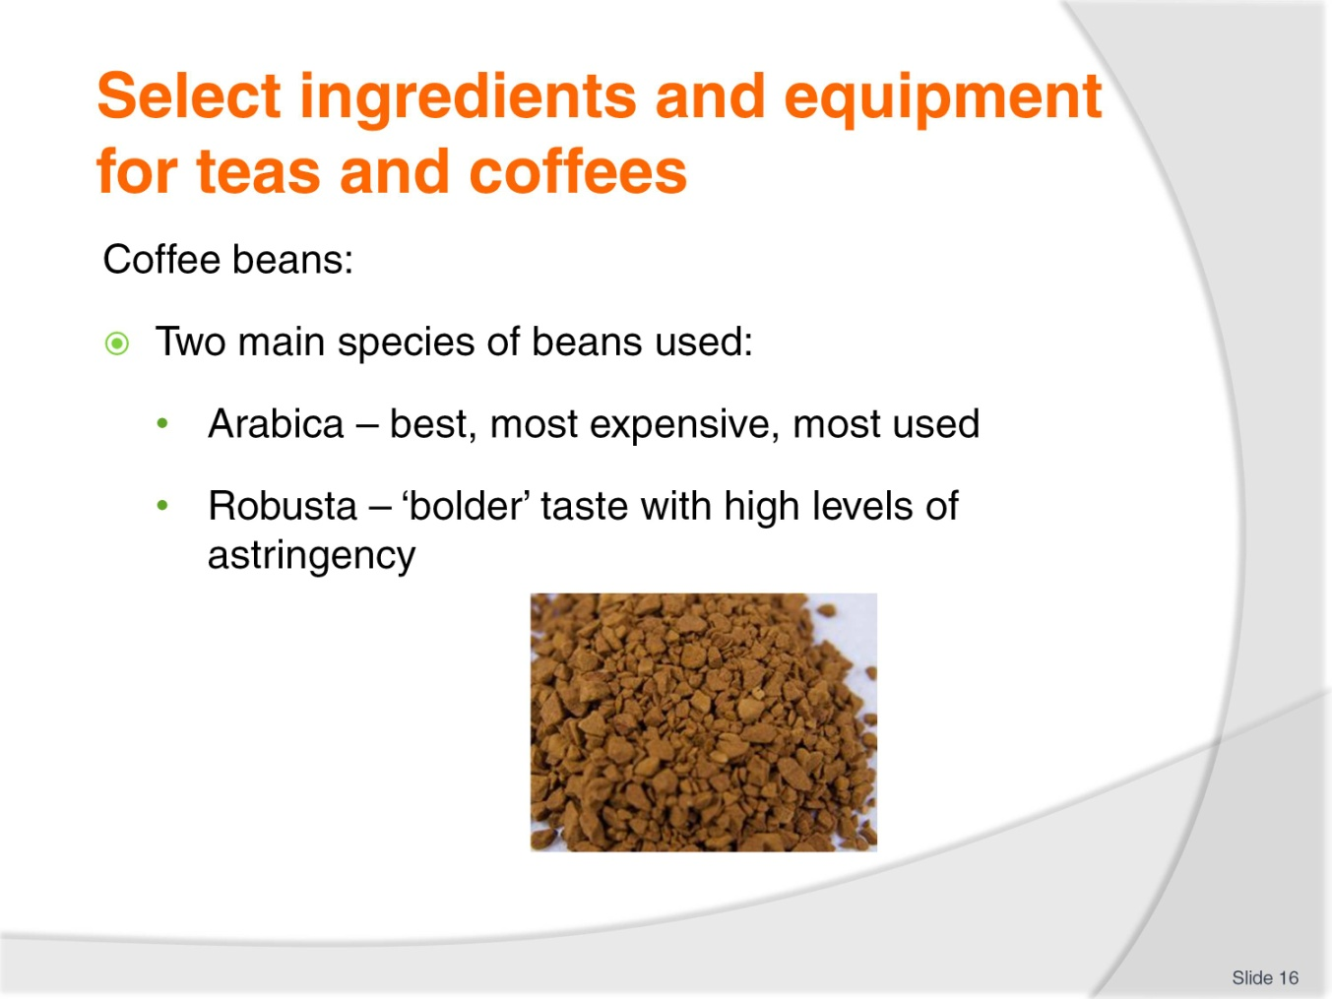
Slide No | Trainer Notes
Trainer distinguishes between coffee beans advising:
The two most widely used varieties of coffee beans are Arabica and Robusta
Arabica beans are more sensitive to climate and altitude. They are considered of premium quality when compared to Robusta beans: Arabica beans are longer, more oval in shape, and have an S-shaped seam
Robusta beans grown in a wider variety of equatorial climates and deliver a bolder taste: the Robusta beans are rounder, smaller and have a straight seam.
Class Activity – Coffee Websites
Trainer arranges for students to view and discuss websites such as:
http://www.nestle.com.au/Default.htm
http://grinderscoffee.com.au/
http://www.lavazza.com.au/
http://www.roberttimms.com/
http://www.vittoriacoffee.com/index.php/1.html
http://www.bushellscoffee.co.nz/.

Slide
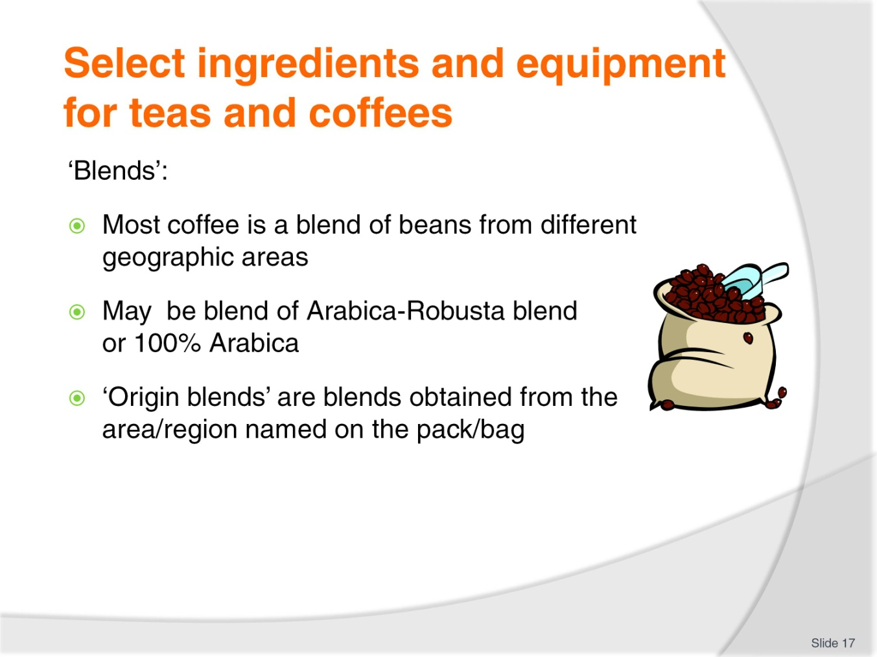
Slide No | Trainer Notes
Trainer discusses ‘blending’ stating:
The vast majority of roast and ground coffee, including all espresso coffees, are roasted coffee blends from various growing regions
Blends include different percentages of Robusta and Arabica or may be 100% Arabica
Each blend tastes different by virtue of the different flavours contributed from the different growing regions. In much the same way the one wine grape variety from different growing regions will also taste noticeably different. It is a fact that each particular coffee growing region produces beans with a distinctive flavour
Very, very few blends are made from 100% Robusta beans because of the level of astringency produced
Some blends are called ‘origin blends’ meaning 100% of the coffee beans are sourced from the area/region named. This enables drinkers to purchase a coffee they know will have certain characteristics – for example, Costa Rican Arabica beans are famed for their fragrance, flavour and full body.
Class Activity – Coffee Websites
Trainer arranges for students to view and discuss websites such as:
http://www.facebook.com/pages/Asean-Coffee-Federation/168413326607869
http://www.gloriajeanscoffees.com.au/
http://www.starbucks.com/
http://www.acta.org.au/
http://www.coffeereview.com/.
Slide
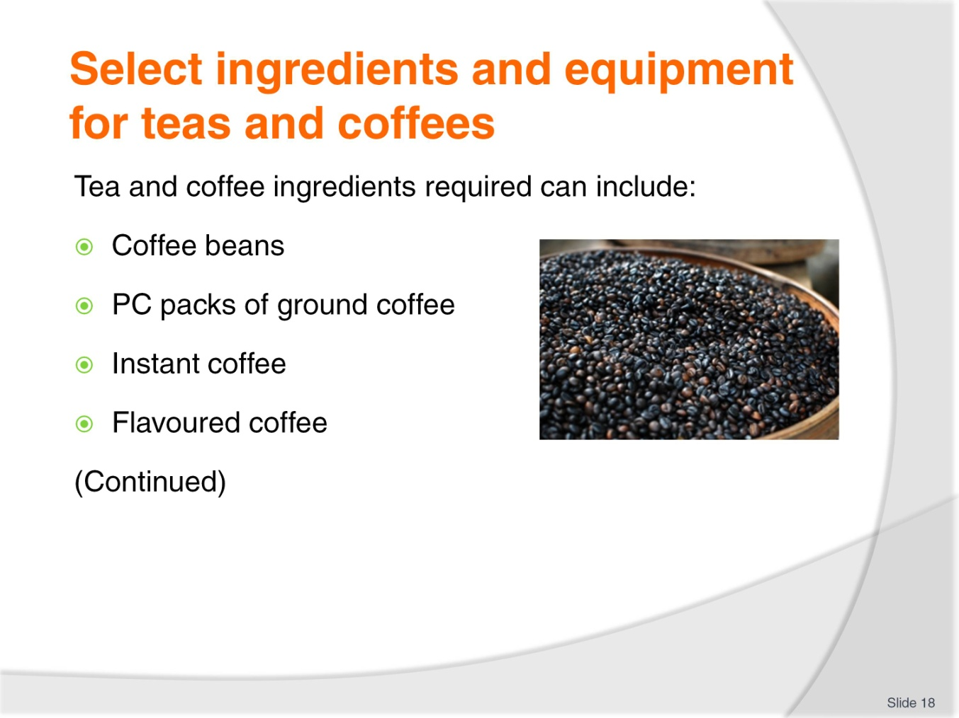
Slide No | Trainer Notes
Trainer instructs students about selecting tea and coffee ingredients stating ingredients required will, as already discussed, depend on the drink ordered by the customers and the house recipes for the property explaining a representative list of ingredients includes:
Coffee beans – premises offering espresso coffee will grind their own beans and may offer a variety of blends
Sachets (PC packs) of ground coffee – for use in other coffee equipment such as plungers and dripolators
Instant coffee, including decaffeinated – despite the explosion in the use of espresso machines there still remains a role for instant coffee in nearly every venue
Proprietary brands of flavoured coffee.
Class Activity 1 – Coffee Websites
Trainer arranges for students to view and discuss websites such as:
http://www1.lavazza.com/corporate/au/index.html
http://www.coffeebean.com.ph/
http://www.nestle.com.au/Products/Featured-Brands/Nescafe
http://www.javaberry.com/?module=429andaction=viewCategoryandidParent=12.
Class Activity 2 – Sample Products
Trainer shows students sample products as identified on slide.
Slide
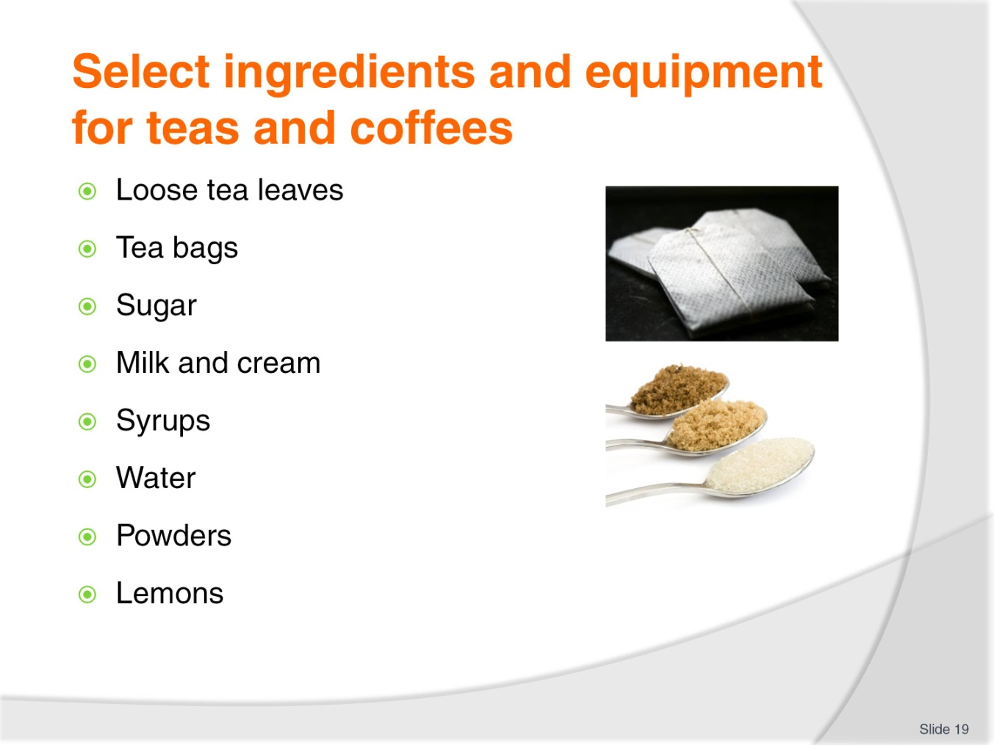
Slide No | Trainer Notes
Trainer continues providing examples of tea and coffee related ingredients:
Loose tea leaves – as appropriate for the types and styles of teas offered by the venue
Tea bags – an option used in many venues for the provision of teas. All types and styles of tea are available in the form of tea bags
Sugar – bulk sugars including refined and raw as well as cubed and portion control (PC) packs: sugar substitutes are now also mandatory inclusions when delivering non-alcoholic beverages
Milk and cream. Dairy products play a central role in offering white teas, coffees/espresso drinks. Make sure dairy products are fresh and not out-of-date. PC packs which combine coffee and milk, and coffee+milk+sweetner are also available and popular for use in guest rooms in accommodation facilities
Syrups for coffees. Many venues offer flavoured coffees through the addition of syrups such as caramel, chocolate, white chocolate, Irish cream, hazelnut
Water. There will always be a need for a good supply of fresh water, iced water and boiling water
Powders – some drinks may require chocolate powder, chocolate sprinkles, cinnamon, cocoa, nutmeg, chai spices and flavours and frappe mixes
Lemons – for use with black tea.

Class Activity 1 – Coffee Websites
Trainer arranges for students to view and discuss websites such as:
http://www.cw-usa.com/supplies-condiments-sweeteners-sugar-packets-case.html
http://www.clubequal.com.au/
http://www.alchemycordial.com.au/shop/coffee-syrups/12.
Class Activity 2 – Sample Products
Trainer shows students sample products as identified on slide.

Slide
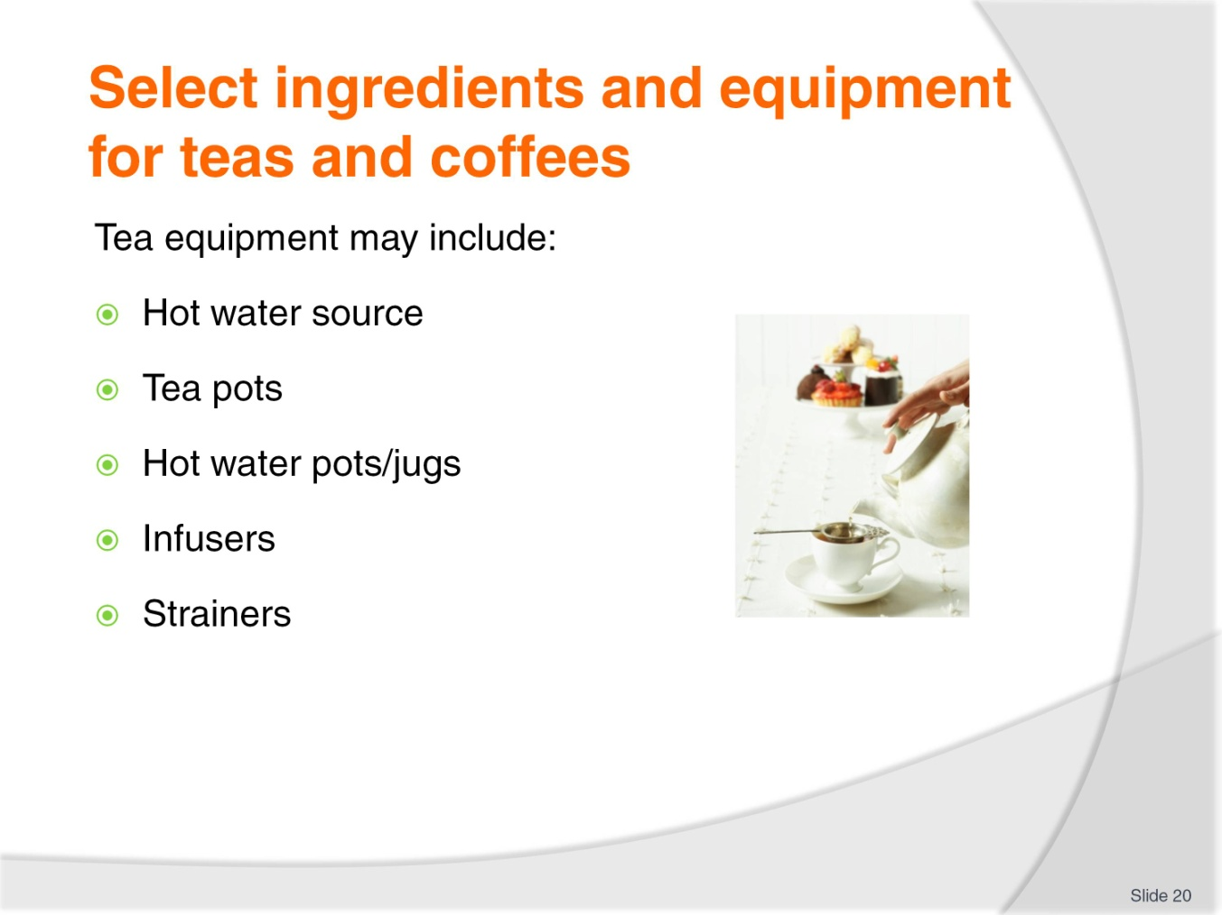
Slide No | Trainer Notes
Trainer continues advising about coffee equipment:
Bins for discarded pucks: called ‘knock box’
Urn or kettle or some other hot/boiling water dispenser (other than the espresso machine)
Percolators, drip filters and plungers for coffee service, other than espresso. These may even be used by premises which have an espresso machine.
Trainer highlights that many of the items used are domestic products used in a commercial setting and some are distinctly commercial in size.
Class Activity 1 – Websites
Trainer arranges for students to view and discuss websites such as:
http://www.hostdirect.com.au/listProduct/Equipment/Urns+and+Percolators/
http://www.vittoriacoffee.com/products-plunger.html.
Class Activity 2 – Sample Equipment
Trainer shows students sample equipment as identified on slide.

Slide
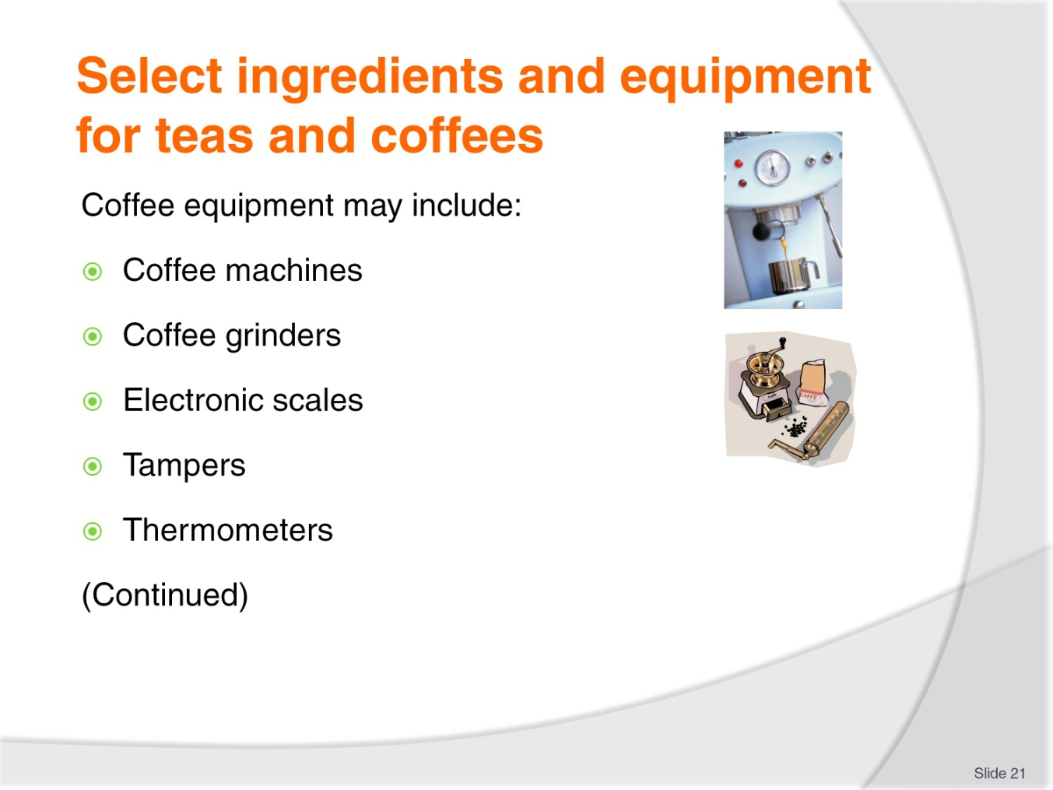
Slide No | Trainer Notes
Trainer advises students about selecting coffee equipment stating equipment required for the preparation of coffees can include:
Coffee machines – often known/referred to as espresso machines
Coffee grinders – these may be provided as part of the main espresso machine or as a separate and stand-alone unit. Most venues grind their beans several times a day. Some buy their coffee already ground meaning they will not need a grinder
Weighing equipment – electronic scales for checking the dosing of coffee dispensers
Tampers – for tamping ground coffee into portafilters
Thermometer – for taking the temperature of milk when heating it and texturing it, for example, for cappuccinos.
Class Activity 1 – Websites
Trainer arranges for students to view and discuss websites such as:
http://www.espressocompany.com.au/
http://www.supremecoffeemachines.com.au/catalogue/commercial-coffee-machines
http://www.fracino.com.au/
http://www.espressoitalia.com.au/coffee/MACHINES/35+Commercial
http://www.santos.fr/40m.html.
Class Activity 2 – Sample Equipment
Trainer shows students sample equipment as identified on slide.

Slide
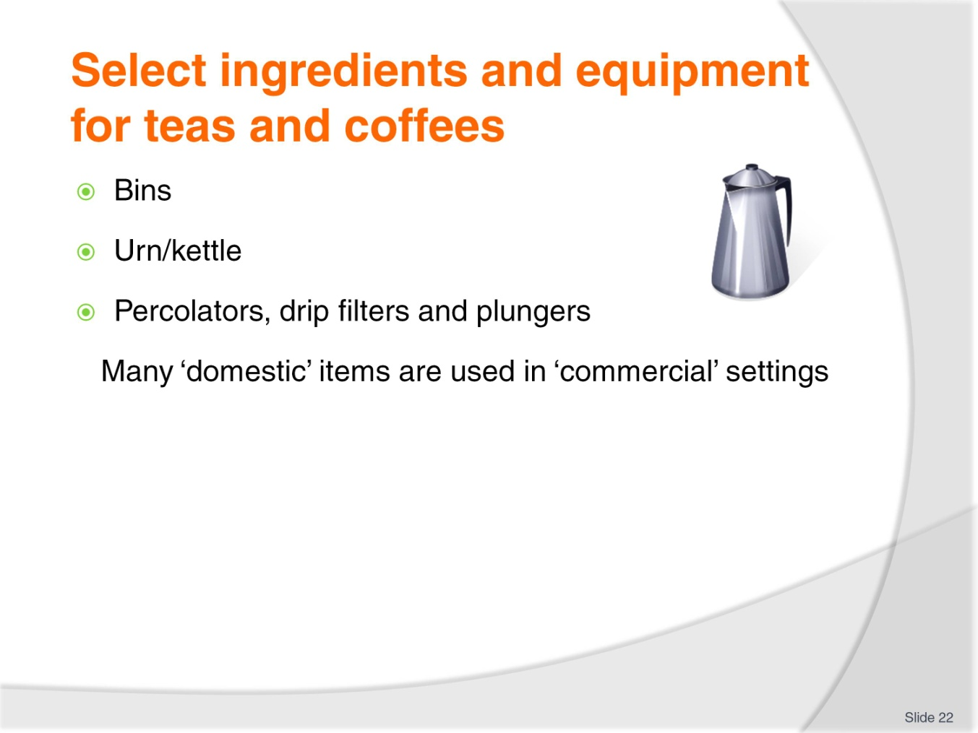
Slide No | Trainer Notes
Trainer continues advising about coffee equipment:
Bins for discarded pucks: called ‘knock box’
Urn or kettle or some other hot/boiling water dispenser (other than the espresso machine)
Percolators, drip filters and plungers for coffee service, other than espresso. These may even be used by premises which have an espresso machine.
Trainer highlights that many of the items used are domestic products used in a commercial setting and some are distinctly commercial in size.
Class Activity 1 – Websites
Trainer arranges for students to view and discuss websites such as:
http://www.hostdirect.com.au/listProduct/Equipment/Urns+and+Percolators/
http://www.vittoriacoffee.com/products-plunger.html.
Class Activity 2 – Sample Equipment
Trainer shows students sample equipment as identified on slide.

Slide
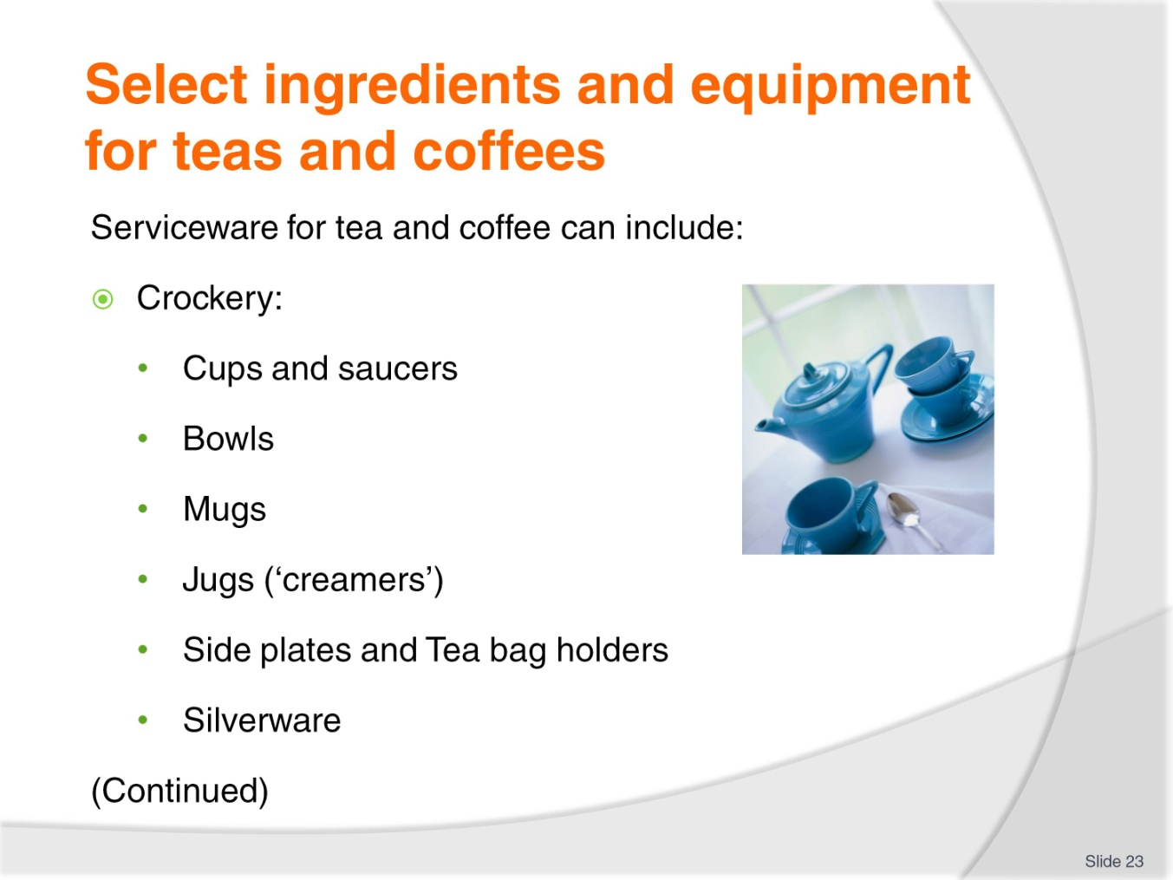
Slide No | Trainer Notes
Trainer discusses selecting crockery, cutlery and glassware for tea and coffee service illustrating with reference to the following:
Crockery – the requirements can include china/porcelain or stainless steel items:
- Cups and saucers – variety of sizes in the range 60 mls (demi-tasse) through to 300 mls
- Bowls – for sugar and accompaniments
- Mugs – for service of large hot and cold drinks: 300 mls plus
- Jugs – for milk, water and juices (150 mls upwards); small jugs may be called ‘Creamers’
- Side plates – for placement/service of accompaniments (biscuits, mints)
- Tea bag holders – for holding used tea bag
- Silverware – for certain service requirements where a higher standard is needed.
Class Activity 1 – Websites
Trainer arranges for students to view and discuss websites such as:
http://www.cateringequipment.com.au/crockery/.
Class Activity 2 – Sample Crockery
Trainer shows students sample crockery as identified on slide.

Slide
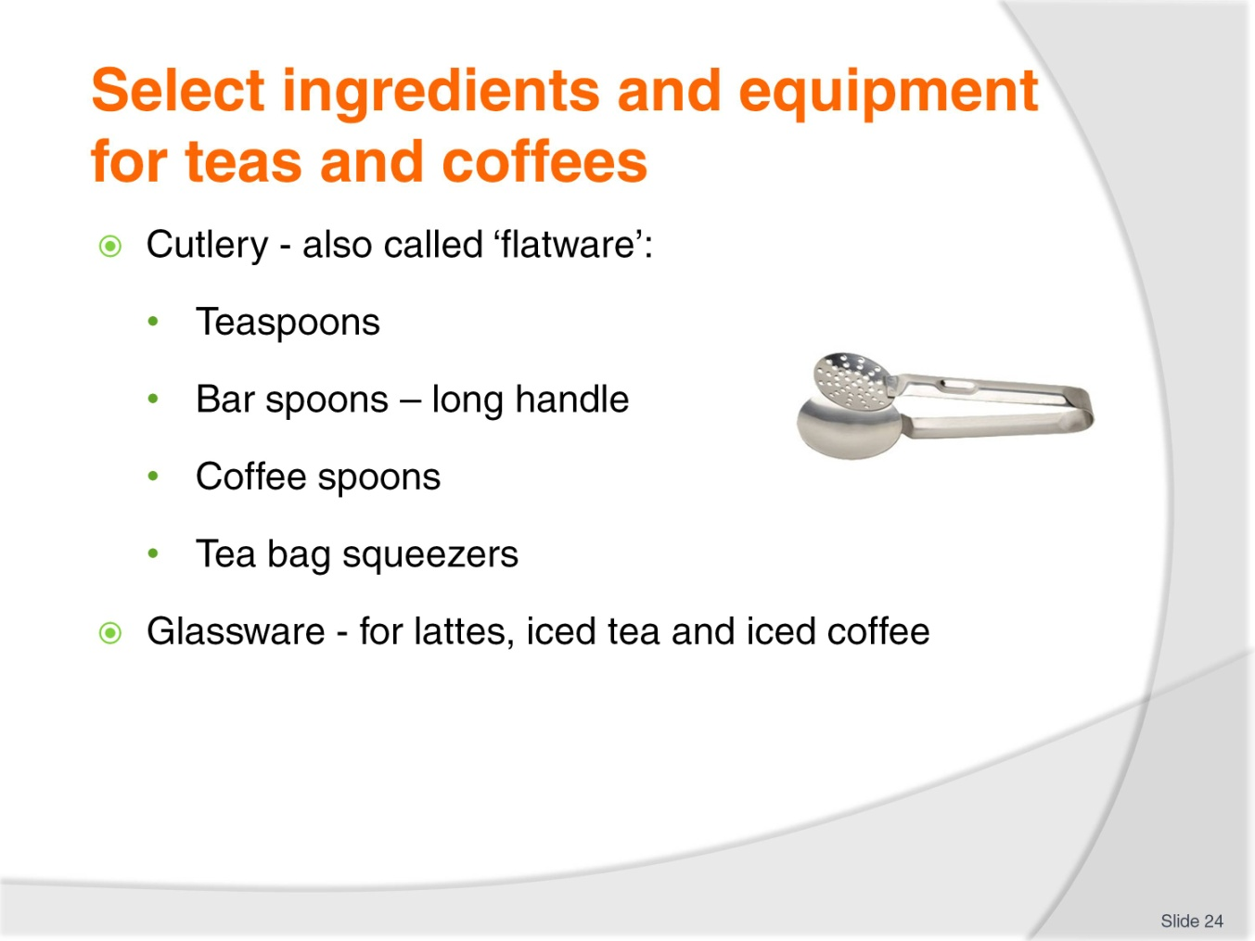
Slide No | Trainer Notes
Trainer identifies cutlery needed for tea and coffee service:
Cutlery – a variety of flatware items may be required such as:
- Teaspoons
- Bar spoons/parfait spoons
- Coffee spoons
- Tea bag squeezers.
Class Activity 1 – Websites
Trainer arranges for students to view and discuss websites such as:
http://www.hostdirect.com.au/listProduct/Equipment/Urns+and+Percolators/
http://www.vittoriacoffee.com/products-plunger.html.
Class Activity 2 – Sample Flatware and Glassware
Trainer shows students sample cutlery and glassware as identified on slide.

Slide
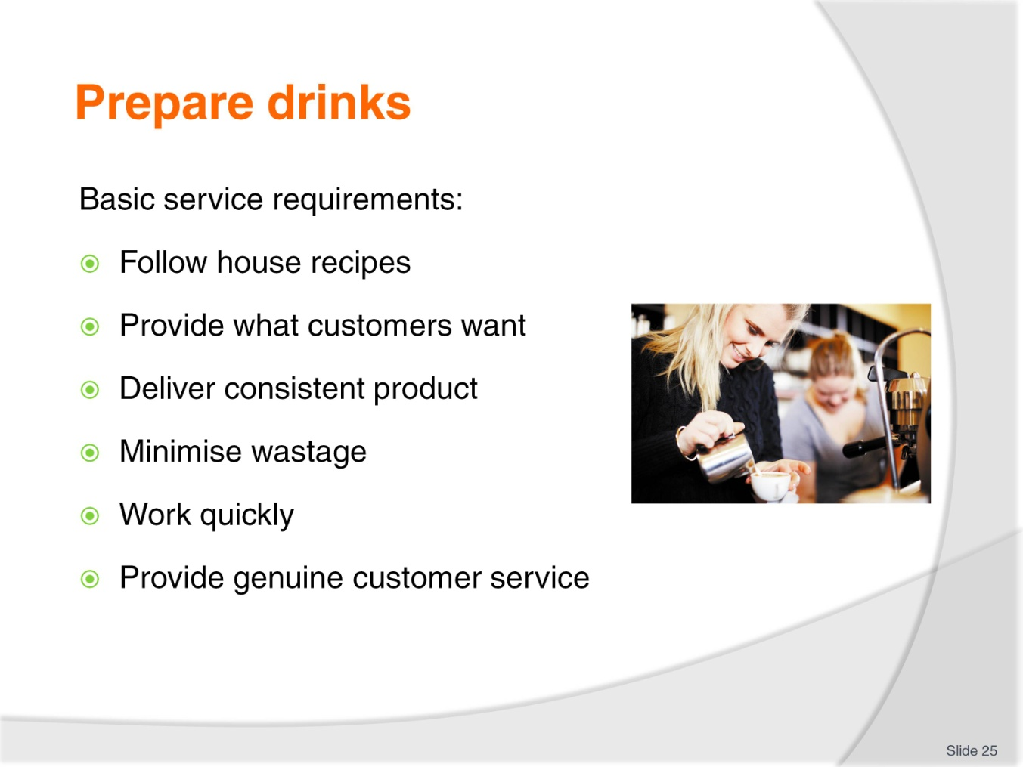
Slide No | Trainer Notes
Trainer indicates basic service requirements when making teas and coffees for customers:
Follow house recipes unless customer orders something different
Provide what the customer wants. There may be a requirement to charge extra where the customer wants a beverage different to what is listed on the menu/drink list so beware of the potential for this
Deliver a consistent product. The same drink should look and taste the same for all customers, today and tomorrow and every time it is made
Minimise wastage by not spilling drinks and through taking care to not over-produce drinks causing product to be thrown out
Work quickly – an ongoing requirement is for all teas and coffees to be produced and served ‘as soon as possible’
Deliver appropriate levels of customer service – when the order is taken and the drink is served.

Slide
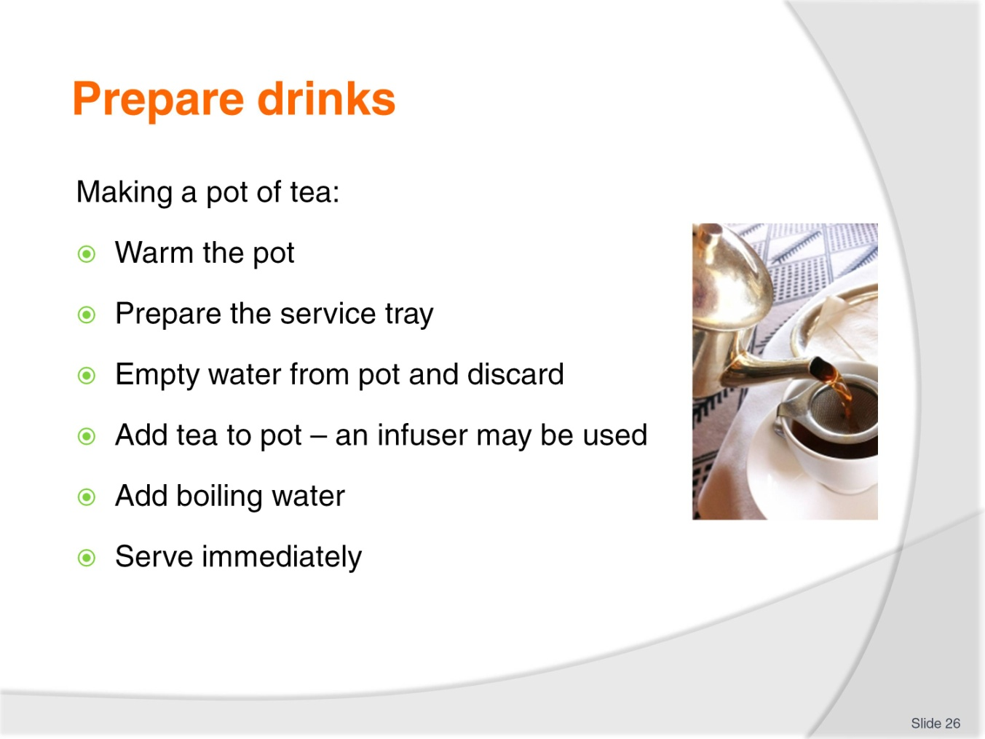
Slide No | Trainer Notes
Trainer describes process for making a pot of tea:
Warm the tea pot by filling with hot water
Prepare the tray in accordance with house standards to serve the tea which may mean:
- Getting the milk ready – pouring milk into a jug
- Getting the sugar ready – obtaining a bowl of white sugar, or sugar PC packs
- Preparing a jug/pot of boiling water used by guests to:
- Weaken the tea, if required
- Add to the pot to make more tea after they have served the first cup/s
- Preparing and setting out the cup/s and saucer/s and spoons and strainer (if infuser is not used)
- Cutting slices of lemon for black tea
- Adding a tea leaf strainer to the tray
- Preparing the tray - this is important so the tea can be served promptly once the boiling water has been added to the pot
Empty the water from the tea pot and discard the water
Place the required amount of the selected tea into the pot or infuser. The amount of tea required will depend on:
- The size of the pot and the number of cups the pot will serve
- Customer preferences for strength of the tea
- House recipes.
A standard rule is one spoonful per person plus one for the pot.
Add boiling water
Serve immediately.
Class Activity – Demonstration
Trainer:
Demonstrates how to make pot of tea
Provides opportunity for students to practice making pot of tea.

Slide
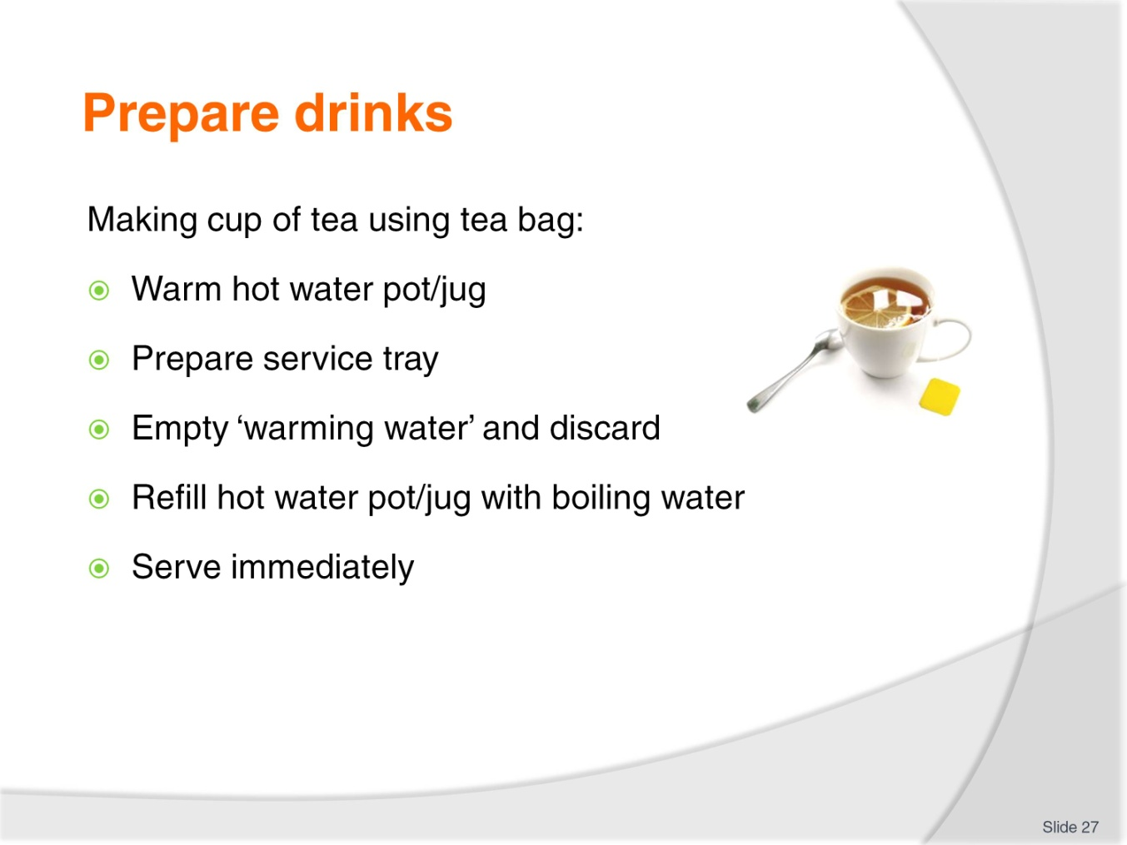
Slide No | Trainer Notes
Trainer describes process for making tea using a tea bag:
Warm a hot water pot/jug by filling with hot water
Prepare the service tray according to house standards with (as appropriate):
- Sugar, milk, lemon
- Hot water jug/pot; Cup/s and saucer/s
- Tea spoon/s
- Tea bag strainer – a squeezer used to squeeze tea from the bag
- Rest for used tea bag
- Select the required tea type as identified by the guest
- Place the tea bag in the cup/s or on a side plate according to house standards
Empty the water from the hot water pot/jug and discard the water
Fill or refill the hot water jug/pot
Serve immediately.
Trainer stresses:
The guest adds the water to the tea bag allowing them to make the tea to their individual preference. The water is not added to the cup and tea bag prior to or as part of service of tea using a tea bag
In some cases sugar is not required in the service tray as the sugar will be a standard part of the table setting.
Class Activity 1 – Demonstration
Trainer:
Demonstrates how to make tea using tea bag
Provides opportunity for students to practice making tea using tea bag.
Class Activity 2 – Websites
Trainer arranges for students to view and discuss websites such as:
http://www.metacafe.com/watch/4620328/how_to_make_the_perfect_pot_of_tea/
http://www.youtube.com/watch?v=OTrIwzRYRB0
http://www.youtube.com/watch?v=1-8LbiVjmXc
http://www.youtube.com/watch?v=v8y46pdaDMI
http://www.youtube.com/watch?v=2ENUZxDx6SU.

Slide
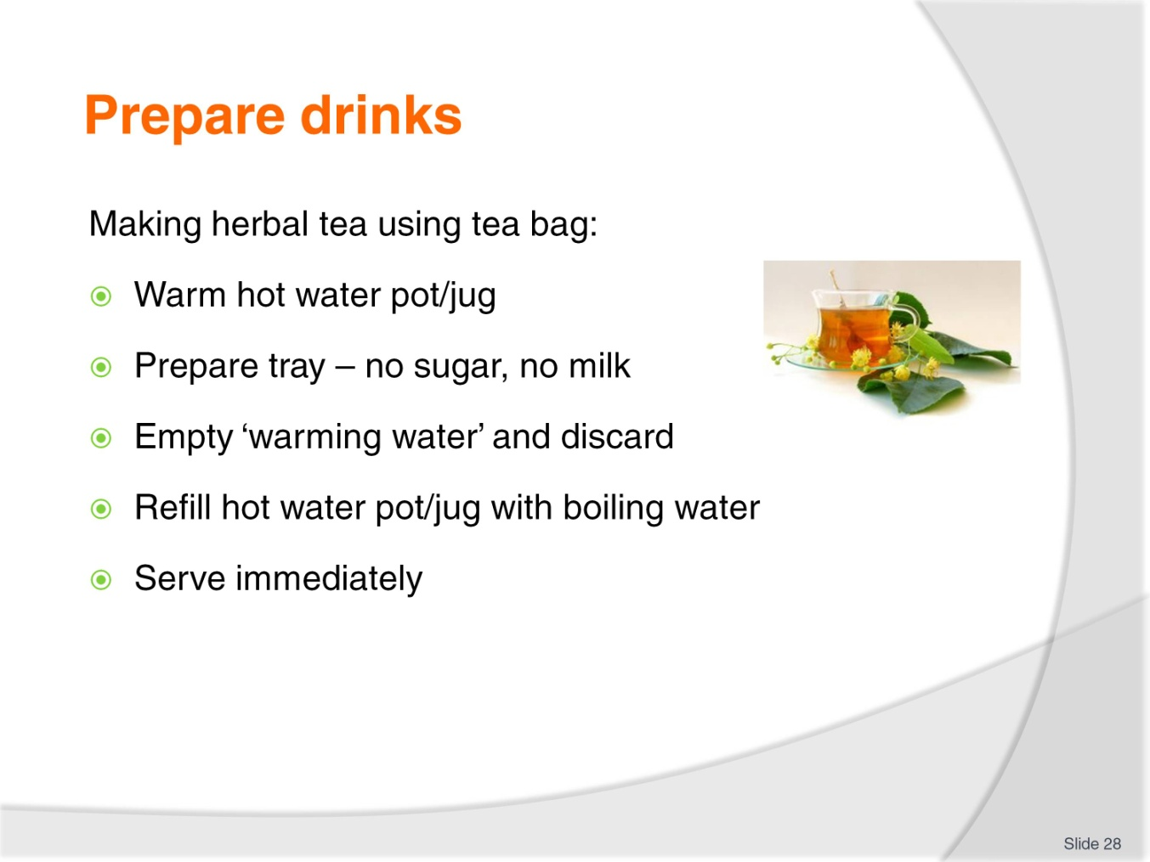
Slide No | Trainer Notes
Trainer discusses making of herbal tea stating that tea bags are used for serving herbal tea in most commercial settings but a pot may also be used and identifying that standard procedure for service of herbal tea is:
Warm a hot water pot/jug by filling with hot water
Prepare tray for service according to house requirements and customer requirements. Note that common practice with herbal teas is:
- Not to serve milk – unless requested
- Not to serve sugar – unless requested. Some venues may provide honey
- Place one cup and saucer for each customer. Many venues use a different style of cup and saucer for herbal teas
- Add one tea bag per person either loaded into cup or placed on side plate
- Add spoon and tea strainer/squeezer
Empty the water from the hot water pot/jug and discard the water
Fill or refill the hot water jug/pot
Serve immediately.
Class Activity – Demonstration
Trainer:
Demonstrates how to make herbal tea using tea bag
Provides opportunity for students to practice making herbal tea using tea bag.
Slide
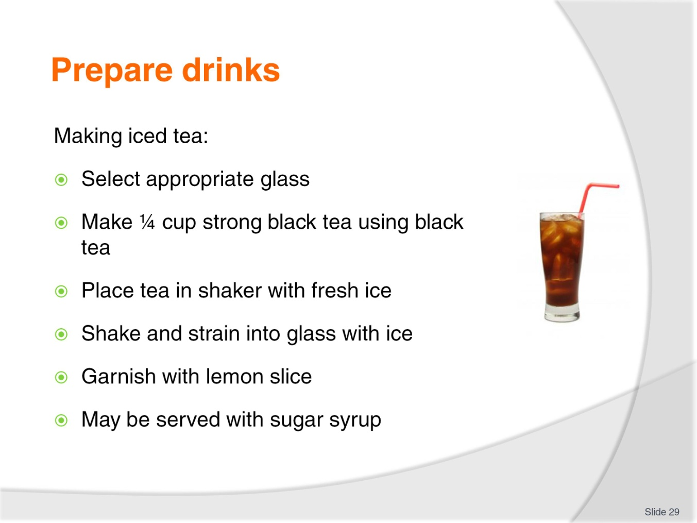
Slide No | Trainer Notes
Trainer discusses making of iced tea highlighting where a standard recipe does not exist, a method is:
Select the appropriate glassware. Iced tea is traditionally served in a glass cup/mug as opposed to tea cup
Make quarter of a cup of strong tea using black tea
Place tea in shaker full of ice
Shake and strain into a glass full of fresh ice
Garnish with a slice of lemon
Sugar syrup served to customer if requested, in preference to serving granulated sugar – see next slide.
Class Activity – Demonstration
Trainer:
Demonstrates how to make iced tea
Provides opportunity for students to practice making iced tea.

Slide
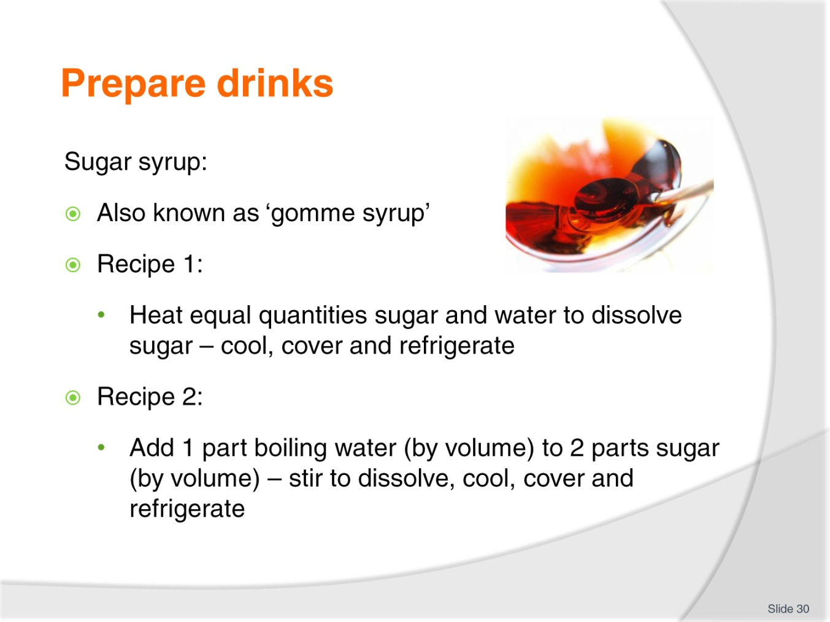
Slide No | Trainer Notes
Trainer explains sugar syrup stating:
Sugar syrup is also known as gomme syrup
The recipe for sugar syrup can vary so find out what applies where you work. The following are two options:
- 500 mls of water and 500 gms of sugar – heat together in a pot, stirring to assist the dissolving of the sugar. Allow to reach the boil. Remove and allow cooling. Refrigerate, cover and store for later use
- Add boiling water (¹/₃ by volume) to sugar (²/₃ by volume) – stir to dissolve sugar. Allow to cool. Refrigerate, cover and store for later use.
Class Activity – Demonstration
Trainer:
Demonstrates how to make sugar syrup
Provides opportunity for students to practice making sugar syrup.

Slide
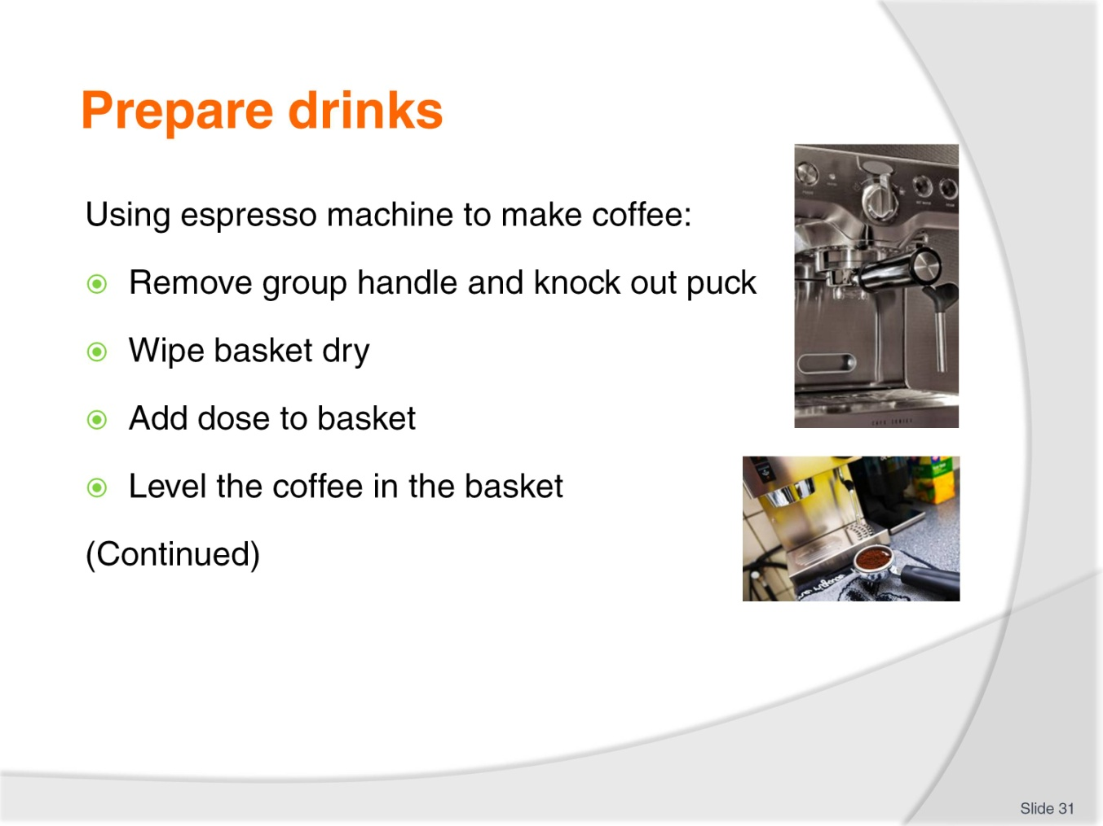
Slide No | Trainer Notes
Trainer discusses how to make an espresso coffee explaining process as:
Step 1
Remove the group handle from the group head and knock out spent grounds from the previous coffee into knock box/tube
Some coffee makers believe the spent coffee grounds should remain in the group filter basket locked in the group head until the next coffee is made in the belief the cake keeps the group at a consistent temperature and prevents metallic tastes from building up in the group head and handle
Other coffee makers feel 10 minutes is maximum time for spent coffee to remain locked in the group handle
Know what applies in workplace – whatever option is followed, it is well recognised a coffee machine in constant use produces the best coffee.
Step 2
Wipe out the basket with a cloth attached to the machine or to your apron and to be used for this purpose only
Ground coffee sits better in a dry basket and clings to the sides
If the basket is rinsed and not dried, water under pressure will flow towards the water on the sides of the basket and not through the coffee, as it should and your coffee will be compromised. Also, rinsing may create a hazard of water on the floor and around the coffee machine
Step 3
Place the group handle under the dispensing opening and dose one flick for a single shot and two for a double
Make sure you use the correct group handle for the number of coffees you are making.
Step 4
Level the coffee by gently tapping the sides of the basket
The coffee will flow towards the point where you are tapping.

Slide
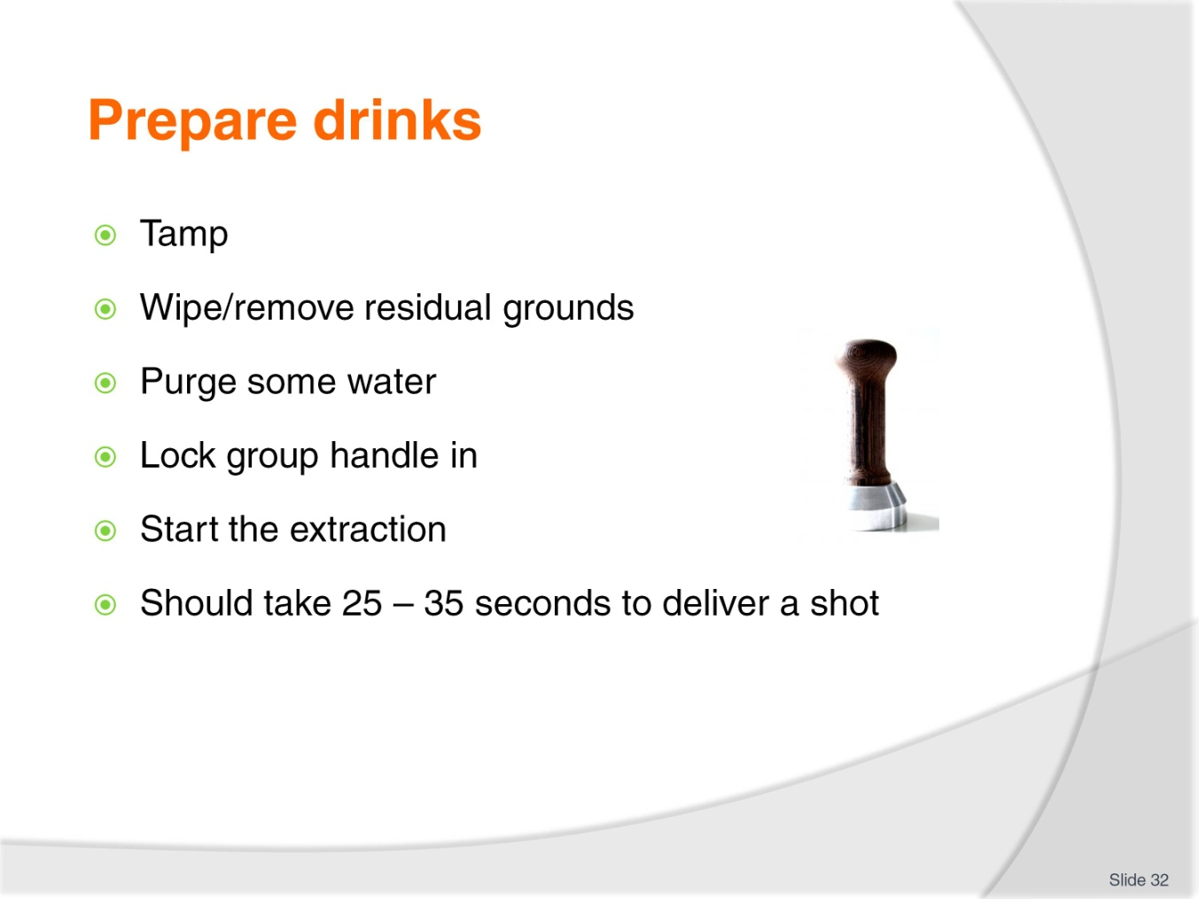
Slide No | Trainer Notes
Trainer discusses how to make an espresso coffee, explaining the process:
Step 5
Tamp the dosage.
Step 6
Wipe any coffee grounds off the top of the group handle.
Step 7
Before locking the group handle into the group run 30- 60 millilitres of water through the group head to flush out any coffee grounds and heat up the group head.
Step 8
Lock the group handle into the group head and press the button to start the extraction.
Step 9
The espresso should start to flow in around 5 seconds and it should take 25 – 30 seconds to extract a shot of 30 – 35 mls.
Class Activity – Demonstration
Trainer:
Demonstrates how to make an espresso using an espresso machine
Provides opportunity for students to practice making espresso using an espresso machine.

Slide
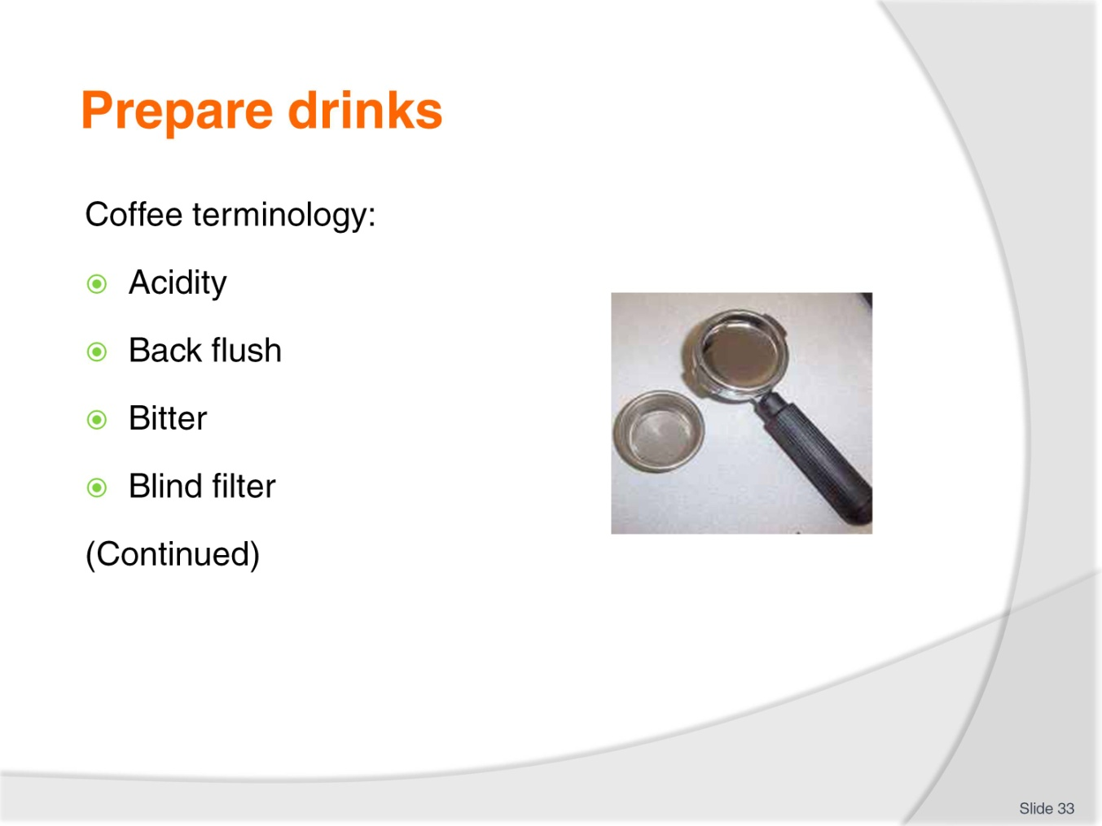
Slide No | Trainer Notes
Trainer defines a range of coffee terms:
Acidity
Acidity should not be confused with bitterness. 100% Arabica blends are characterised by a lively or fresh taste.
Acidity is picked up on the sides of the tongue when tasting coffee. Acidity decreases with darker roasting.
Back flush
Cleaning process using a blind filter and ‘flushing’ spent coffee grounds from the shower screen and around the rubber gasket in the group head.
Bitter
Bitter coffee is felt at the back of the tongue and is the result of badly brewed coffee.
Blind filter
A filter basket with no holes for cleaning the shower screen.
Class Activity 1 – Demonstration
Trainer demonstrates how to back flush espresso machine.
Class Activity 2 – Sample
Trainer shows students a blind filter.
Slide
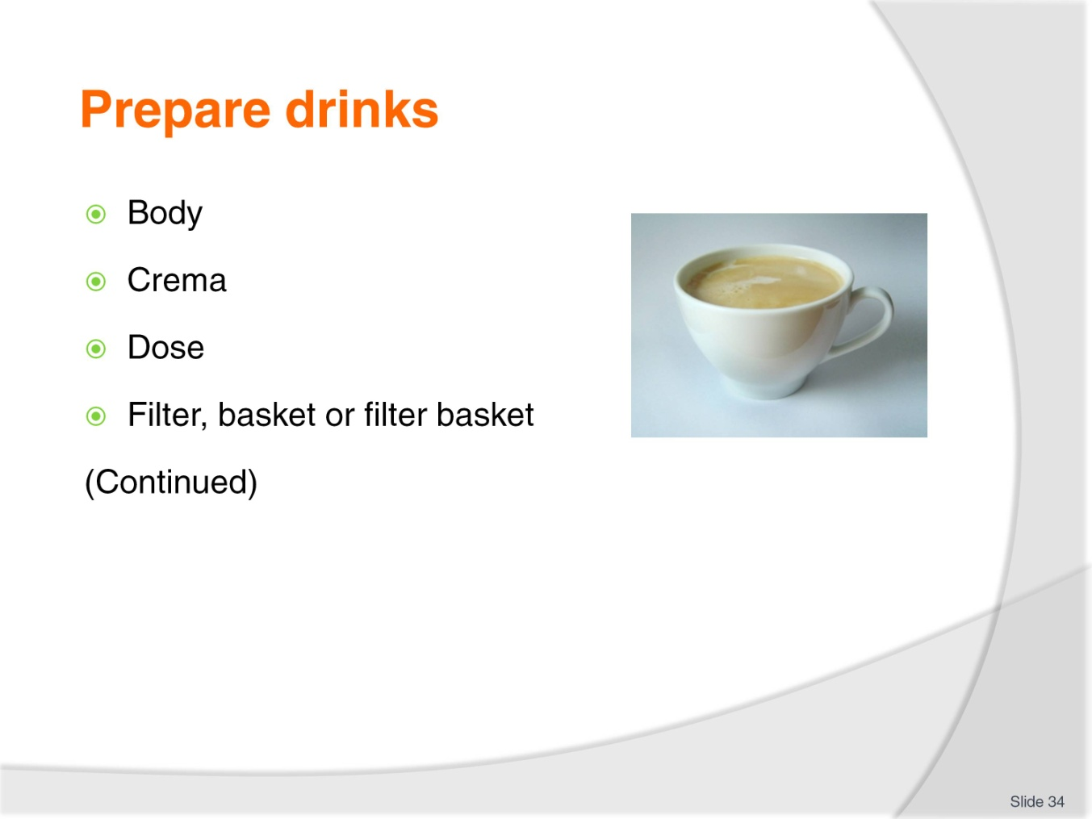
Slide No | Trainer Notes
Trainer continues defining a range of coffee terms:
Body
Is the feel of the coffee in the mouth. Darker roasts have more body than lighter roasts.
Robusta has more body than Arabica and the ‘espresso’ method gives more body.
Crema
A well-made espresso should have this golden layer to about ½ centimetre on its surface. It is tiny bubbles of coffee oils and CO₂ trapped as the water is forced through the finely ground tightly packed coffee.
Crema can be used to diagnose a range of problems with coffee, grinder settings and the settings on the espresso machine.
Dose
This is the amount of ground coffee dispensed into the filter basket.
Should be 7 – 9 grams for a single shot and 14 – 18 grams for a double shot.
Filter, basket or filter basket
This is a metal basket with tiny holes on the bottom which holds a specific dose of coffee. Filter baskets come in varying sizes.
7, 8 or 9 gm for the single filter holder or 14, 16 or 18 for the double.
Class Activity – Examples
Trainer shows students examples of crema and basket.
Slide
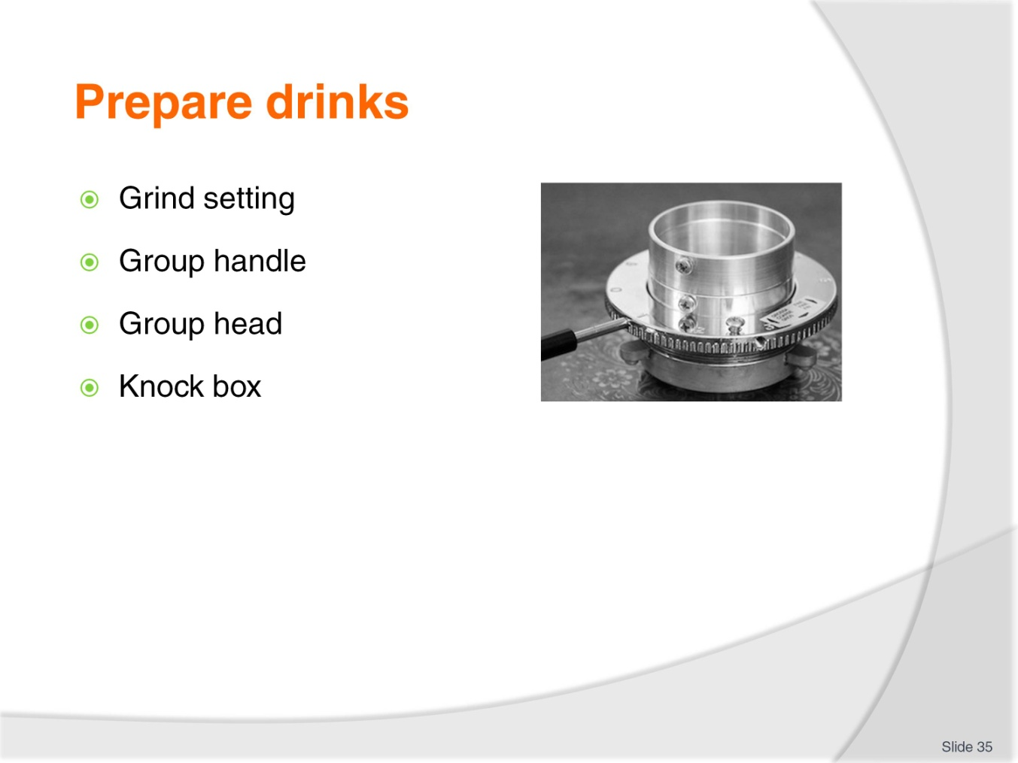
Slide No | Trainer Notes
Trainer continues defining a range of coffee terms:
Grind setting
Is the distance the grinding blades are apart to produce the required grind.
Grind setting can/should vary due to atmospheric conditions or blade wear.
Group handle
Also called filter holder or portafilter. Can be double-spouted or single spout.
It holds the filter basket and is inserted into the group head to make coffee.
Group head
This is the part where the group handle is inserted. It contains the shower screen and a rubber gasket/seal.
Knock box or tube
A tube or a box where the spent grounds are removed/knocked out into.
Class Activity 1 – Demonstration
Trainer demonstrates how to change grind setting.
Class Activity 2 – Sample
Trainer shows students a group handle, group head and knock box.

Slide
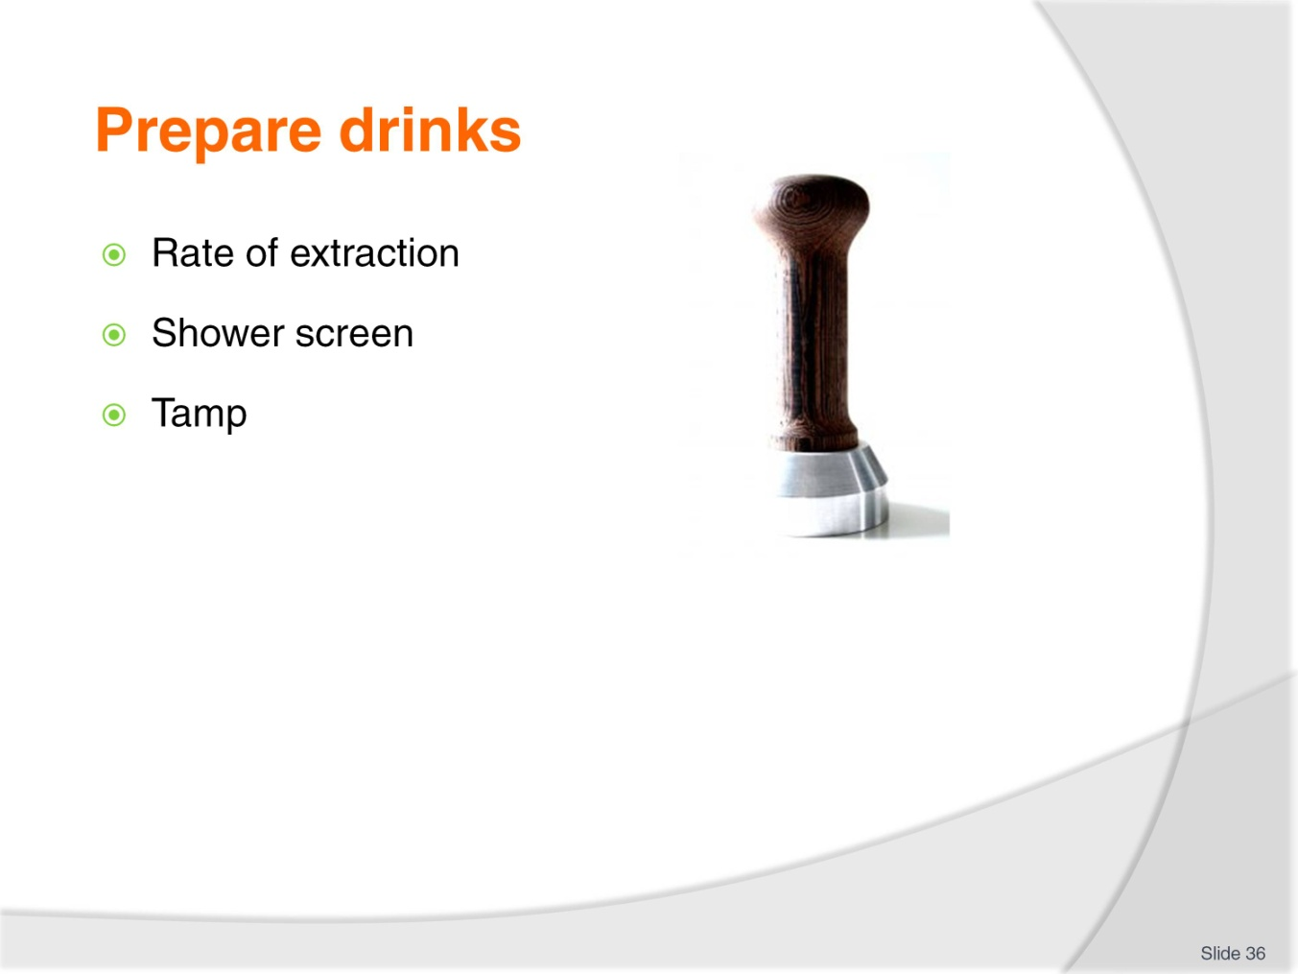
Slide No | Trainer Notes
Trainer continues defining a range of coffee terms:
Rate of extraction
This is the rate at which the coffee flows from the group handle. The rate should be 30 – 35 mls in 25 to 30 seconds.
Correct rate of extraction depends on grind, dose and tamp.
Shower screen
This is a flat metal disk attached to the group head. The top side has fewer larger holes and the underside has many mesh sized holes. This disperses the pressurised water over the coffee in the filter basket.
Tamp
A tool used to compact and polish the coffee grounds in the group handle.
Can be attached to the grinder or be a metal tool – 15 kgs of pressure is applied when tamping.
Class Activity 1 – Demonstration
Trainer demonstrates how to tamp.
Class Activity 2 – Sample
Trainer shows students a shower screen.

Slide
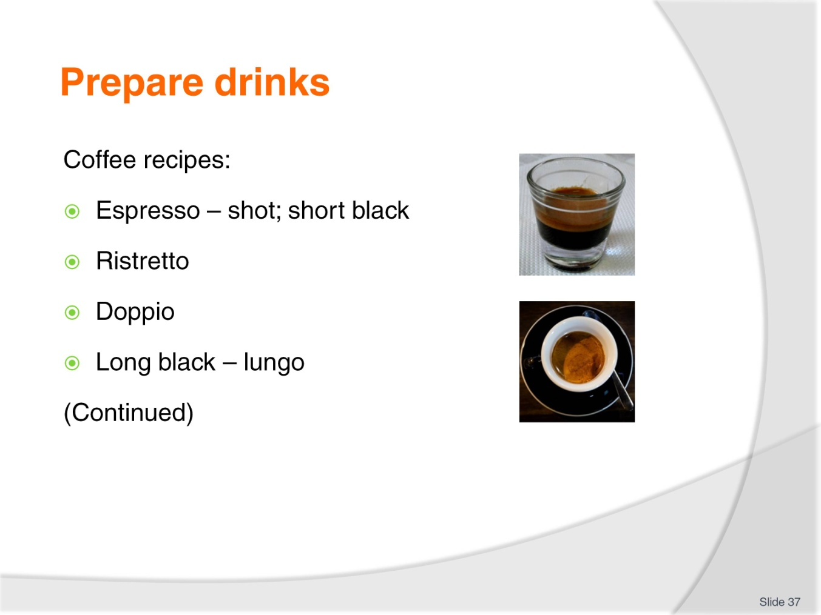
Slide No | Trainer Notes
Trainer identifies different coffee recipes:
Espresso, shot or short black
A short (30 – 35 ml) intense coffee with a thick layer of caramel coloured crema on top results. Usually served in a small-preheated glass or espresso cup.
An espresso is the base of all drinks on the espresso menu.
Ristretto
In Italy this is the most popular drink on the espresso menu. It is usually called ‘un caffe’.
Only the first 15 mls is extracted from the coffee resulting in a very short, intense drink. The Italians refer to ristretto as ‘the poison of the coffee’.
Doppio
A double shot served in the one glass or cup. This may be a doppio espresso (60 mls), or a doppio ristretto (30 mls).
A doppio espresso is used for longer drinks and a doppio ristretto is used as the base of any strong drinks.
Long black Americano or lungo
An espresso or a doppio espresso diluted with hot water from the boiler.

Class Activity – Demonstration
Trainer:
Demonstrates how to make coffees listed on slide
Provides opportunity for students to practice making coffees shown on slide.

Slide
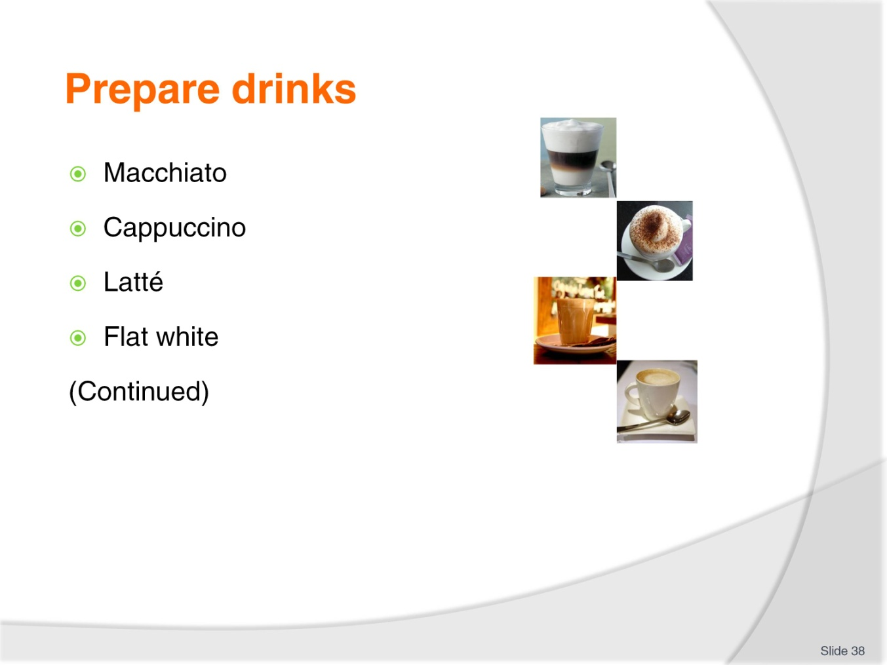
Slide No | Trainer Notes
Trainer continues identifying different coffee recipes:
Macchiato
An espresso stained with a drop of cold or hot milk and served with a dollop of foam. Macchiato may be served short (an espresso) or long (a doppio and hot water in a glass).
The long Macchiato is a Melbourne invention. Order macchiato in Italy and you will be served hot milk with a stain of coffee.
Cappuccino
Equal volume of espresso, hot milk and foam/milk crema.
Cappuccino is the ‘strongest’ milk drink as it is less diluted with milk.
Latté
It is an espresso with hot milk and 1 centimetre of dense foam/milk crema on top.
Flat white
Simply espresso and hot milk.
Class Activity – Demonstration
Trainer:
Demonstrates how to make coffees listed on slide
Provides opportunity for students to practice making coffees shown on slide.
Slide
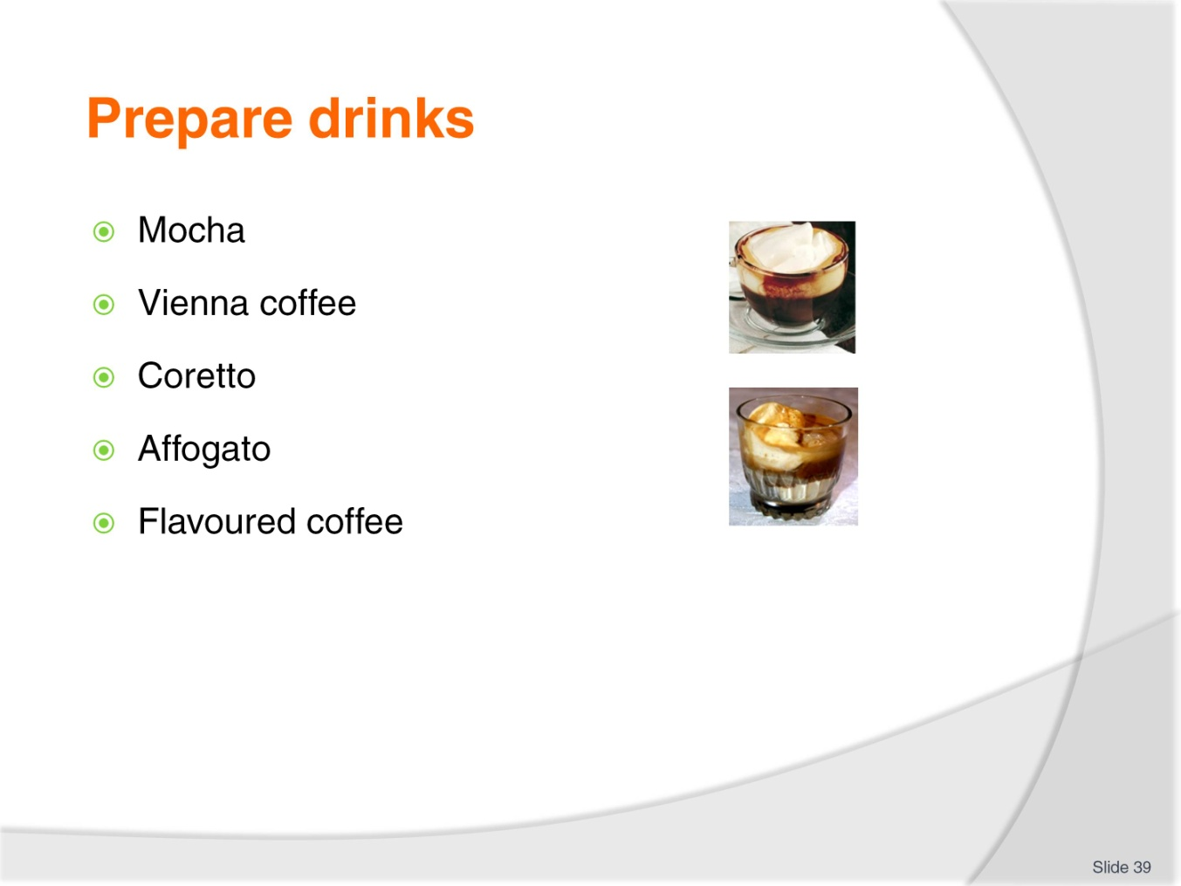
Slide No | Trainer Notes
Trainer continues identifying different coffee recipes:
Mocha
Foamed chocolate milk is added to the espresso. Can be a mocha latté or a mochaccino.
Vienna coffee
A long black topped with thickened cream.
Coretto
An espresso with a measure of flavoured liqueur or grappa.
Affogatto
Vanilla ice cream or gelato served with an espresso and can be served with a measure of flavoured liqueur.
Flavoured coffee
Flavoured sugar syrups have become a feature of many coffee outlets. Syrup is added to the espresso or foamed with the milk.
Class Activity – Demonstration
Trainer:
Demonstrates how to make coffees listed on slide
Provides opportunity for students to practice making coffees shown on slide.

Slide
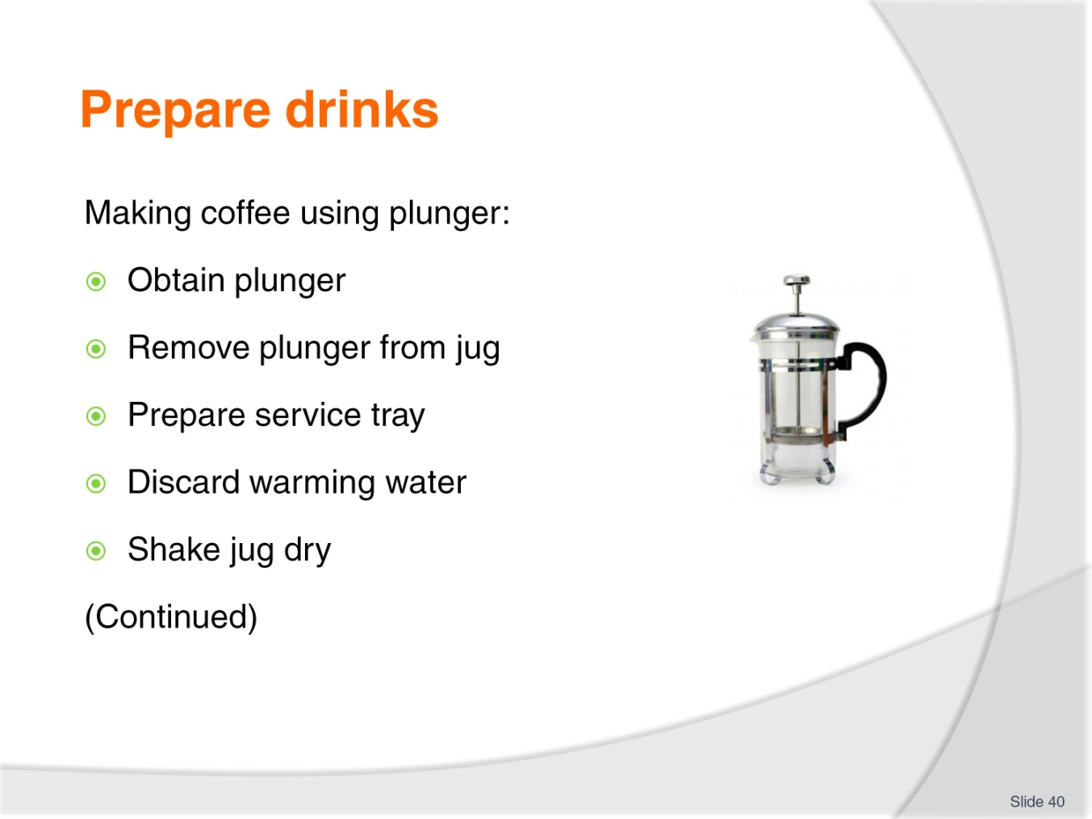
Slide No | Trainer Notes
Trainer discusses making of coffee using a plunger explaining procedure as follows:
Obtain correct size plunger – they are available in single, double and larger sizes
Remove plunger and half-fill jug without water to warm the glass
Prepare the service tray with sugar, milk or cream, cups, saucers, tea spoons, napkin, after dinner mint and/or other as required
Discard hot water from glass jug and discard water
Shake jug to remove excess water. Do not dry with cloth.

Slide
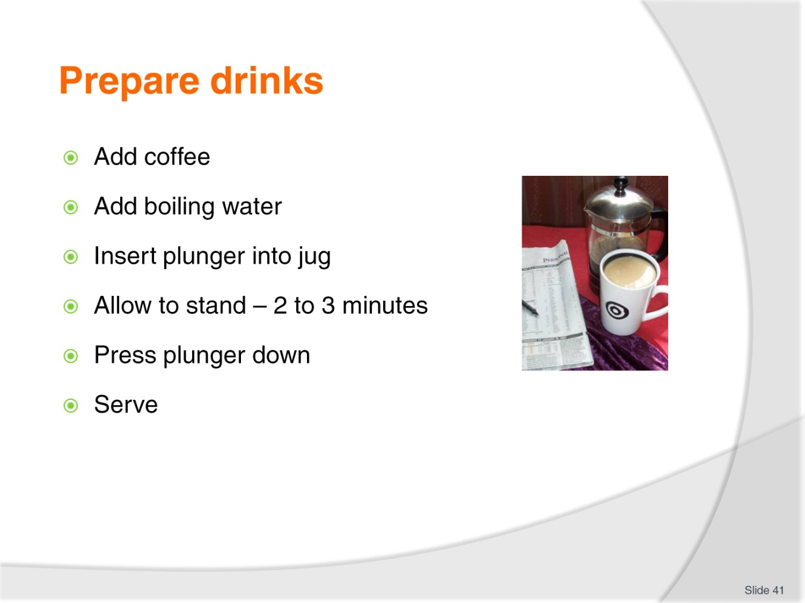
Slide No | Trainer Notes
Trainer finishes discussing making of coffee using a plunger explaining procedure as follows:
Add required ground coffee according to house recipe and number of cups the plunger will hold
Add boiling water over the coffee until the glass jug is nearly full
Place/insert plunger into the jug, on top of the water and leave in this position until all the coffee granules have risen to the top (this could take two – three minutes)
Press plunger down carefully and slowly to avoid spilling the coffee to filter the coffee and press all the granules against the base of the jug
Plunger coffee is now ready to serve.
Class Activity – Demonstration
Trainer:
Demonstrates how to make coffee using plunger
Provides opportunity for students to practice making coffee using plunger.

Slide
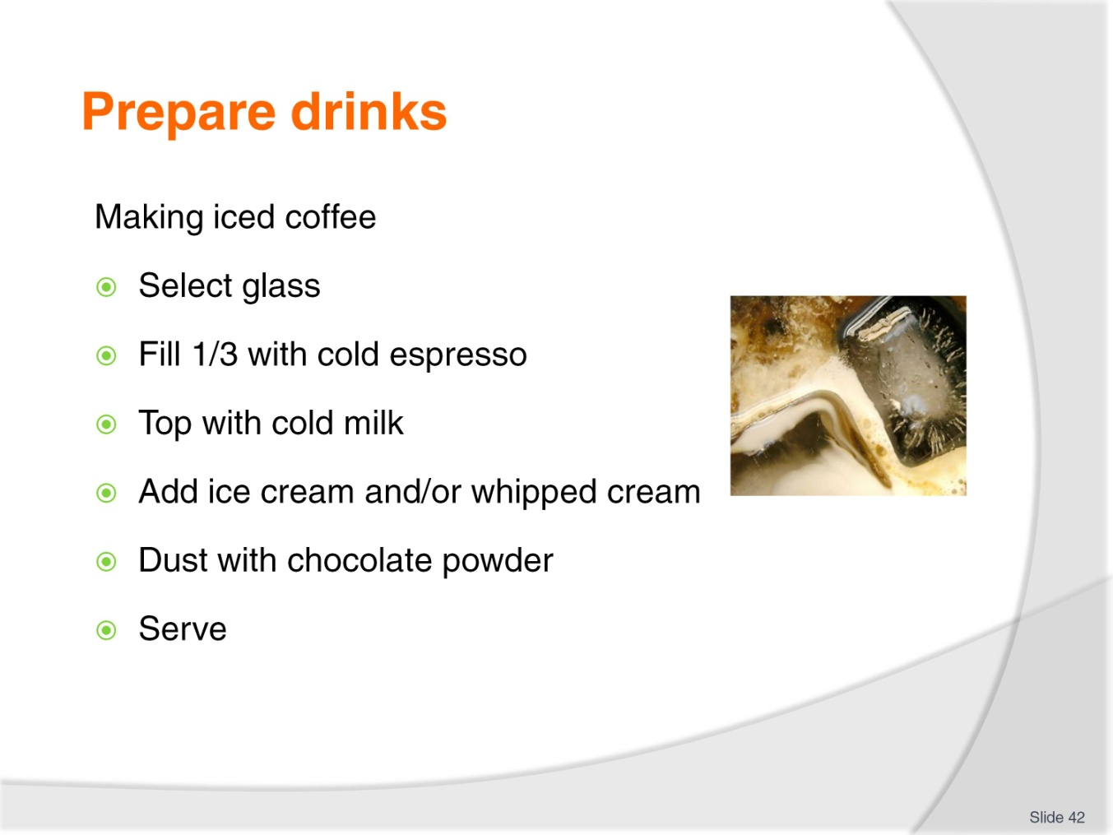
Slide No | Trainer Notes
Trainer discusses how to make iced coffee explaining where a standard recipe does not exist, a possible method is:
Select the appropriate glassware – as determined by house recipe
Fill ¹/₃ with cold espresso coffee
Fill ²/₃ with cold milk
Add ice cream and/or whipped cream
Sprinkle with chocolate powder
Serve immediately before cream/ice cream melts and starts running down side of glass.
Class Activity 1 – Demonstration
Trainer:
Demonstrates how to make iced coffee
Provides opportunity for students to practice making iced coffee.
Class Activity 2 – Online video
Trainer arranges for students to view and discuss videos at:
http://www.youtube.com/watch?v=rFOAW3aplPo
http://www.youtube.com/watch?v=gc-sloCajV0
http://www.youtube.com/watch?v=dDvpCyeKXS8.
Slide
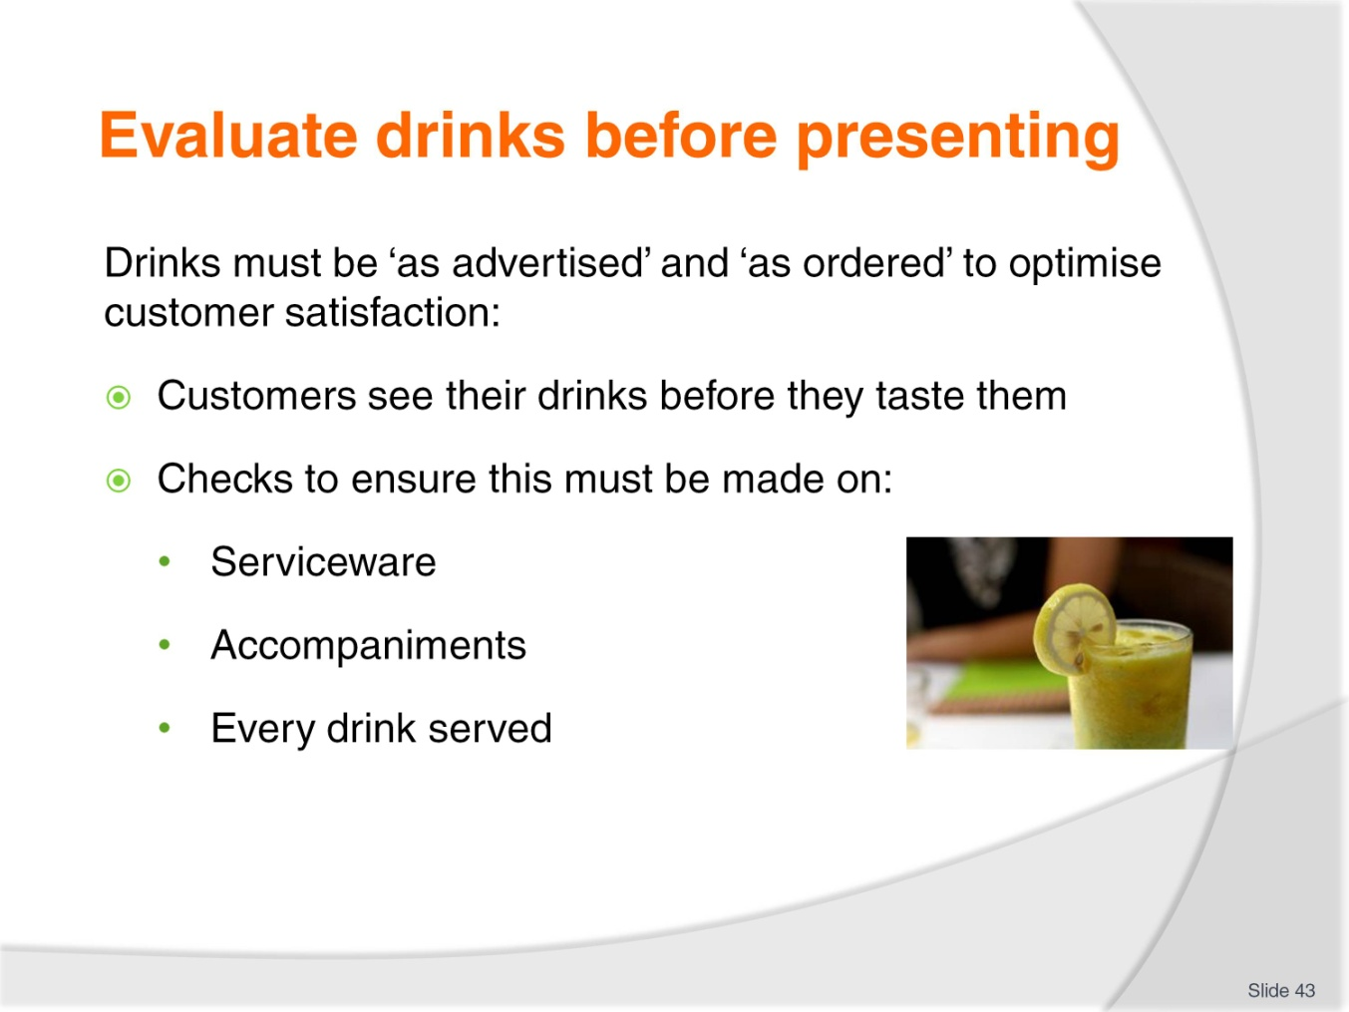
Slide No | Trainer Notes
Trainer highlights it must be standard practice to check all teas and coffees before they are served to customers to optimise the service of the ‘perfect’ cup of tea or coffee. Explain that it is important to understand ‘eye appeal’ is ‘buy appeal’ and stress that customers will see their drink before they taste it and they will start forming opinions about what it will taste like based on the way it is presented.
Trainer identifies three areas for checks as:
Checks on serviceware – see next slide
Checks on accompaniments – see following slides
Checks on every drink made – see following slides.

Slide
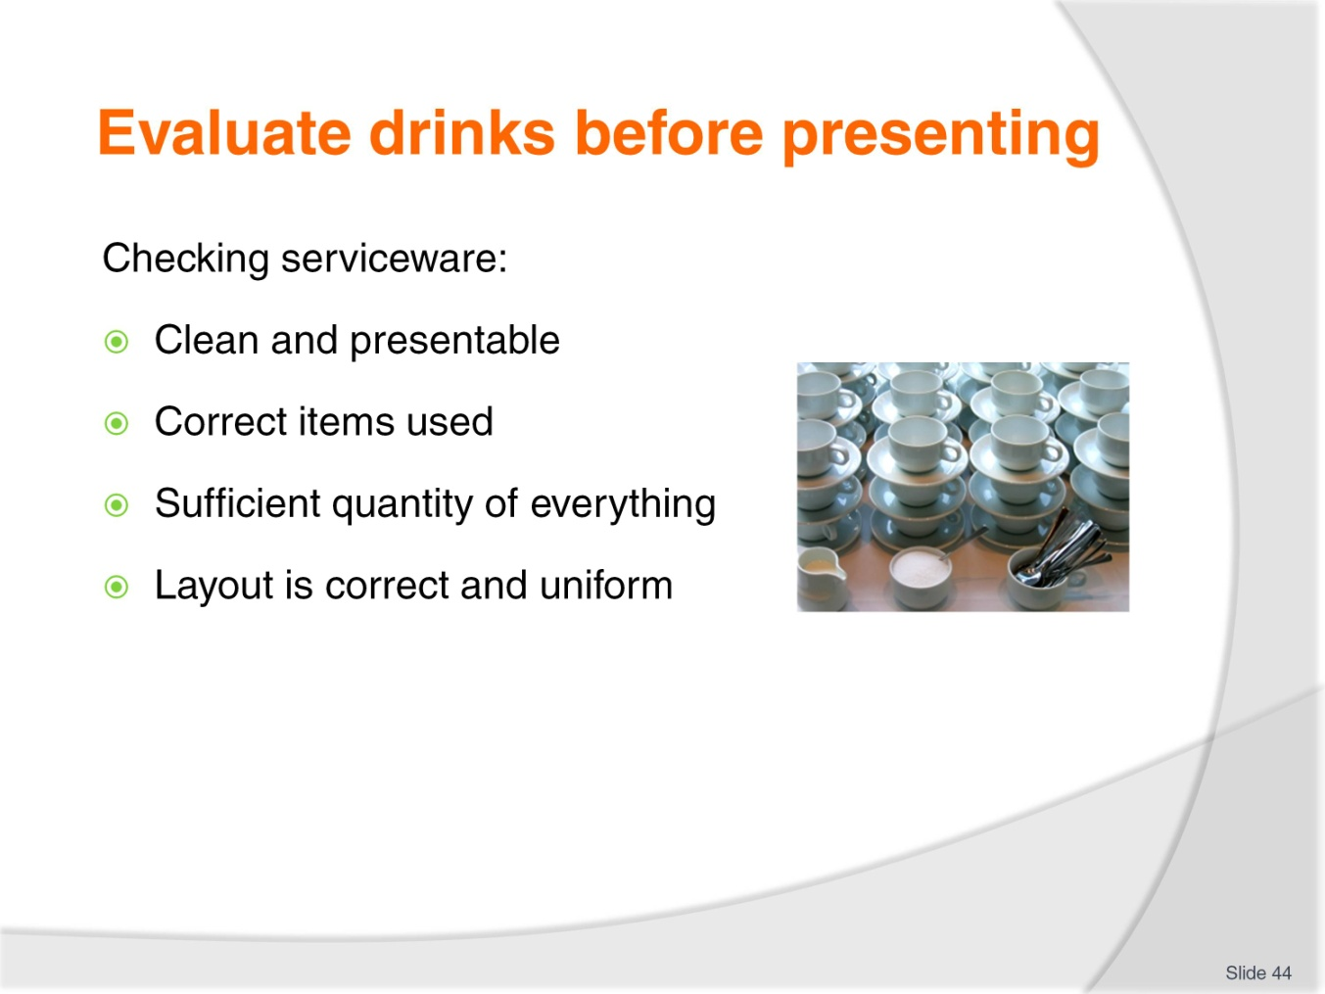
Slide No | Trainer Notes
Trainer highlights need for checking of serviceware:
All serviceware is clean and not cracked or chipped
The correct items have been provided to match the drink
Sufficient quantity of items have been supplied to cater for the number of beverages to be served
Layout of items on service trays is uniform and conforms to house standards.

Slide
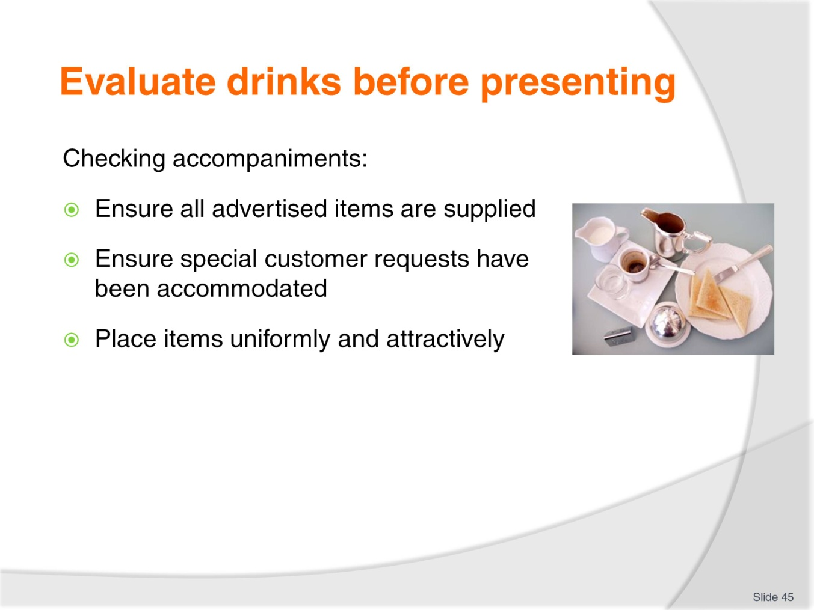
Slide No | Trainer Notes
Trainer details requirements for checking accompaniments when serving tea and coffee:
All advertised items have been provided as indicated:
- On the menus/drink lists
- By house recipes
Special requests made by customers have been provided
Accompaniments have been positioned uniformly and conform to house standards.

Slide
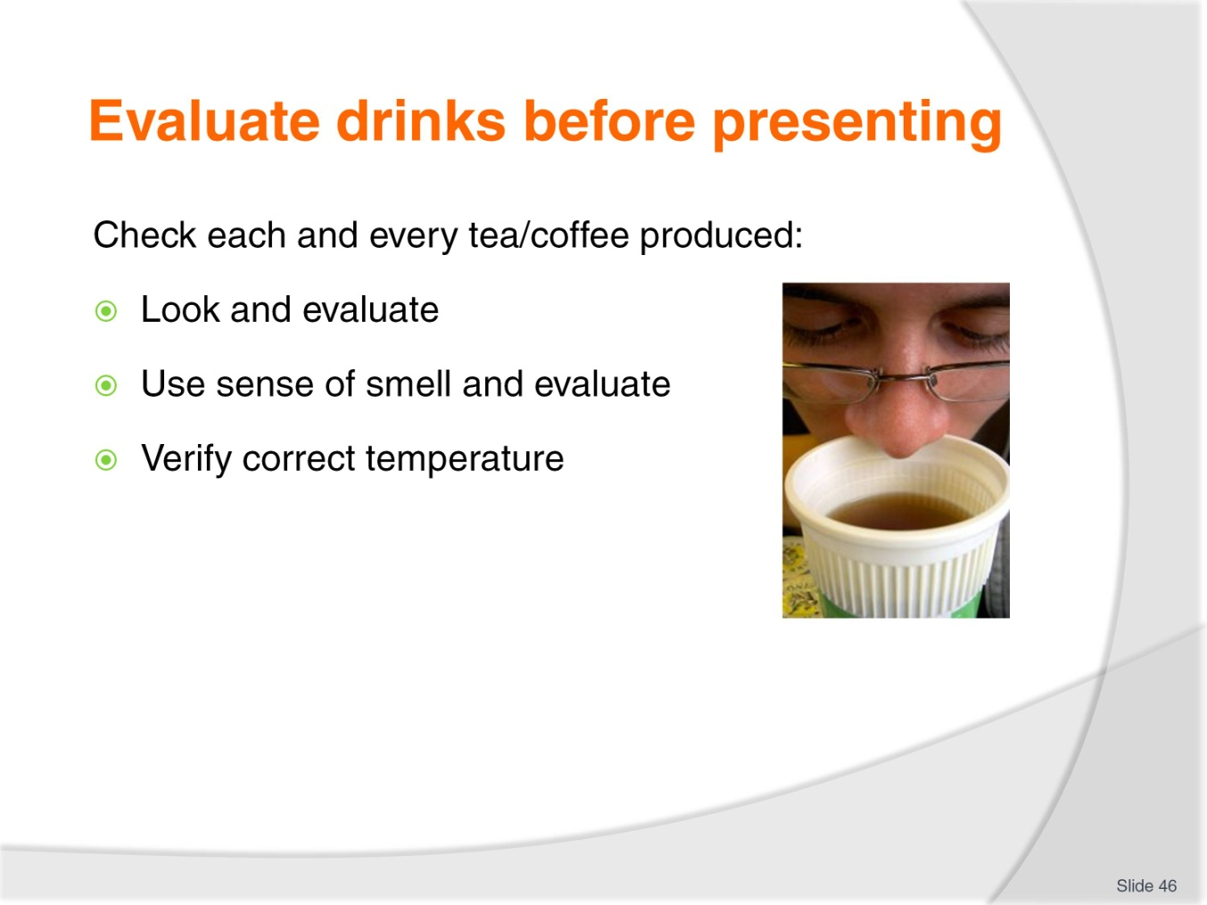
Slide No | Trainer Notes
Trainer explains checks to be made on every tea and coffee made:
Looking at the finished product to make sure it looks acceptable. Things to check are:
- All products of the same type, look the same – filled to same level; dusted as appropriate, in the same style glass/cup/mug; with the required topping (cream, sprinkles, marshmallows)
- The correct number of drinks have been served to match the order placed
- Milk and cream used has nor exceeded its ‘Use By’ date
- Sufficient cups and saucers are provided for the number of people who are partaking in a pot of tea or coffee
- The in-glass/in-cup product looks as it should look – that is nothing floating in solution which should not be there and no ingredients used which should not have been used
- Specific customer requests have been accommodated in relation to strength, size of cup/glass, additions or reductions
- There are no spills into the saucer or drips running down the side of a cup or mug or glass. If service of drink results in the drinking being spilled into a saucer or napkin placed under a drink then you should replace the saucer and/or napkin: in some cases it may be necessary to re-make the drink
Using sense of smell to detect if there are any ‘off’ smells from things such as, for example, sour milk or cream which is out-of-date, or brewed coffee which has become stewed and/or burnt
Using sense of touch to ensure:
- Hot drinks are served hot
- Cold drinks are served cold
- A key in ensuring this occurs is to ensure items are served immediately they have been made.
Class Activity – Demonstration
Trainer demonstrates how to evaluate/check a range of tea and coffee beverages prior to service to ensure its quality and acceptability.

Slide
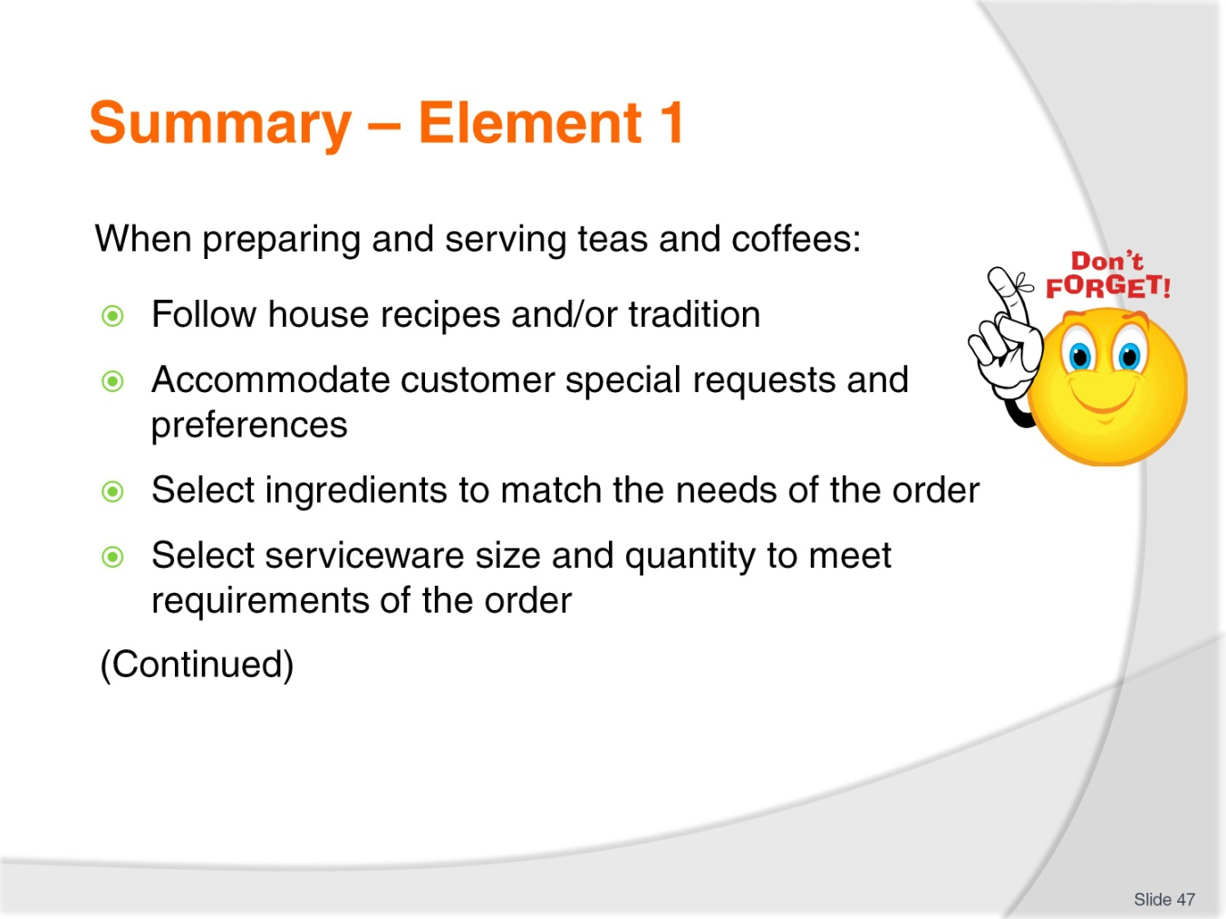
Slide No | Trainer Notes
 | Trainer provides a recap of the Element asking questions to check trainee understanding and responding to questions from trainees, as required.

Slide
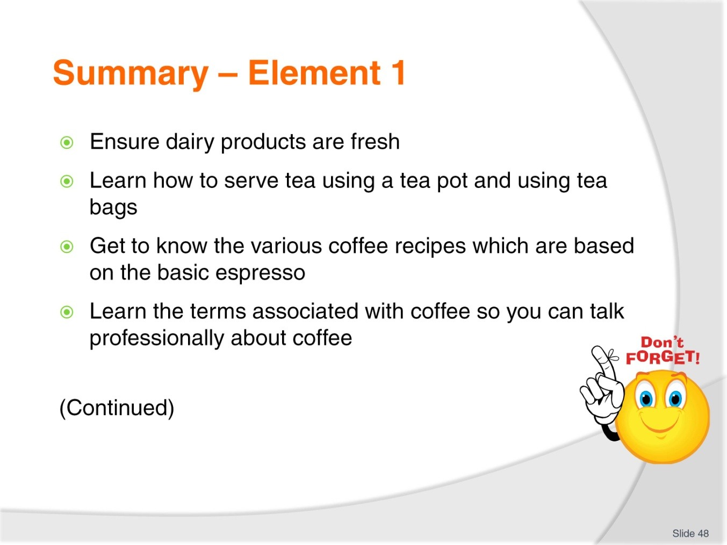
Slide No | Trainer Notes
 | Trainer provides a recap of the Element asking questions to check trainee understanding and responding to questions from trainees, as required.

Slide
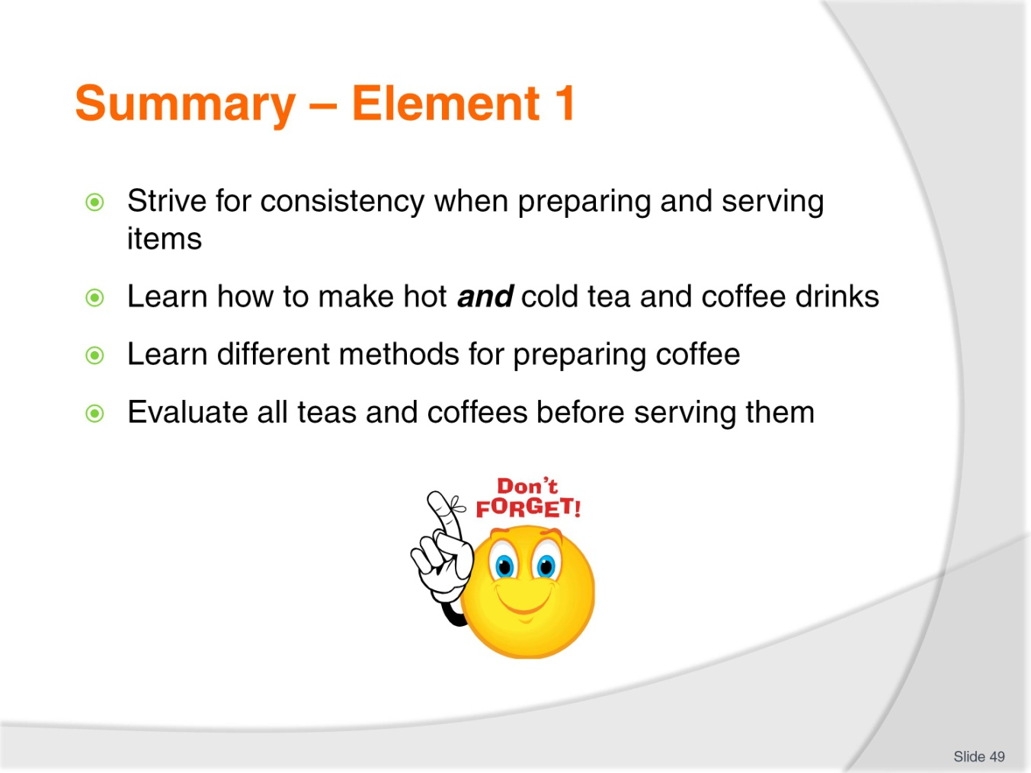
Slide No | Trainer Notes
 | Trainer provides a recap of the Element asking questions to check trainee understanding and responding to questions from trainees, as required.

Slide
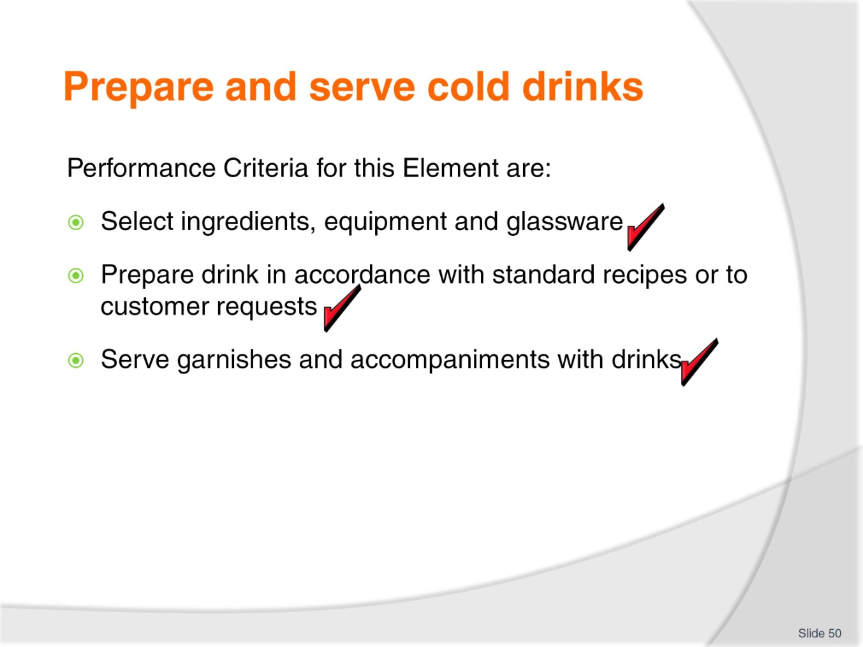
Slide No | Trainer Notes
Trainer identifies for trainees the Performance Criteria for this Element, as listed on the slide.
Class Activity – Discussion
Trainer asks trainees questions about preparing and serving cold drinks by asking questions such as:
What do you think are the important points to consider/address when making a cold non-alcoholic drink for customers?
What are examples of cold non-alcoholic drinks which might be made?
What ingredients and tools/equipment do you think would be used to prepare non-alcoholic cold drinks?
What is the role of non-alcoholic cold drinks in hospitality?

Slide
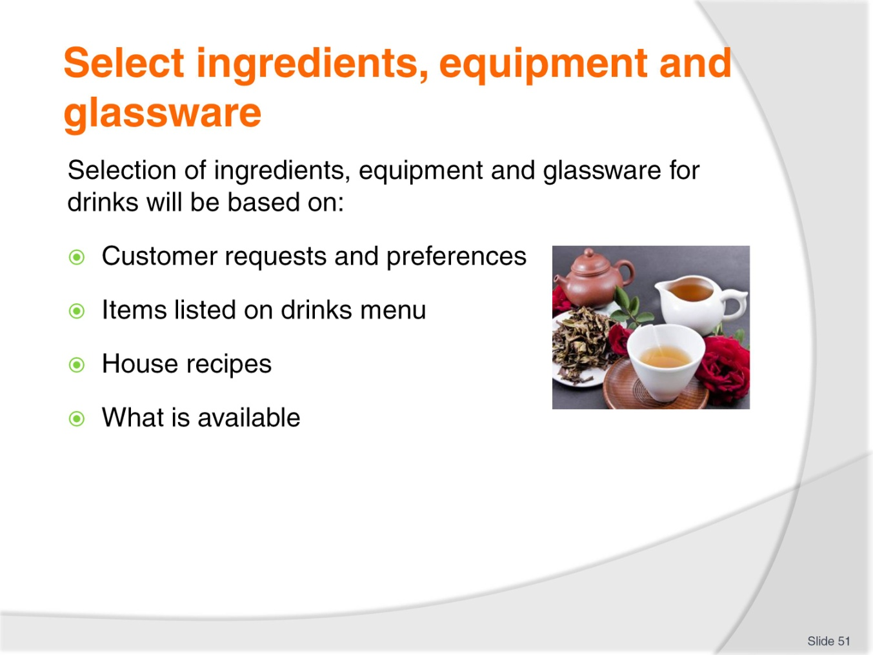
Slide No | Trainer Notes
Trainer explains selection of ingredients, equipment and glassware for the preparation and service of cold drinks will be dictated and influenced by:
Customer requests and preferences which should always be accommodated if possible
Items offered on the menu/drinks list. Most cold drinks prepared for customers are taken from this list and the necessary ingredients and other items for preparing these beverages are usually available at the workstation
House recipes
What is available in the venue – all venues have limitations in terms of what they have available.

Slide
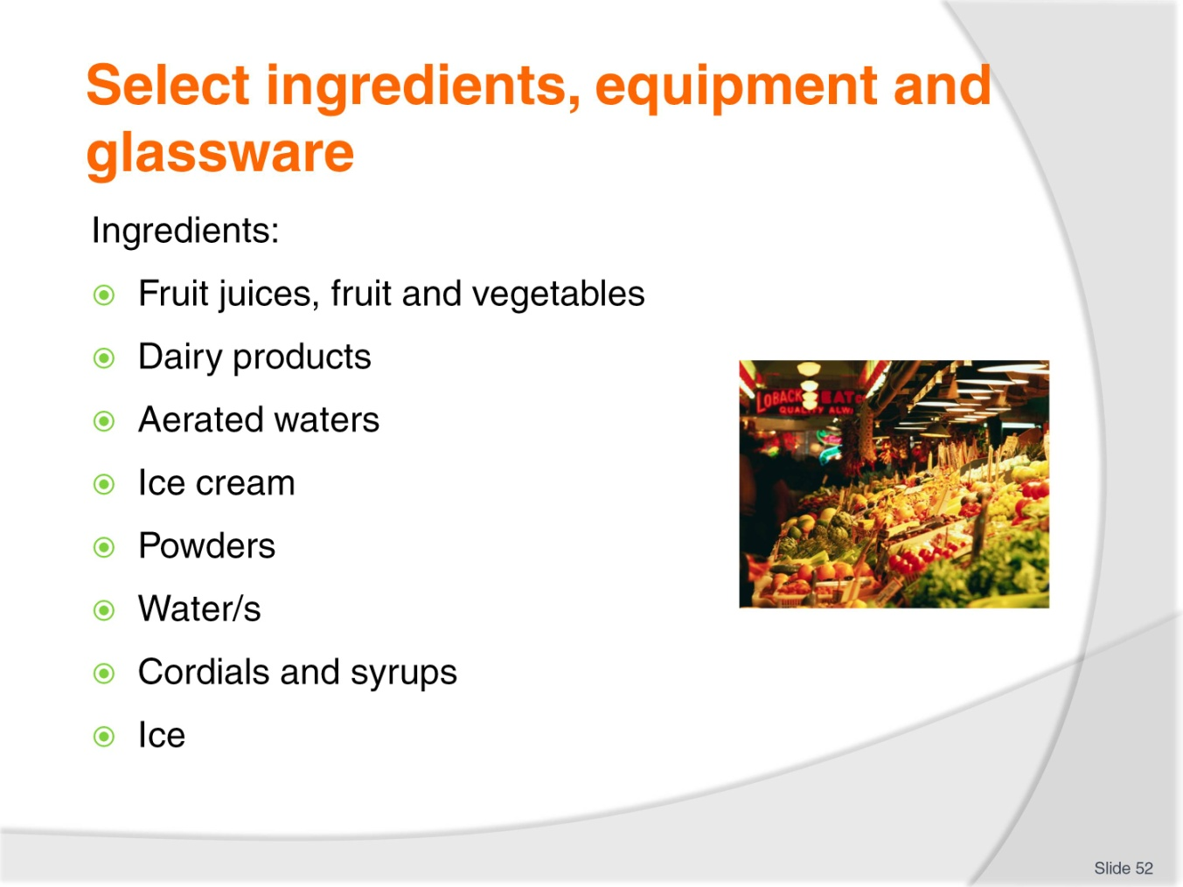
Slide No | Trainer Notes
Trainer identifies possible ingredients as:
Fruit juices – all types: fresh squeezed and commercially prepared (‘bought in’ already prepared). Verify they are fresh and within ‘Use By’ date
Fruit and vegetables for producing fruit juices, vegetable juices and garnishes. Check products are fresh and suitable for use
Dairy products such as milk, cream and yoghurt. Check items are within their ‘Use By’ date
Aerated waters – ‘soft drink’ also known as ‘carbonated beverages’
Ice cream for use in milkshakes, thick shakes and iced coffee. This may be traditional ice cream or specialist soft-serve product
Powders – chocolate, malt
Water/s – still, sparkling and flavoured
Cordials – to add to other beverages for colour and flavour
Ice – block and crushed.
Class Activity – Samples of Ingredients
Trainer shows students a range of ingredients as identified on the slide.

Slide
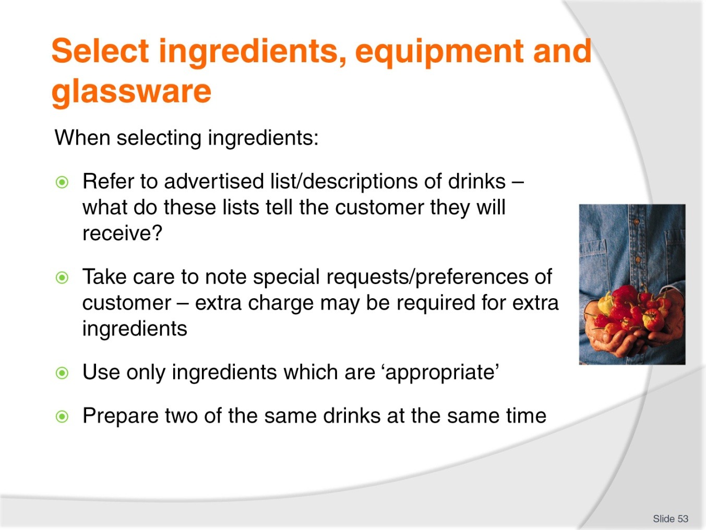
Slide No | Trainer Notes
Trainer identifies points to note when selecting and assembling ingredients for non-alcoholic drinks:
Refer to the advertised drinks list
The list of non-alcoholic drinks the venue offers must be seen as the starting point for selecting and assembling ingredients (and equipment)
Experience will quickly teach you which items are the most popular and more effort needs to be spent ensuring materials are ready for those popular items/lines
In some properties a checklist is used to guide staff through their preparation activities to make sure all necessary requirements are in place and in sufficient quantities.
Note any stated – or known – customer preferences
Some customers prefer their drink customised to an extent and you should be happy to do this
Use common sense about meeting the variations requested and ask management where you think an additional charge should be made for extra ingredients
The addition of extra flavouring/syrup, extra fruit, more ice cream or the use of a larger glass/take away drink container will normally incur extra charges.

Use appropriate ingredients
In many circumstances the preparation of non-alcoholic drinks can enable you to use raw materials unfit for use anywhere else. This is not to say there is anything wrong with these products other than they simply look unacceptable
Fruit is a common example. It can look unappetising if presented as an item of fruit on a platter but it is perfectly suitable for blending, or juicing. Note fruits and vegetables used on displays must look appealing, attractive and appetising.
Prepare enough ingredients for all the orders
For example, if you have an order for two smoothies of the same type then make both at the same time in the one blender
Do not make one in one blender and one in another
By making both drinks at the same time, you achieve consistency of the finished product in terms of eye appeal, taste, texture, colour and temperature.

Slide
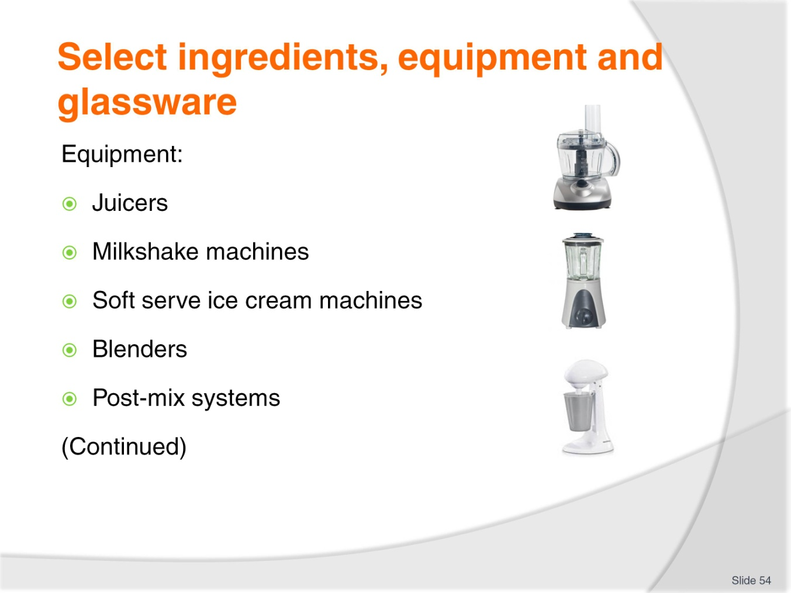
Slide No | Trainer Notes
Trainer identifies equipment which is used to make cold non-alcoholic drinks:
Juicers – commercial and domestic versions are used. Commercial ones have a larger capacity and more powerful motor
Milkshake machines for mixing milkshakes and thick shakes
Soft serve ice cream dispensers – for example for thick shakes
Blenders – used for making smoothies, frappes and other drinks
Post-mix systems – a bulk soft drink dispensing system.
Class Activity – Samples of Equipment
Trainer shows students a range of equipment items as identified on the slide.

Slide
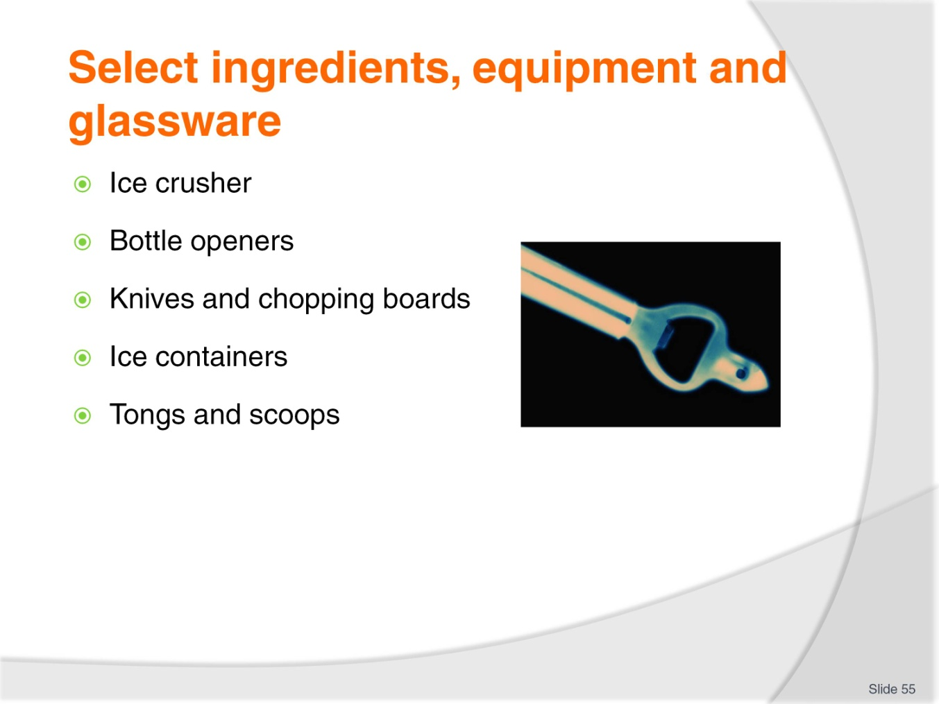
Slide No | Trainer Notes
Trainer continues to identify equipment which is used to make cold non-alcoholic drinks:
Ice crusher – for example, for making crushed ice for frappés
Bottle openers
Knives and chopping boards for cutting fruit
Ice containers
Tongs and scoops for handling ice and fruit pieces.
Class Activity – Samples of Equipment
Trainer shows students a range of equipment items as identified on the slide.

Slide
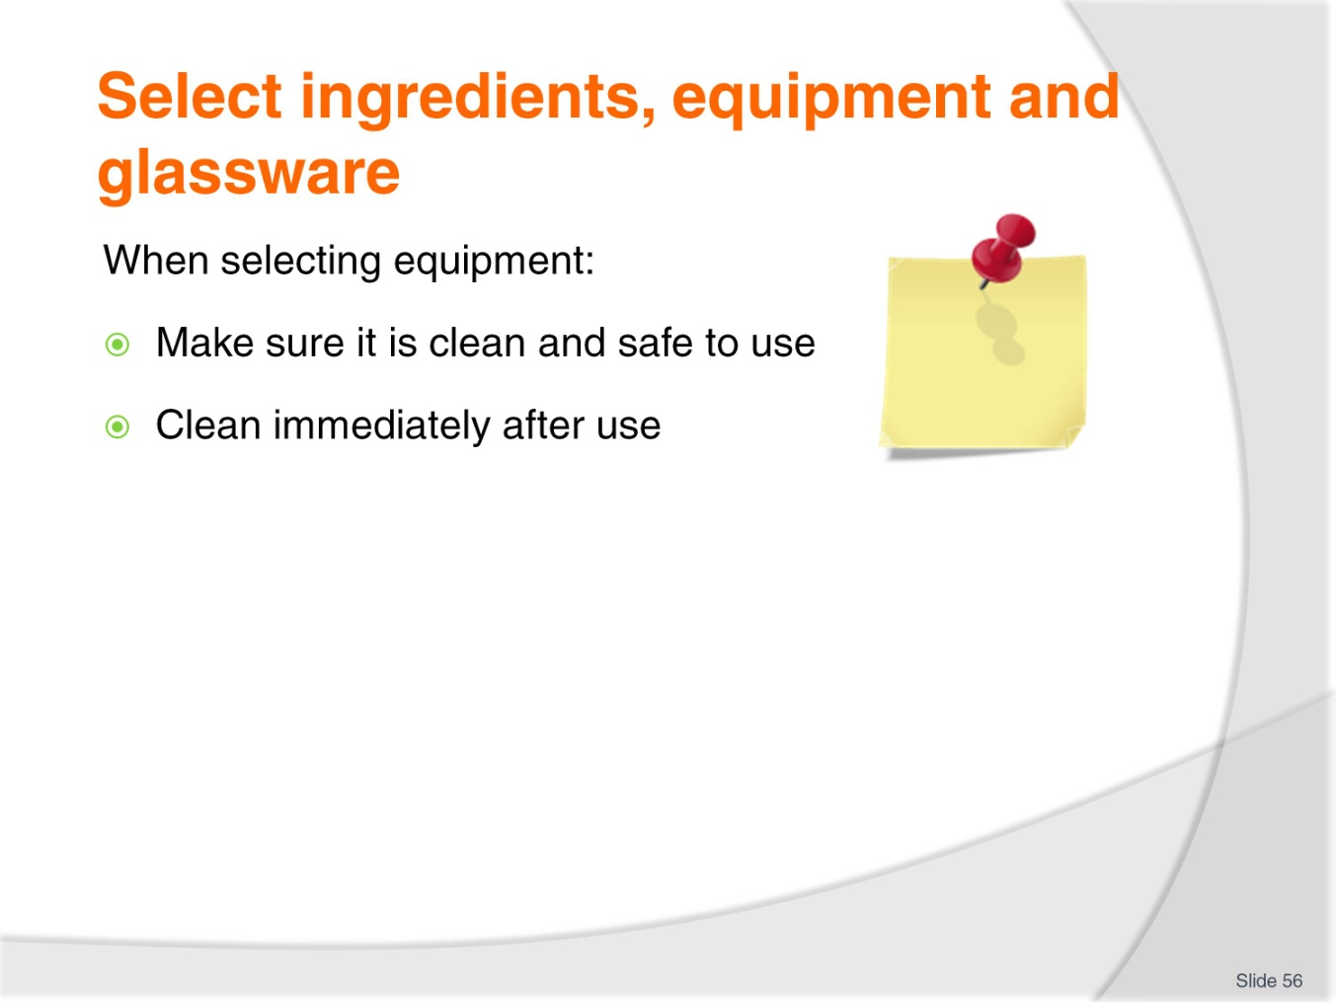
Slide No | Trainer Notes
Trainer identifies points to note about equipment selected to make drinks:
Ensure all equipment and machinery used is clean
This means, especially where it is on public display, all equipment used in the drink production process looks clean, and it is clean inside
This is particularly an issue where there is limited equipment and each item can be expected to experience high usage.
Ensure all equipment used is well cleaned immediately after use
This may be easier said than done, but it is important. For example, if you leave the blender uncleaned, then someone else may pour ingredients into it before realising it hasn’t been cleaned
This means those ingredients will have to be thrown out. If they are used, then the customer will receive a tainted drink, and may complain, or not return
Follow the requirements of your Food Safety Plan when cleaning these items. Generally speaking equipment will need to be cleaned and sanitised after every use/in between uses, and the sooner they are cleaned after use the easier they will be to clean.

Slide
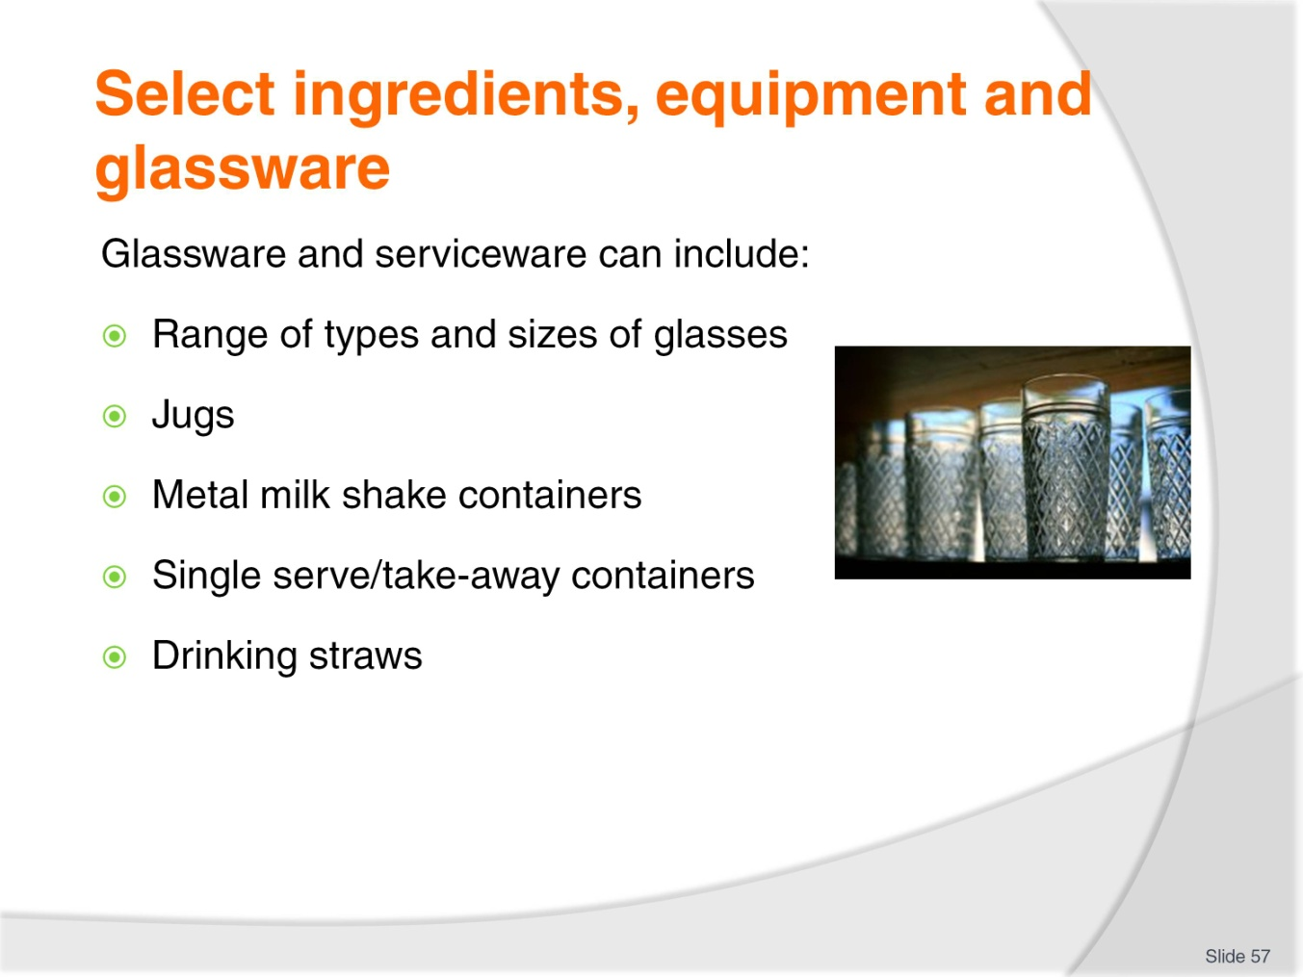
Slide No | Trainer Notes
Trainer identifies glassware and serviceware used for non-alcoholic drinks:
Glasses such as:
- Old fashioned glasses
- Highball glasses
- Pilsener glasses
- Mugs
- Milkshake glass
- Soda glass
- Cocktail glasses – for non-alcoholic cocktails
Jugs – range of sizes: for fruit juices, sugar syrup
Metal milkshake containers
Take-away drink containers with lids known as single serve items
Drinking straws.
Class Activity – Samples of Items
Trainer shows students a range of items as identified on the slide.

Slide
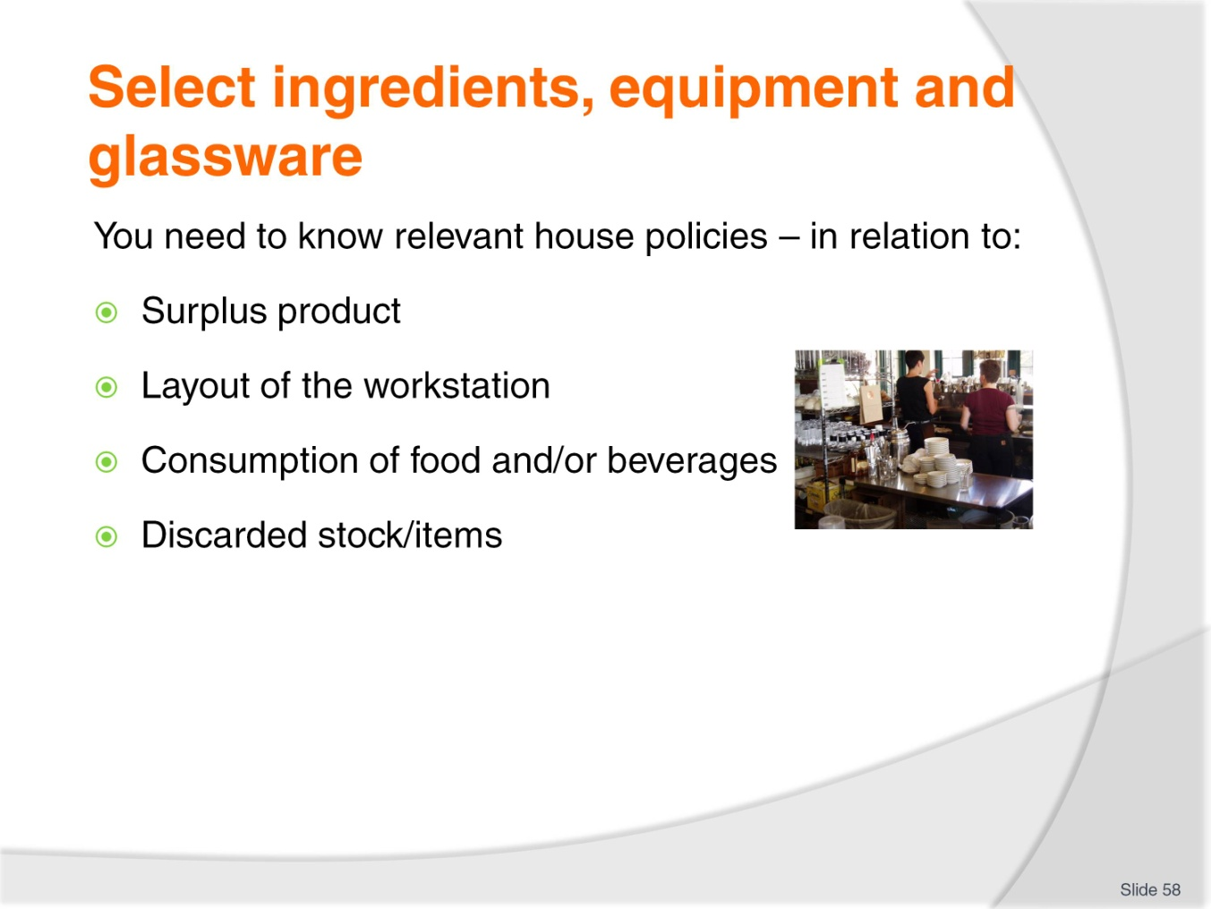
Slide No | Trainer Notes
Trainer emphasises need to know house polices regarding making and serving of drinks:
Surplus product
When making a drink during a service session you need to know the house policy on wastage and overages e.g. what is the house policy if you make too much of a product? Do you give it to the customer as a bonus? Or is the policy to throw it out? Are you allowed to drink it?
Layout of ingredients and equipment
Most properties will have a standard, pre-set layout for all their equipment and ingredients which you will be expected to comply with
This facilitates stocktaking and re-ordering and provides a consistent location for items to optimise working efficiency.
Refraining from eating/drinking the products
Some venues will allow you to eat/drink almost anything while others will stipulate a restricted range of nominated items you can eat/drink free of charge, and some will prohibit staff from eating or drinking anything when on duty
Most employers will require you to eat and drink out of public view.

Discarded stock
Some properties have requirements relating to discarded stock (that is, stock which has to be thrown out)
Where stock has to be thrown out because it has ‘gone off’ or exceeded its use-by date there may be a need for you to complete a form identifying:
- What was discarded
- How much was discarded
- How it was discarded
- Why there was a need to discard it.

Slide
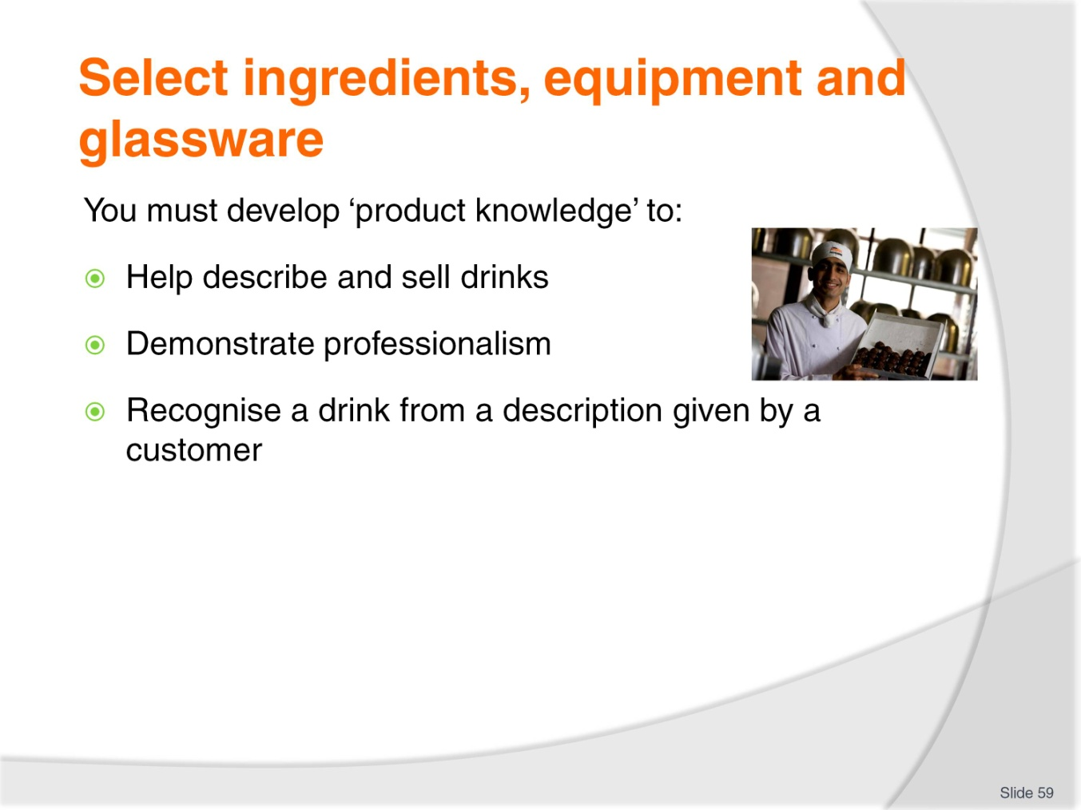
Slide No | Trainer Notes
Trainer states product knowledge is a vital aspect of professionalism in any industry sector/role and it is no different when dealing with non-alcoholic beverages explaining students must cultivate this knowledge of non-alcoholic drinks so they can:
Describe and suggestively sell non-alcoholic drinks to customers
Recognise a non-alcoholic beverage from a description given to you by a customer who is not sure about what they want to order.

Slide
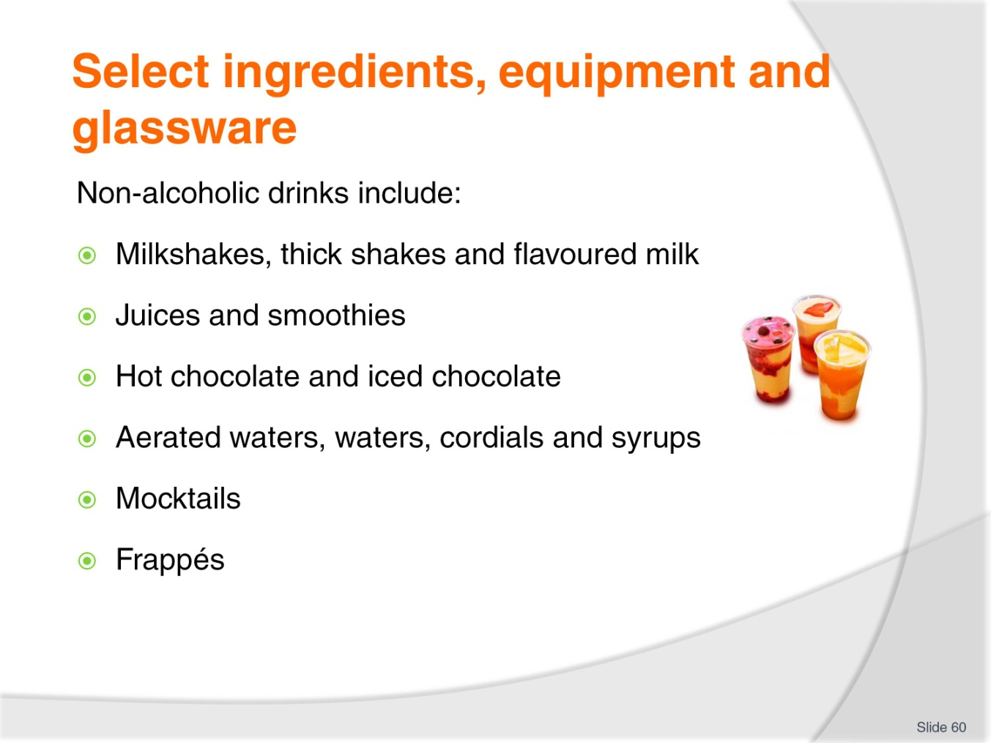
Slide No | Trainer Notes
Trainer identifies non-alcoholic beverages include both hot and cold drinks, and are nearly always available for on premises consumption as well as in take away form providing the following generic examples:
Milk shakes
Flavoured milks
Smoothies
Hot/iced chocolate
Juices, and freshly squeezed juices
Cordials and syrups
Waters
Soft drinks – also known as aerated waters; either bulk ‘post mix’ products or products from bottles or cans
Non-alcoholic cocktails – known as ‘mocktails’
Frappés.

Slide
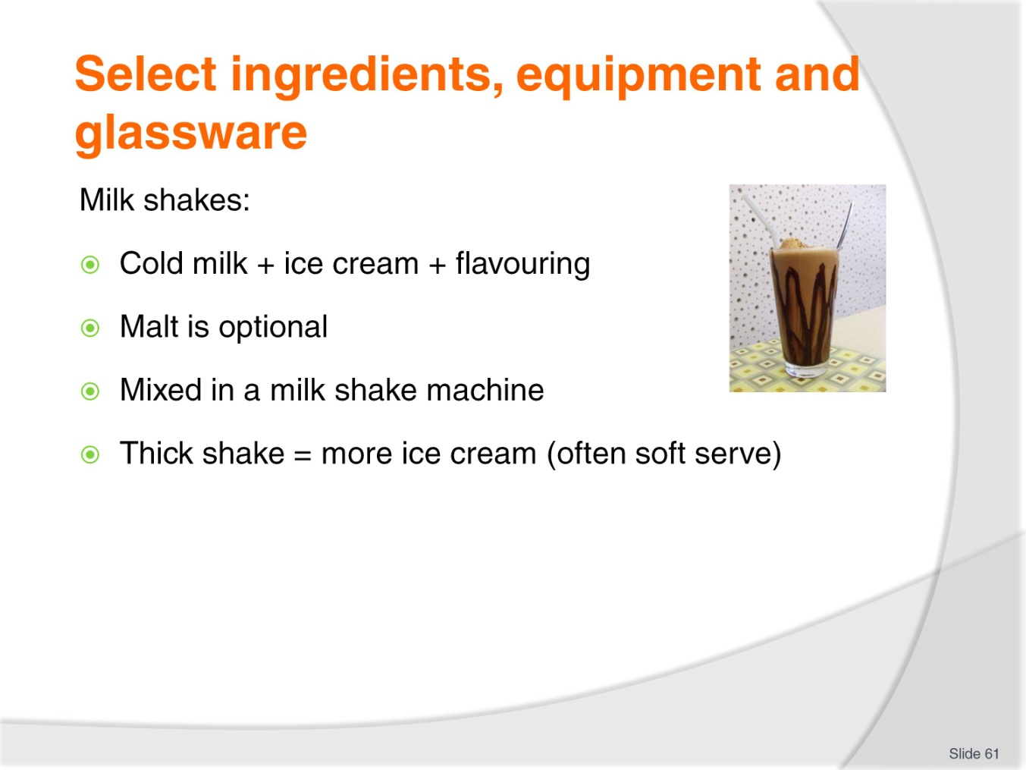
Slide No | Trainer Notes
Trainer discusses milkshakes:
These are traditional favourites and extremely popular despite other alternative milk-based drinks available
The basic milkshake is a blend of cold milk, ice cream and a flavouring agent (cordial or essence): malt is a common option
Customers may ask for extra ice cream, extra flavour or double malt
There is a range of flavours, and preparation and service varies marginally in some aspects, and widely in others
A variation on the milkshake is a thick shake; basically the same as a milk shake but with more ice cream
Venues with soft serve ice cream machines generally use softserve to make their thick shakes.
Class Activity – Online research
Trainer arranges for students to view and discuss:
http://en.wikipedia.org/wiki/Milkshake.

Slide
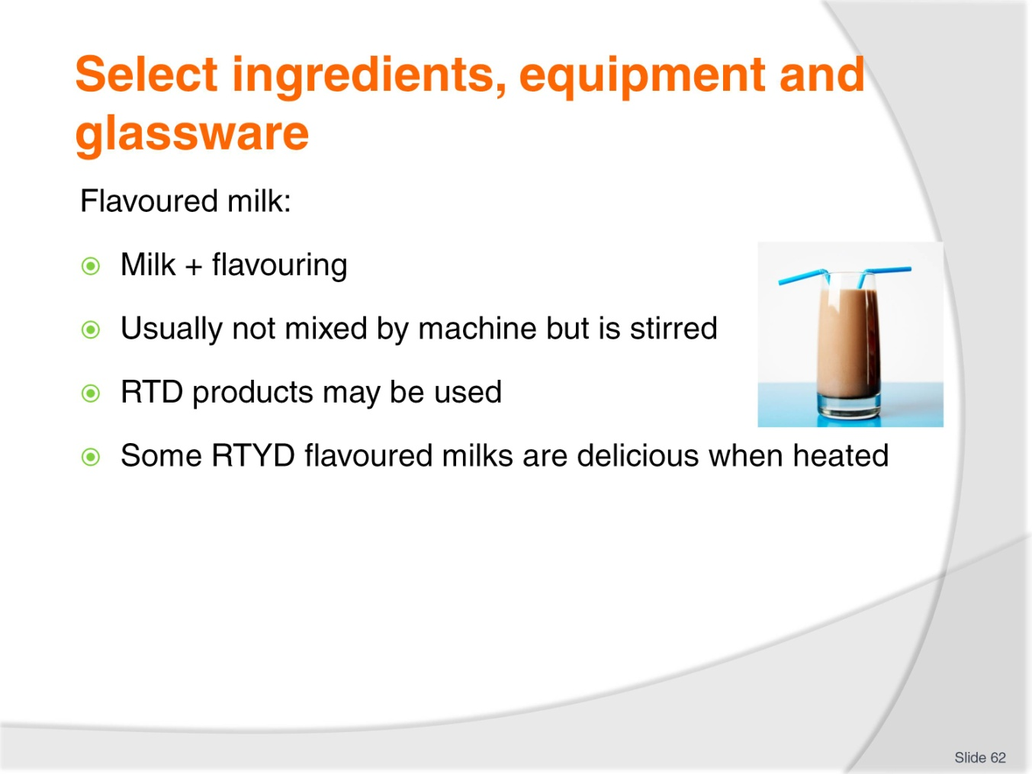
Slide No | Trainer Notes
Trainer discusses flavoured milk:
A variation on the traditional milkshake is the simpler ‘flavoured milk’: milk with added flavouring sometimes stirred by the milkshake machine, sometimes not
In some premises, the proprietary brands of RTD flavoured milk are also available for service
Flavoured milks are normally served chilled, but some (‘egg nog’ and ‘chocolate’) are also delicious when heated (using microwave or espresso machine steam wand).

Slide
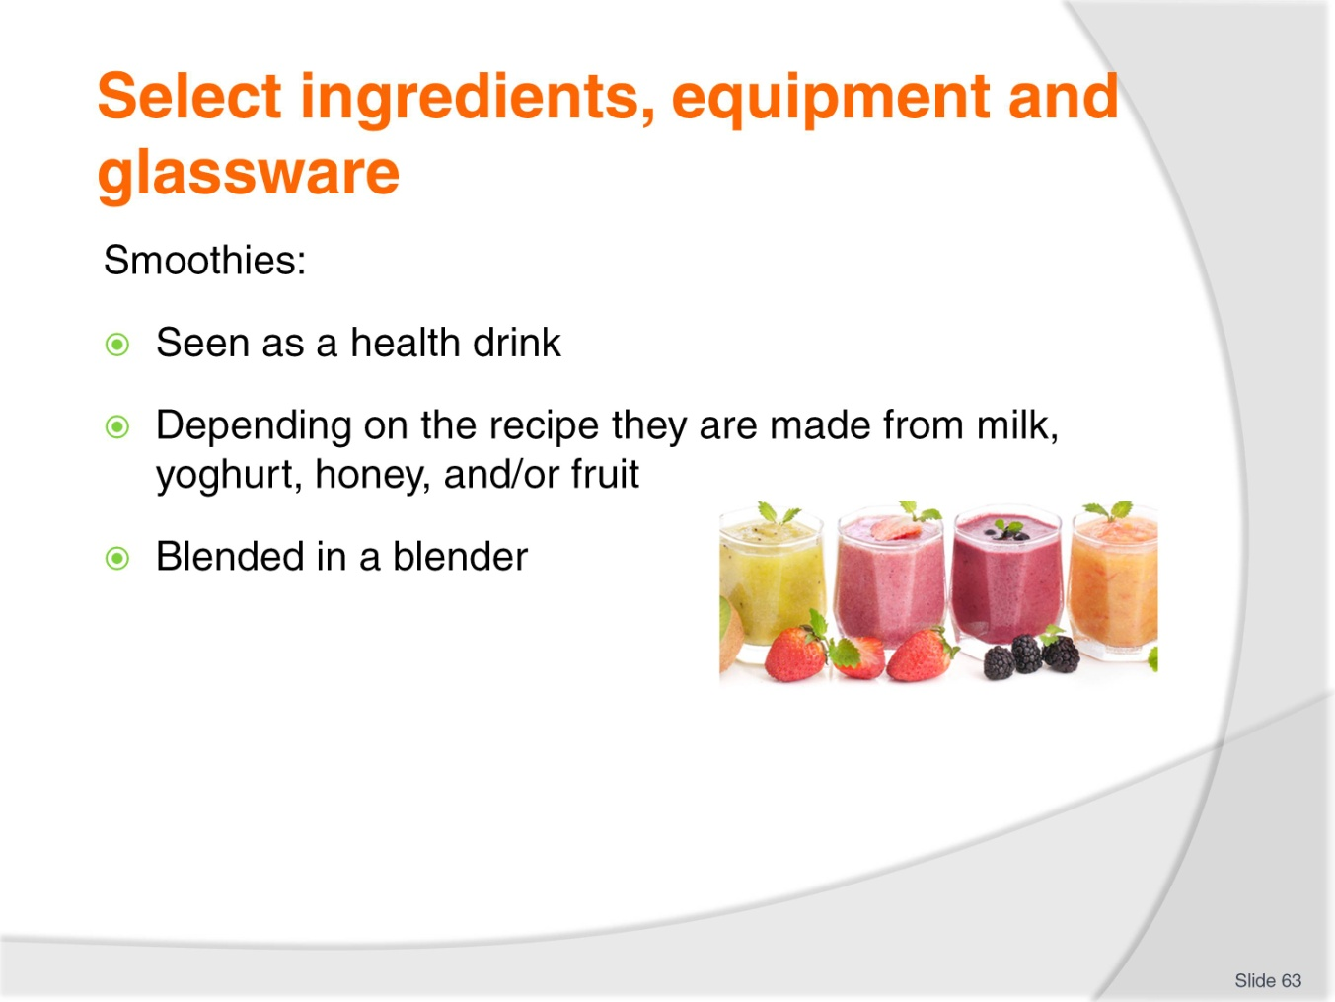
Slide No | Trainer Notes
Trainer discusses smoothies:
A healthy drink combining milk and fruit
Blended with ice in a blender until ‘smooth’.

Slide
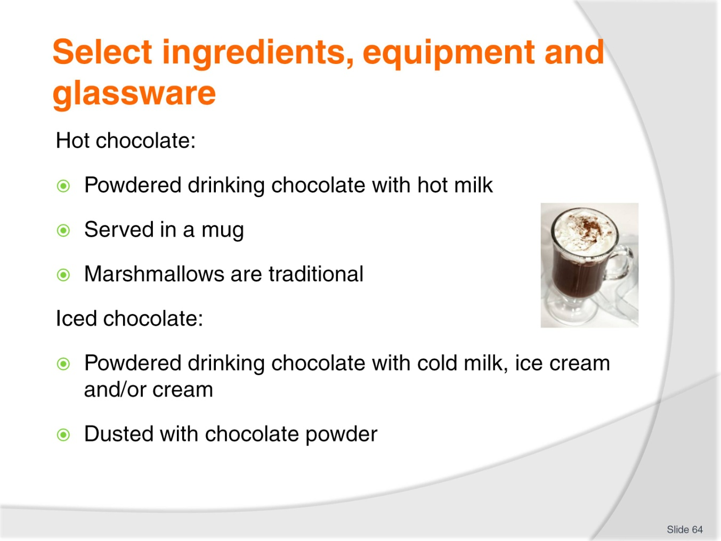
Slide No | Trainer Notes
Trainer discusses chocolate drinks:
Hot chocolate
This is powdered drinking chocolate with hot milk. Milk can be heated in microwave or using steam wand on espresso machine
Sugar optional
Served in a big mug perhaps with a marshmallow.
Iced chocolate
This is powdered drinking chocolate with icy cold milk, vanilla ice cream and sometimes cream
Dust with powdered drinking chocolate, serve in a parfait glass with a parfait spoon.

Slide
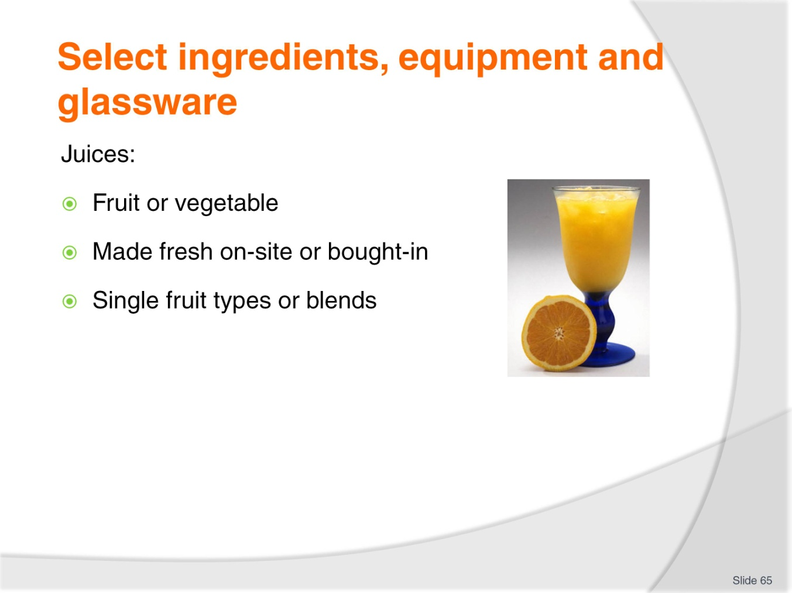
Slide No | Trainer Notes
Trainer discusses juices:
Many types of fruit can be turned into juices and Juice Bars have made these a popular drink type
Some establishments only use proprietary brand fruit juices bought in and they offer only the traditional tomato juice, orange juice, pineapple juice and perhaps, apple juice
Venues serving breakfasts usually boast more juices than other premises
Bought-in product may come in PCs or in larger containers (tins or plastic containers), ranging from 1 litre to 10 litres which are decanted into jugs, which in turn are used to fill glasses
Other venues boast a domestic or commercial juicer and make their own juice/s. There are many single fresh juices that can be made, plus lots more combinations of two, three or more different juices
Making vegetable juices is an option too.
Class Activity – Operating a Juicing Machine
Trainer:
Demonstrates how to juice fruit using a machine
Provides opportunity for students make juice using a juice machine
Demonstrates how to clean the machine after use.
Slide
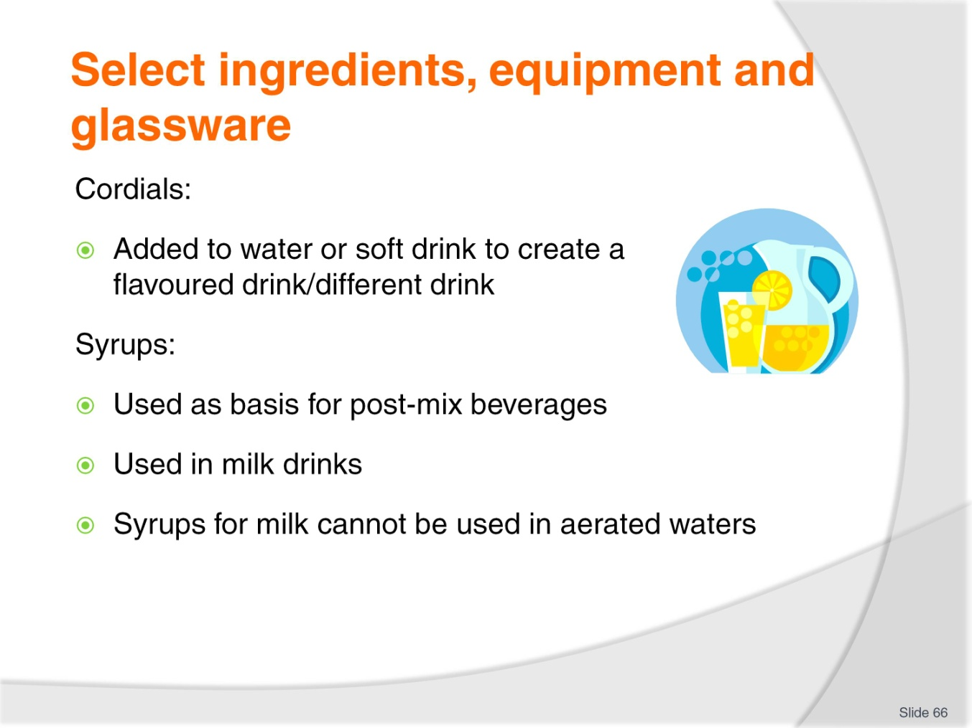
Slide No | Trainer Notes
Trainer discusses cordials and syrups:
Cordials are mixed with water, soda water, or lemonade to create a flavoured drink
The amount of cordial used will depend on customer taste and the quality (which really means intensity of flavour) of the product
Common cordials are lime juice, sarsaparilla, cloves, raspberry, peppermint and grenadine (a bright red, pomegranate flavour)
Syrups can be one of two types: for mixing with water or for mixing with milk. Syrups/cordials for soft drink cannot be used for milk drinks and vice versa
Used as the base for post-mix, syrup is mixed with chilled water to produce the finished ‘aerated water’ product
Syrups can be used to flavour milk shakes and flavoured milk
When discussing non-alcoholic drinks, it is a good idea to make sure you know which one is being talked about: a caramel milk shake sounds good but a blue heaven aerated water would not be.
Class Activity – Online Research
Trainer enables to view and discuss:
http://www.shakeking.com/.

Slide
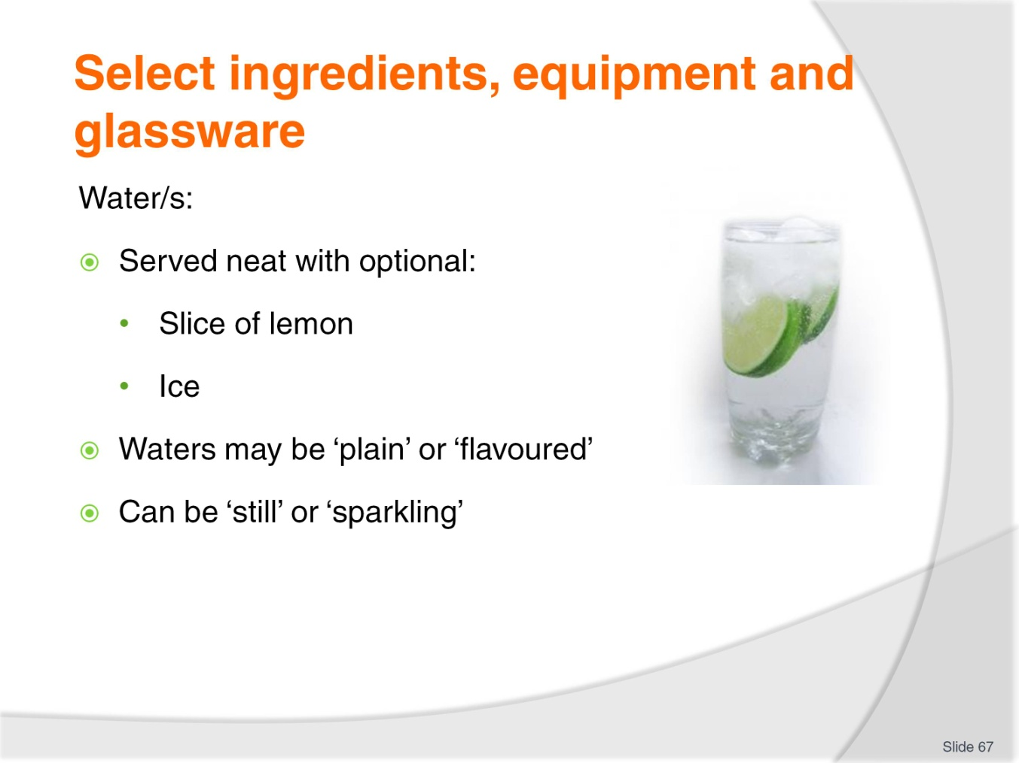
Slide No | Trainer Notes
Trainer discusses water/s:
Water has become an amazingly ‘trendy’ drink – it can cost more than an alcoholic drink, and now comes in a wide range of choices
Most waters are served neat, with a slice or wedge of lemon: ice is offered
Small ‘split’ bottles are common – one split per serve, presented unopened to guarantee the contents are genuine. The top/cap can be removed in front of customer
The majority of waters are ‘plain’. Options include spring water, mineral water, spa water, local or imported, still or sparkling
Some waters offer added fruit juice – around 5% fruit juice – in a variety of flavours including lemon, pineapple, and orange.
Class Activity – Sample Products
Trainer shows students a range of waters.

Slide
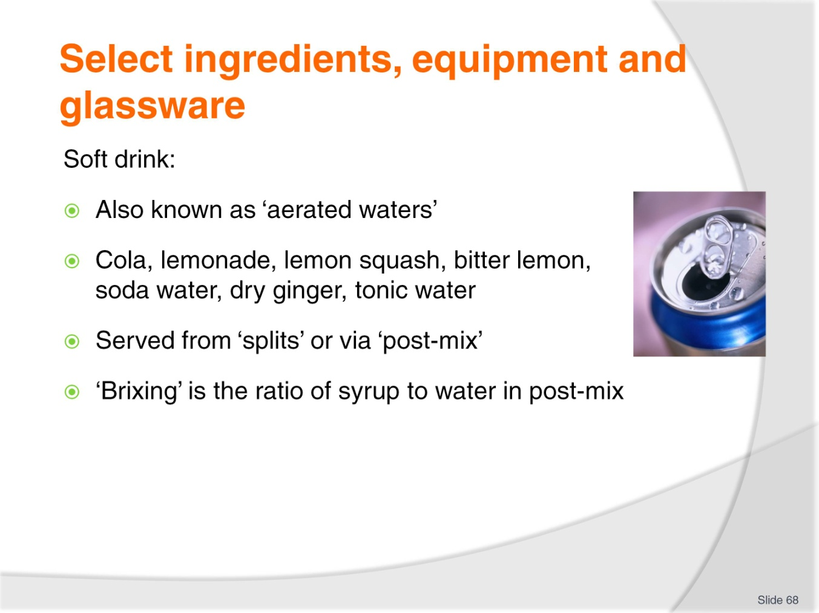
Slide No | Trainer Notes
Trainer discusses soft drink:
Soft drink – also known as 'aerated waters' - includes cola, lemon squash, lemonade, bitter lemon, soda water, dry ginger and tonic water
Post-mix is a popular delivery system. It is quick (there are no empties to get rid of, and you aren’t always opening bottles and cans and forever running out) but some outlets will insist on using the traditional bottles and cans
Many customers prefer the packaged option but post-mix is more popular with management. The profit from post-mix is much higher than from the packaged alternative
It is always wise to have some packaged soft drink stowed away somewhere for use in an emergency – perhaps when the power goes off, or the post-mix stops working
Generally speaking, though, the packaged units are only kept for sale as takeaways.
Brixing
Where a post-mix system is used to serve soft drink, there should be a program in place to check the quality of the final product. This includes checking the product temperature, and checking (and adjusting where necessary) the ‘brixing’
With use, the ratio of syrup to water can alter, resulting in the drink not tasting as it should
Each head (the unit where syrup and water are mixed together at the point of service) is able to be individually adjusted – meaning you can increase or decrease the mix of both water and syrup
Suppliers of the syrup will inform you of the correct brixing for each product line, and the equipment manufacturer/supplier will show you how to check and adjust the brixing
Incorrect brixing is the biggest criticism of post-mix drinks – many customers will say the product tastes weak, or is not as it should be
The post-mix also needs to have its carbonation level checked to ensure its effervescence is correct.

Slide
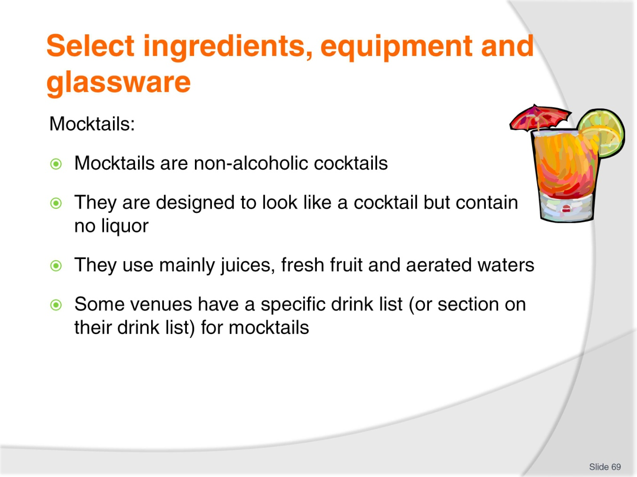
Slide No | Trainer Notes
Trainer discusses mocktails:
Mocktails are non-alcoholic cocktails. The base is usually carbonated soft drink or a fruit juice
You can add fresh fruit wedges, sugar, honey, milk, yoghurt, sugar syrup, concentrate pulp, just to name a few suitable ingredients
Mocktails usually require blending because they often have chunks of fruit in them needing to be liquefied. They are usually served in a cocktail glass and garnished with the type of fruit best matching the base
Your establishment may have a special Mocktail List. You can invent your own mocktail – ensure it is tasty, looks inviting and of course, contains no alcohol.
Class Activity – Internet Research
Trainer visits and discusses:
http://cocktails.about.com/od/mocktailmocktail/Mocktail_Recipes.htm
http://www.drinkalternatives.com/non-alcoholic-mocktail-recipes/.

Slide
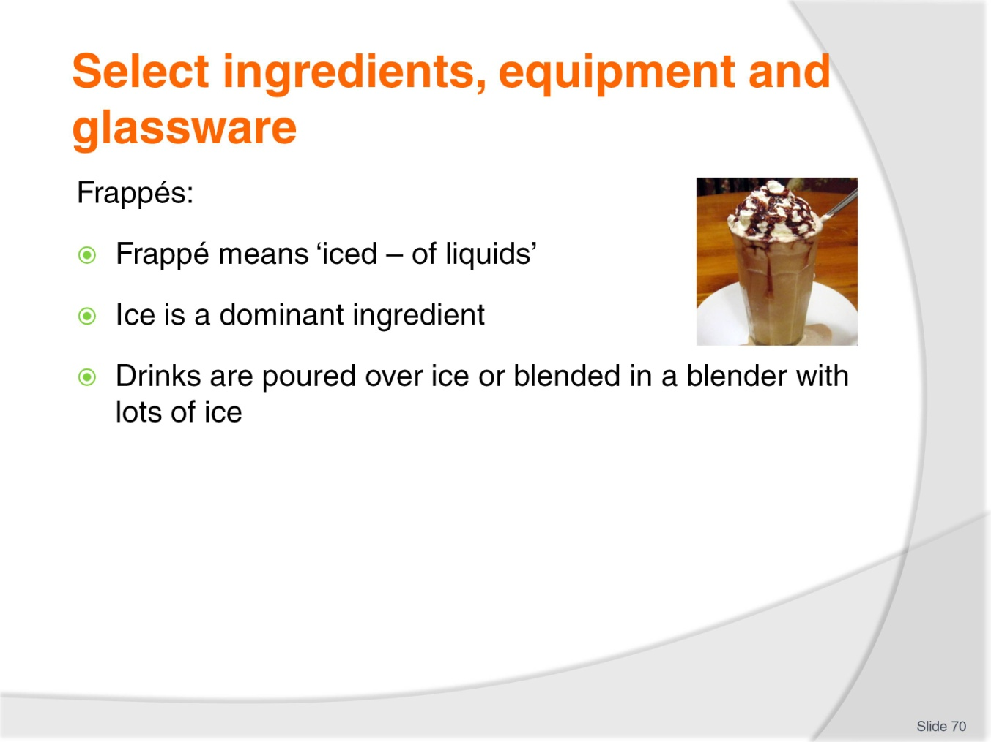
Slide No | Trainer Notes
Trainer discusses frappés:
Frappé is French and means ‘iced – of liquids’
It is therefore a style of service where the beverage – use whatever you want or whatever the customer orders – is poured over crushed ice, or blended in a blender with ice
The beverage used needs to be fairly flavoursome because the ice melts and dilutes the beverage. Common options include juices and syrups.
Class Activity – Internet Research
Trainer visits and discusses:
http://www.drinksmixer.com/cat/28/.

Slide
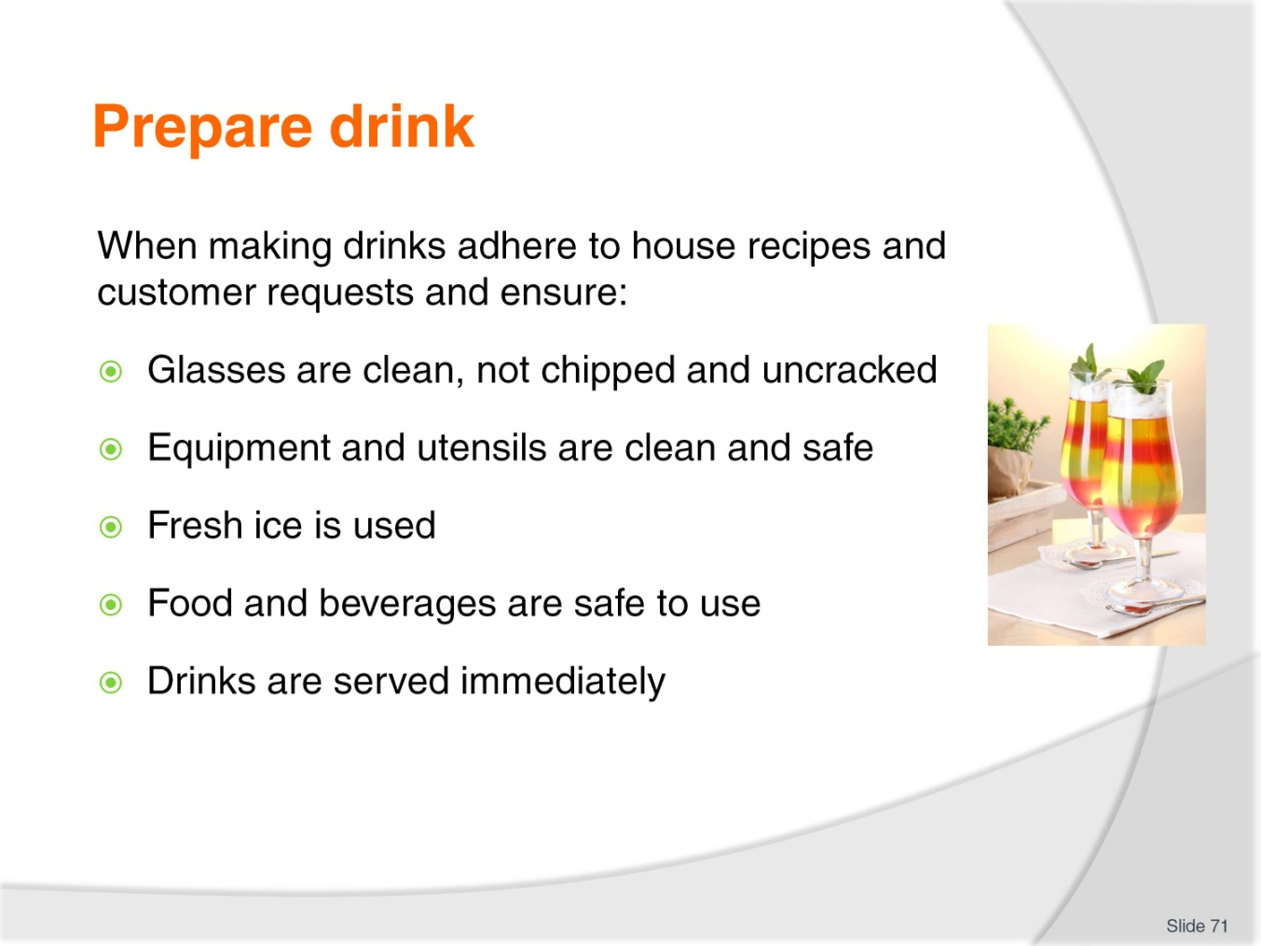
Slide No | Trainer Notes
Trainer reminds drinks should be made to the house standard (recipe) or specific customer requests stating basic requirements when making cold drinks include ensuring:
Glasses used are clean – no remains of fruit or cream, no lipstick
Glasses are not cracked
Glasses are unchipped
Equipment and utensils used are clean and safe to use
Fresh ice is used
All food and beverage items are safe to use – that is, they have been correctly stored and handled to maintain their food safety
Drinks are served immediately they have been made.

Slide
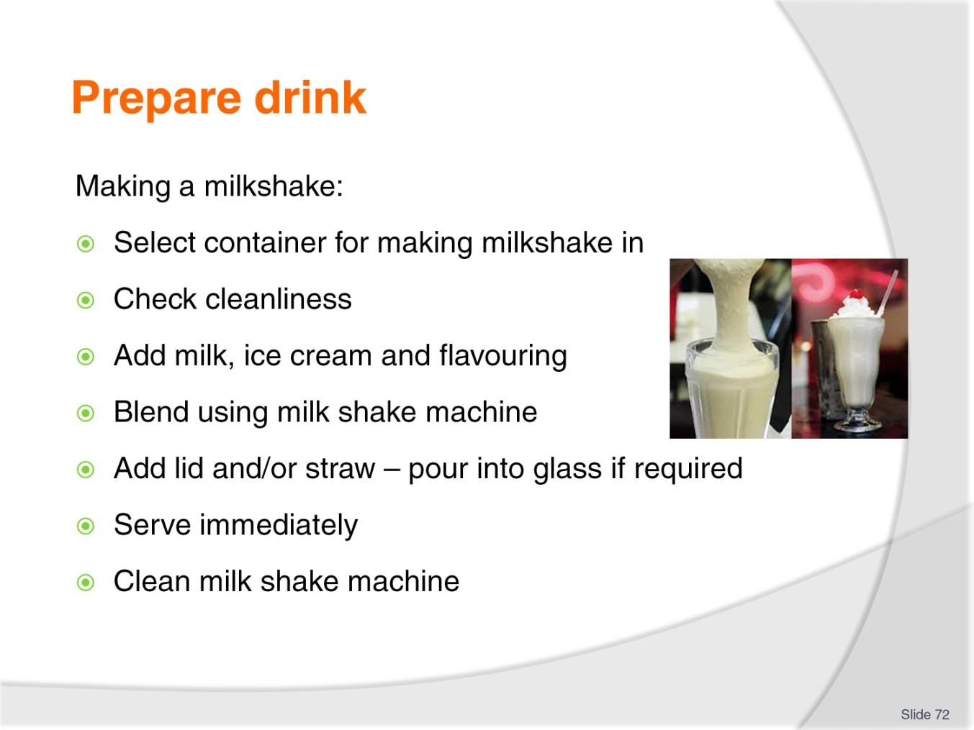
Slide No | Trainer Notes
Trainer discusses making and serving milkshakes describing process:
Select container to be used – metal or take away/single serve container, correct size
Check machine and container for cleanliness
Add chilled milk, ice cream, flavouring/syrup and malt powder (optional – as per order)
Blend using milkshake machine. Follow house timing requirements; extra ice cream requires more time. 10 – 15 seconds is a guide
Remove from machine and follow house procedure for service. This may be to add a lid and a straw to take away milkshakes, or to serve milk shake in a glass with a straw, with the remainder of the milk shake left and served in the metal container
Add drinking straw
Serve immediately
Clean the machine.
Class Activity 1 – Online Videos
Trainer has students view and discuss videos such as:
http://www.youtube.com/watch?v=aCG5VTCAhFw
http://www.youtube.com/watch?v=ANOx9-1i9Sk.
Class Activity 2 – Demonstration and Practical
Trainer:
Demonstrates how to make and serve milk shakes
Provides opportunity for students to practice making and serving milkshakes.

Slide
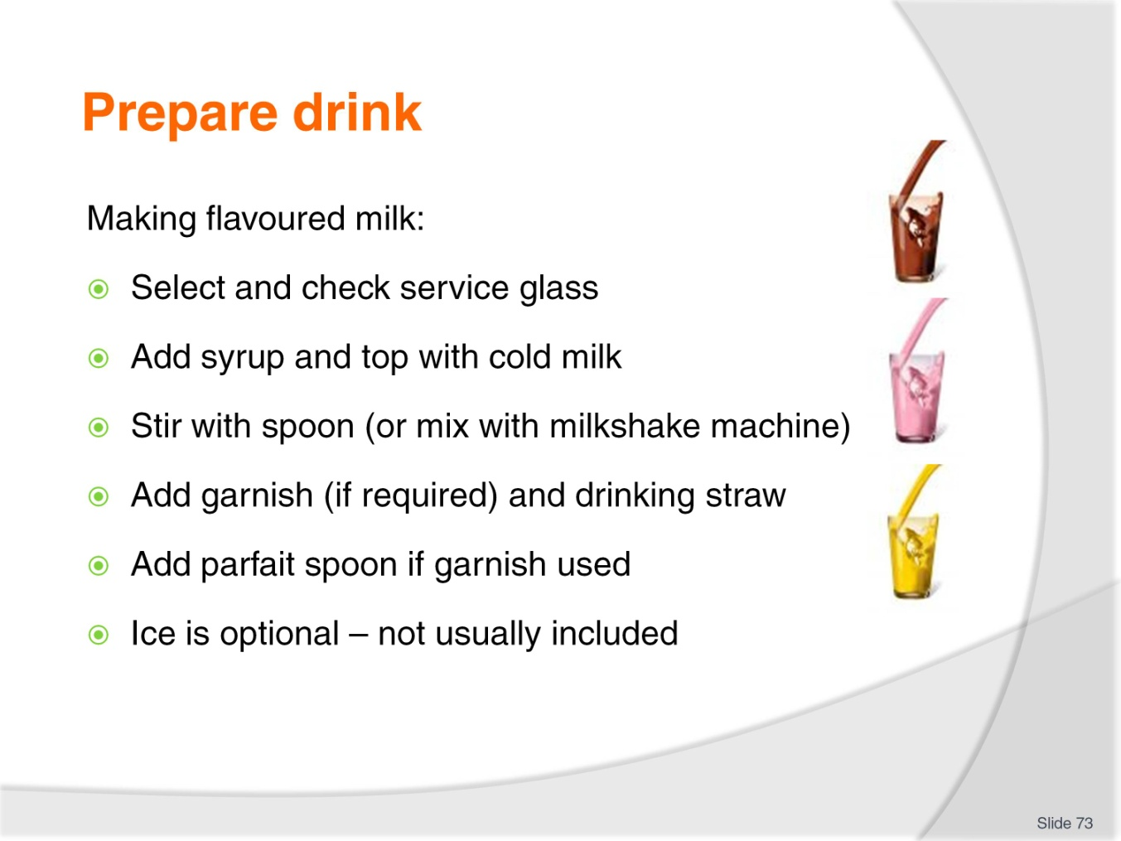
Slide No | Trainer Notes
Trainer discusses making and serving flavoured milk:
Select correct size glass – check it is clean, unchipped and uncracked
Add syrup for flavour as chosen by customer. Quantity will depend on size of glass
Top with very cold milk
Stir with bar spoon (long-handled spoon) and ensure syrup is thoroughly mixed
Add garnish if appropriate. Garnishes are not common for flavoured milk but may include:
- Crushed strawberries for strawberry flavoured milk
- Chocolate powder with chocolate flavoured milk
Add drinking straw
Place on service plate/saucer lined with doily
Add a parfait spoon if garnish includes fruit or other edible product
Ice is optional for this drink. It is not usually added unless requested. If ice is required it should be added after milk and syrup has been stirred.
Class Activity – Demonstration and Practical
Trainer:
Demonstrates how to make and serve flavoured milk
Provides opportunity for students to practice making and serving flavoured milk.
Slide
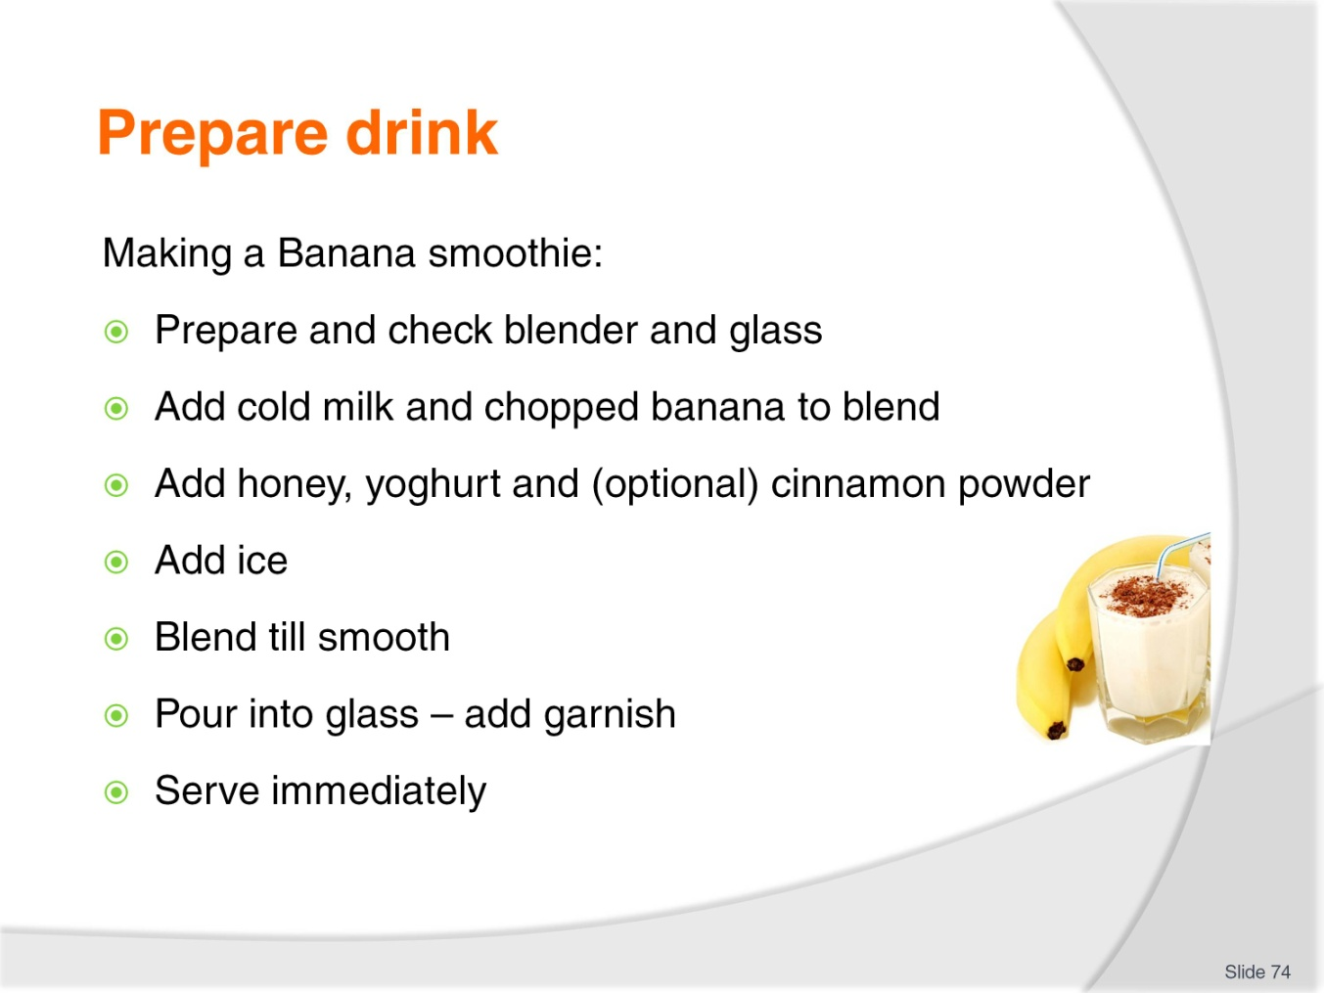
Slide No | Trainer Notes
Trainer discusses making and serving smoothies:
Banana smoothie:
Prepare blender – check it is clean
Prepare glass/serviceware – check they are clean
Add ice cold milk to blender
Add roughly chopped banana/s to blender
Add honey
Add yoghurt
Add cinnamon powder (optional)
Add ice
Blend together until smooth
Pour into glass
Add garnish – according to house recipe
Serve immediately.
Class Activity – Demonstration and Practical
Trainer:
Demonstrates how to make and serve smoothies
Provides opportunity for students to practice making and serving smoothies.
Slide
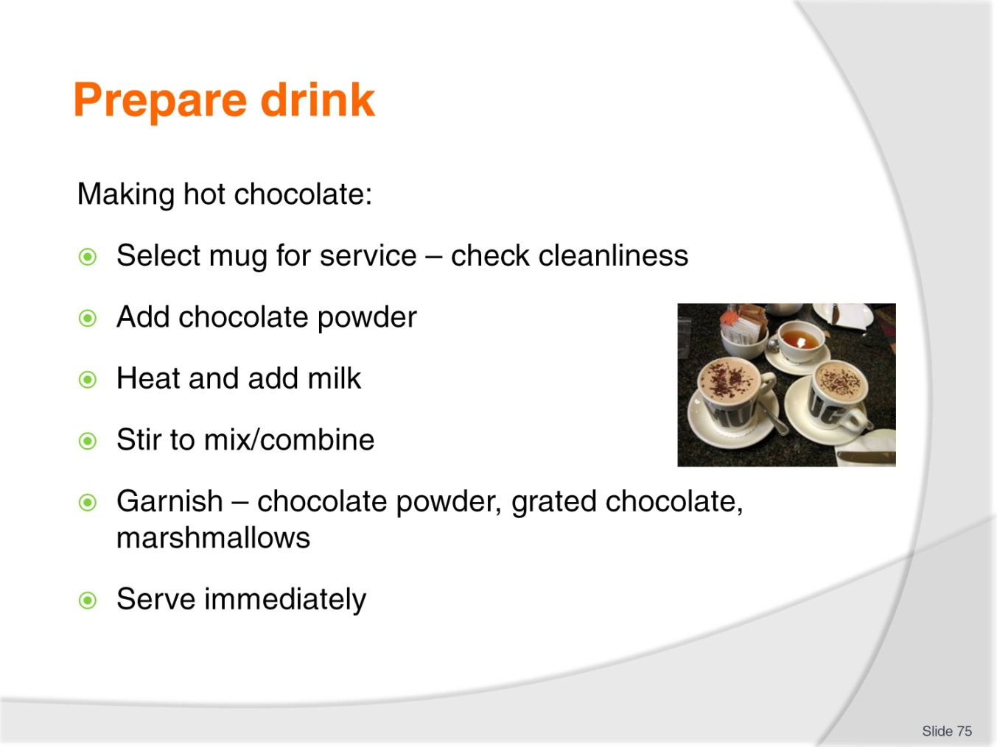
Slide No | Trainer Notes
Trainer discusses making and serving hot chocolate:
Select mug for service of drink. Check it is clean and presentable
Add chocolate powder. Most commercial hot chocolates are made using a proprietary brand of chocolate powder/hot chocolate powder as opposed to making the drink from actual chocolate (and melting the chocolate with milk in a bain-marie or over low heat)
Heat milk – milk may be heated in microwave, or by using steaming wand on espresso machine
Add hot milk and stir
Dust with chocolate powder – or top with grated chocolate
Add marshmallows
Serve immediately.
Class Activity 1 – Online Videos
Trainer has students view and discuss video:
http://www.howdini.com/howdini-video-6677099.html.
Class Activity 2 – Demonstration and Practical
Trainer:
Demonstrates how to make and serve hot chocolate
Provides opportunity for students to practice making and serving hot chocolate.
Slide
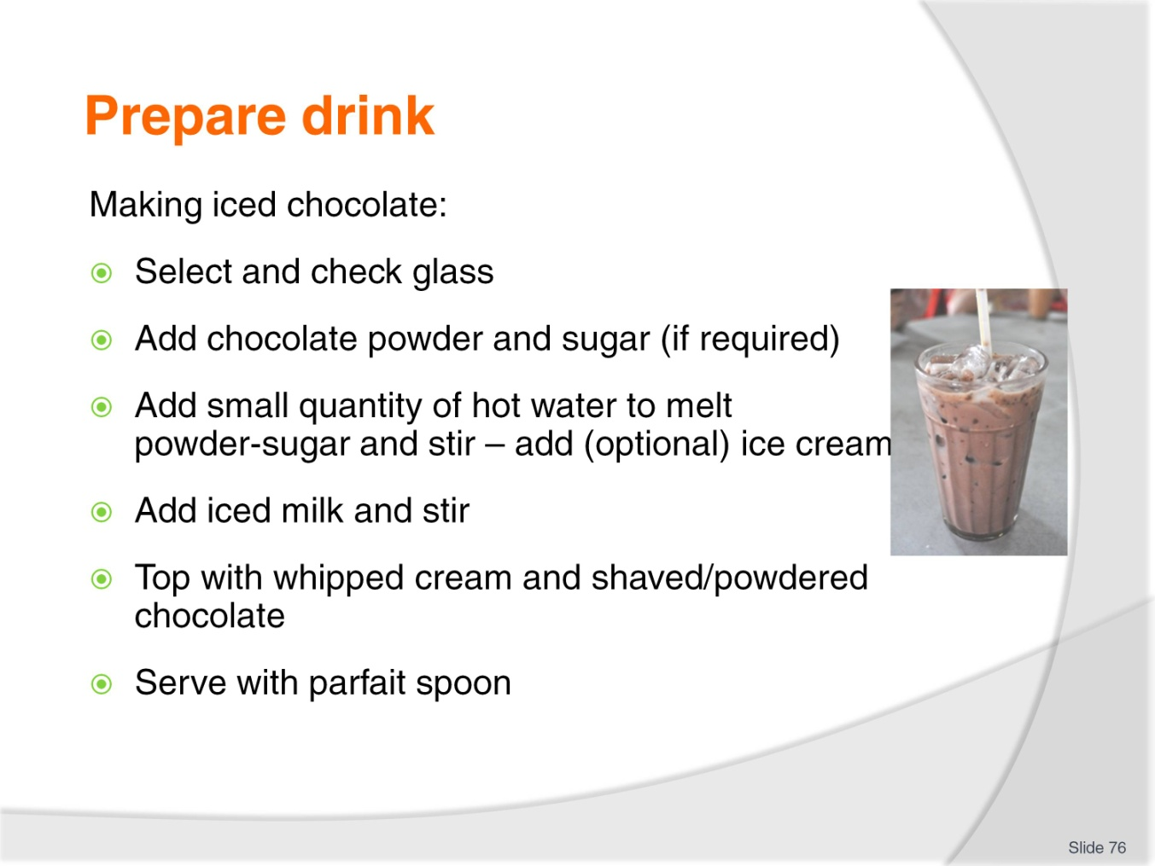
Slide No | Trainer Notes
Trainer discusses making and serving iced chocolate:
Select glass – check for cleanliness and suitability
Add commercial chocolate or cocoa powder or syrup
Add sugar if required
Add very small quantity of hot water to dissolve powder and sugar and stir
Add ice cold milk and stir
Top with whipped cream
Add chocolate shavings or powder
Serve immediately with parfait spoon.
Note:
Ice cream is added in some venues
This drink may be made in a blender with ice added and served as part of the blended drink.
Class Activity – Demonstration and Practical
Trainer:
Demonstrates how to make and serve iced chocolate:
- In glass
- Using a blender making the drink with ice
Provides opportunity for students to practice making and serving iced chocolate.
Slide
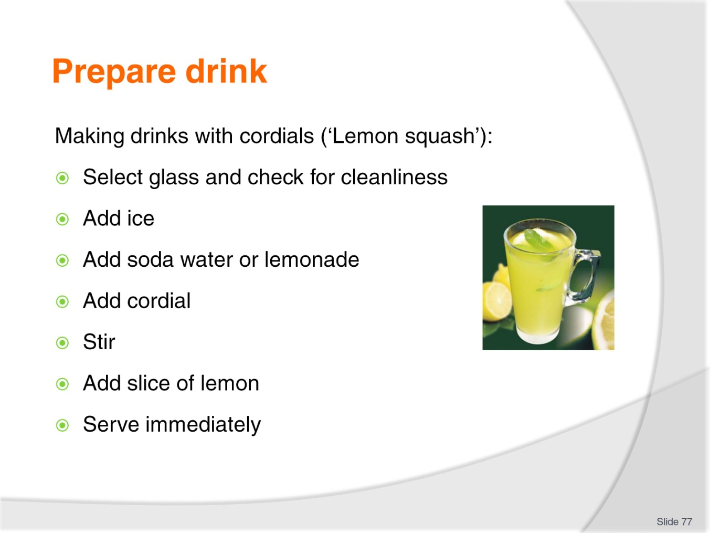
Slide No | Trainer Notes
Trainer discusses making and serving drinks with cordials:
Lemon squash
Select the glass to be used. Check for cleanliness
Add ice using tongs/utensil, not fingers. Ice always goes into the glass first. Never add ice as the last ingredient
Add the base beverage such as soda water or lemonade (according to guest request/preference)
Add the cordial and stir
Add garnish – slice of lemon
Serve immediately – drinking straw may be added.
Class Activity – Demonstration and Practical
Trainer:
Demonstrates how to make and serve drinks with cordials
Provides opportunity for students to practice making and serving drinks with cordials.

Slide
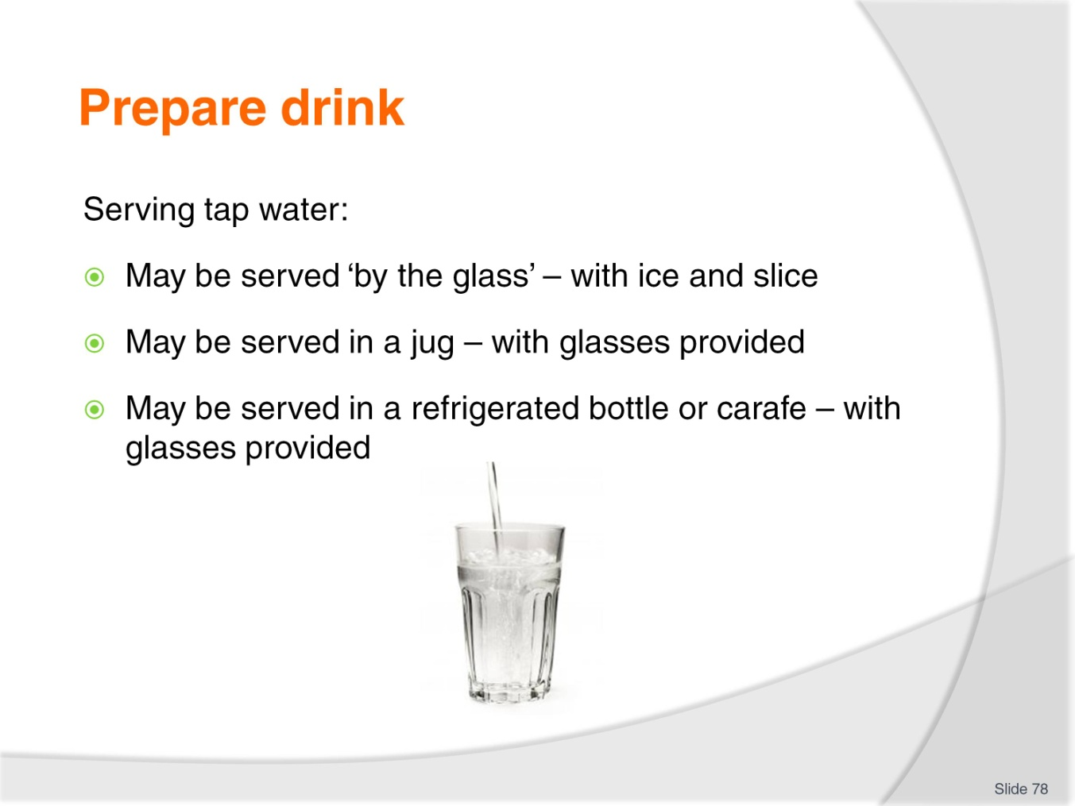
Slide No | Trainer Notes
Trainer discusses serving tap water:
It may be served in a glass with ice and slice of lemon
It may be served with ice in a jug and the customer pours their own into a glass with ice and lemon slice
It may be served in a refrigerated bottle/carafe to the table and each guest has a glass so they can help themselves.
Class Activity – Demonstration and Practical
Trainer:
Demonstrates how to serve tap water in the ways identified on the slide
Provides opportunity for students to practice serving tap water.

Slide
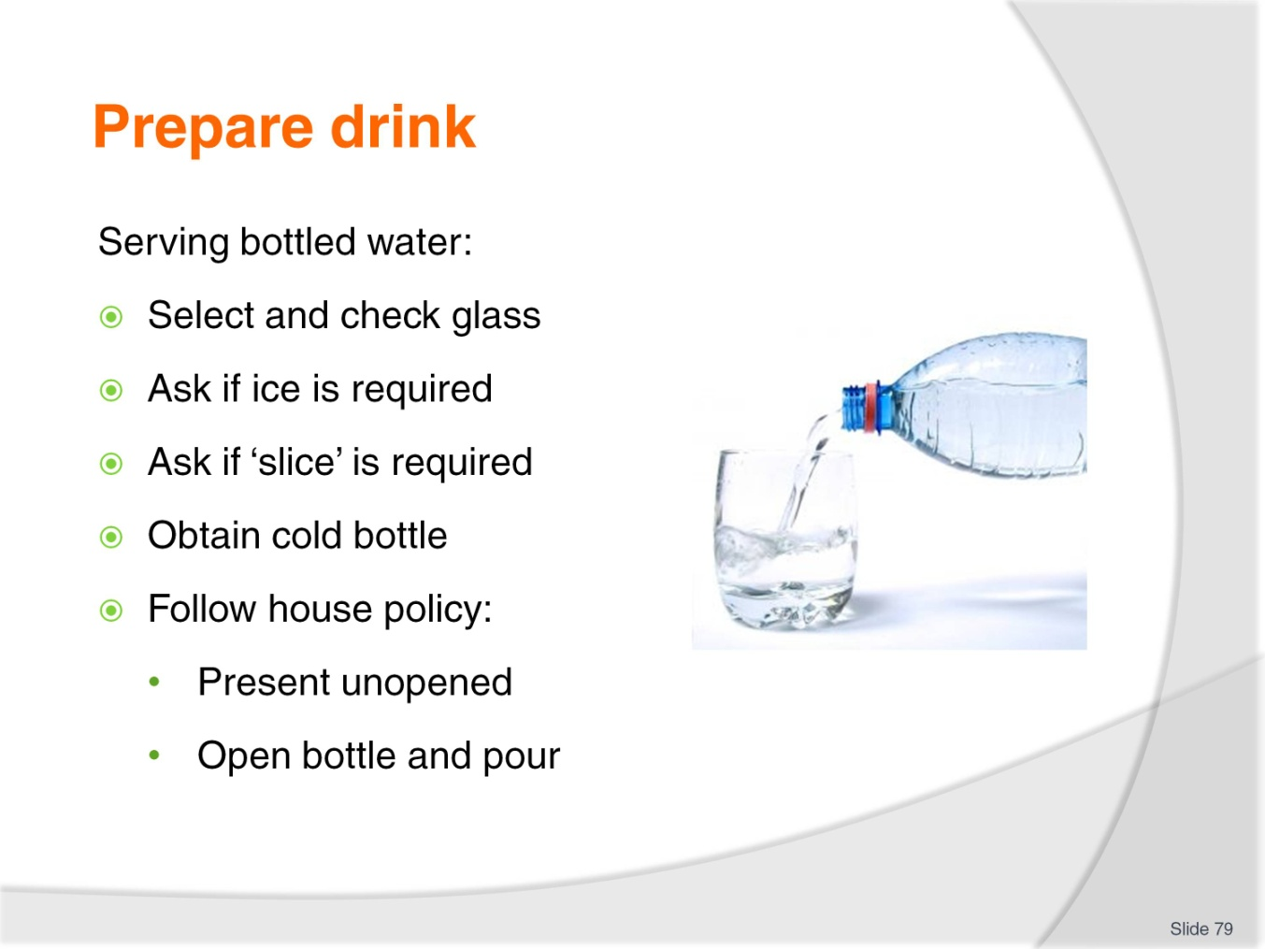
Slide No | Trainer Notes
Trainer discusses serving proprietary brands of bottled water:
Select required glass – check for cleanliness
Enquire if customer wants ice – add ice to glass if required
Enquire if customer would like slice of lemon or lime – add if required
Obtain nominated refrigerated bottle from the refrigerated unit
Follow house policy which may be:
- Present sealed bottle and prepared glass to guest allowing them to break the seal on the bottle and pour their own drink
- Open the bottle and pour a glass of water presenting remainder of bottle to guest.
Class Activity – Demonstration and Practical
Trainer:
Demonstrates how to serve bottled water
Provides opportunity for students to practice serving bottled water.

Slide
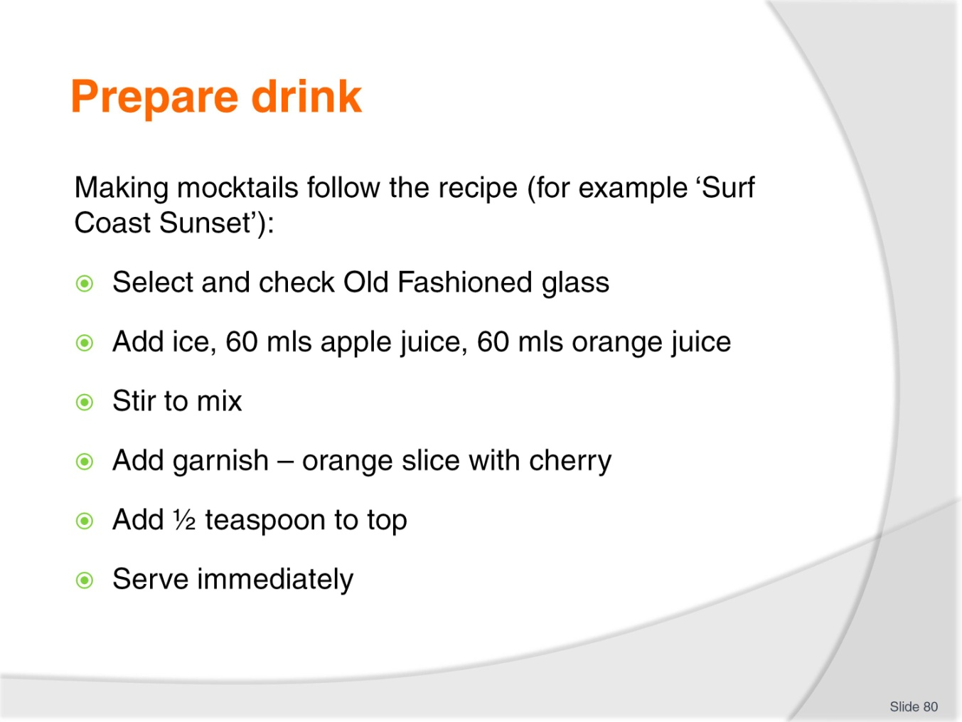
Slide No | Trainer Notes
Trainer discusses making and serving mocktails using ‘Surf Coat Sunset’ as example.
Class Activity 1 – Online Videos
Trainer has students view and discuss videos:
http://www.youtube.com/watch?v=fiVV2wjBb1g
http://www.youtube.com/watch?v=0tupptfzHDk.
Class Activity 2 – Demonstration and Practical
Trainer:
Demonstrates how to make and serve mocktails
Provides opportunity for students to practice making and serving mocktails.

Slide
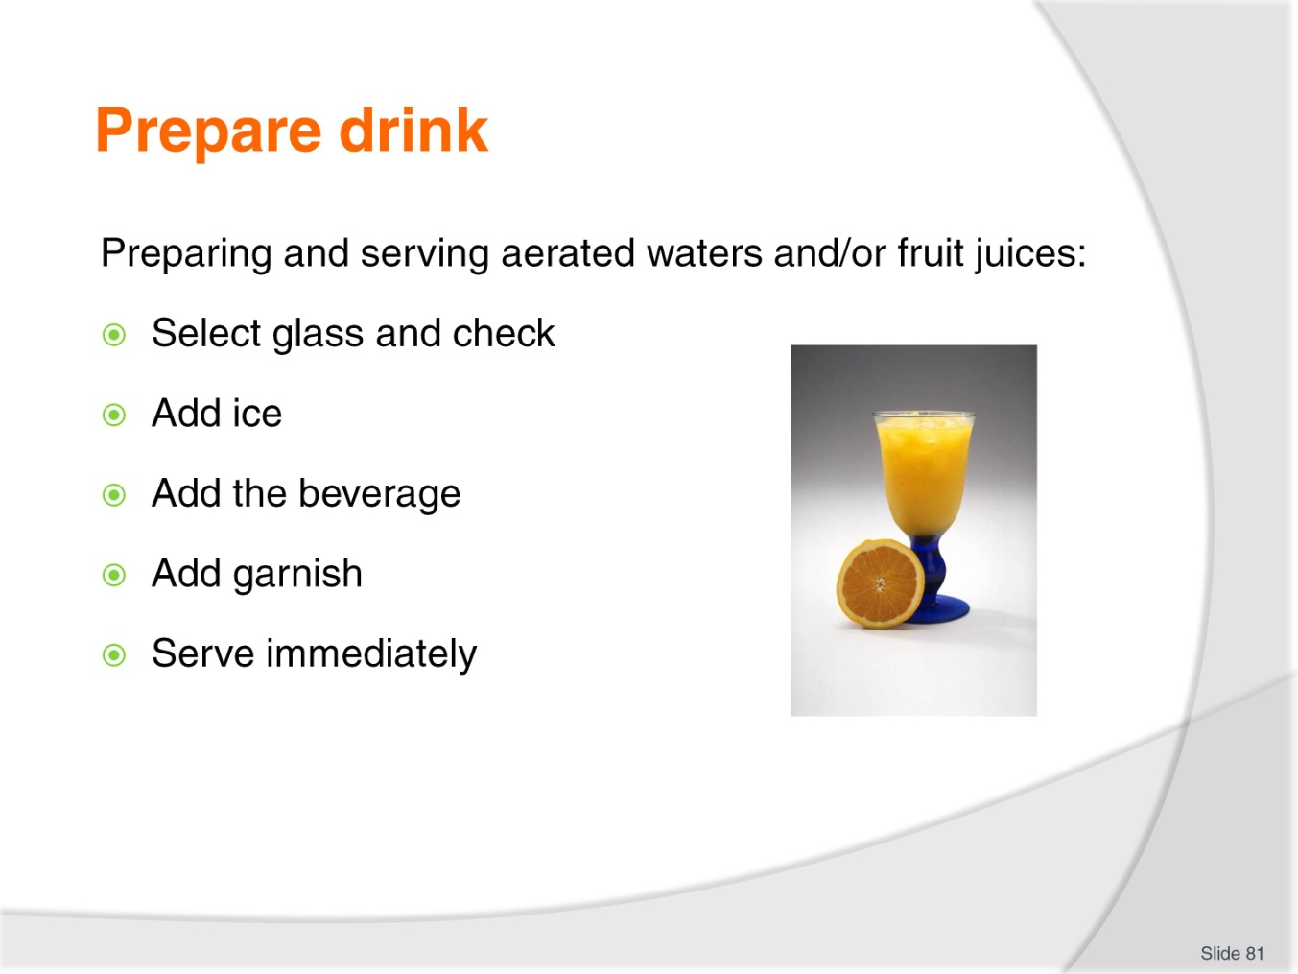
Slide No | Trainer Notes
Trainer discusses preparing and serving aerated waters and fruit juices:
Select the glass to be used. Check for cleanliness
Add ice
Add the beverage – fruit juice may need to be shaken/stirred prior to being poured in
Add garnish – such as a slice of orange with orange juice
Serve immediately – drinking straw may be added.
Class Activity – Demonstration and Practical
Trainer:
Demonstrates how to prepare and serve aerated waters and fruit juices
Provides opportunity for students to practice preparing and serving aerated waters and fruit juices.

Slide
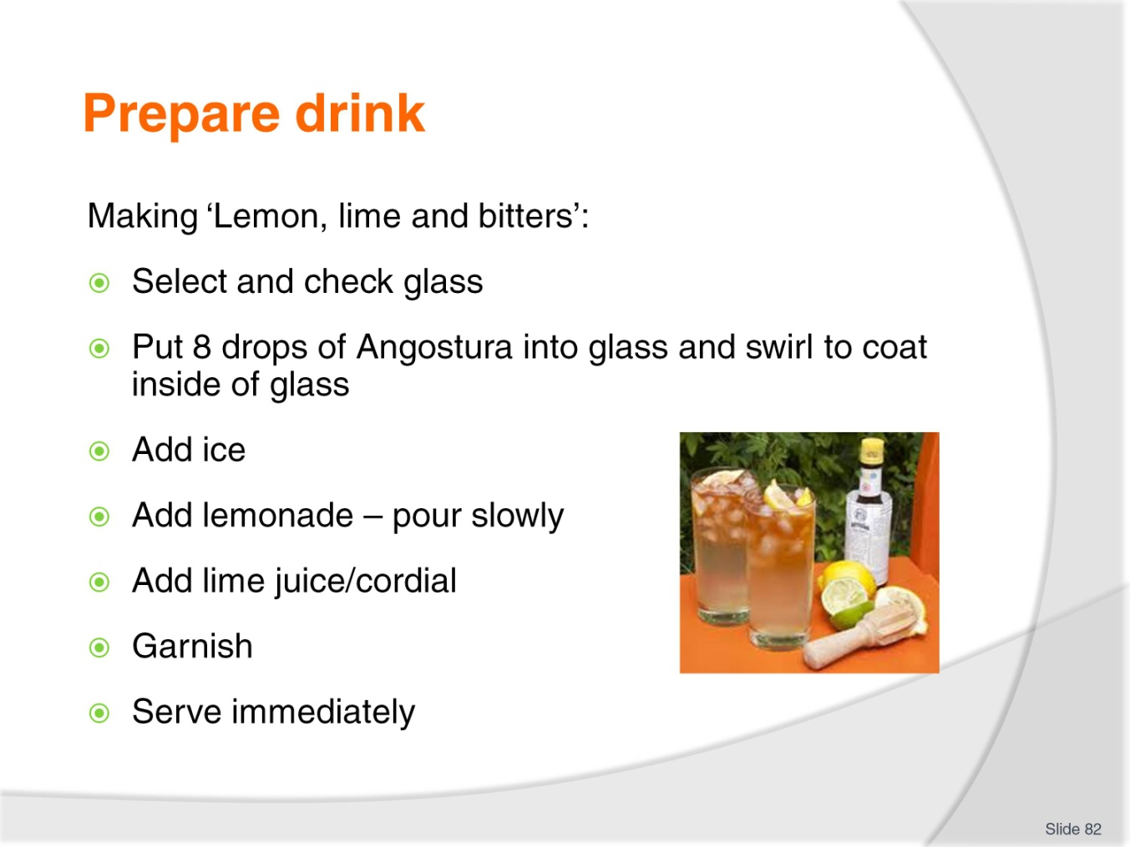
Slide No | Trainer Notes
Trainer discusses making and serving ‘Lemon, lime and bitters’ stressing Angostura bitters contains alcohol so some people do not consider this a true non-alcoholic drink:
Select the right glassware such as a highball glass
Place up to 8 drops of Angostura Bitters and swirl glass so the bitters coats the sides of the glass
Place ice into glass
Fill glass with lemonade. Add slowly as the bitters will cause it to froth
Add lime juice/cordial according to taste or house recipe
Garnish with slice of lemon
Place straw into glass
Serve straight away.
Class Activity – Demonstration and Practical
Trainer:
Demonstrates how to make and serve lemon, lime and bitters
Provides opportunity for students to practice making and serving lemon, lime and bitters.

Slide
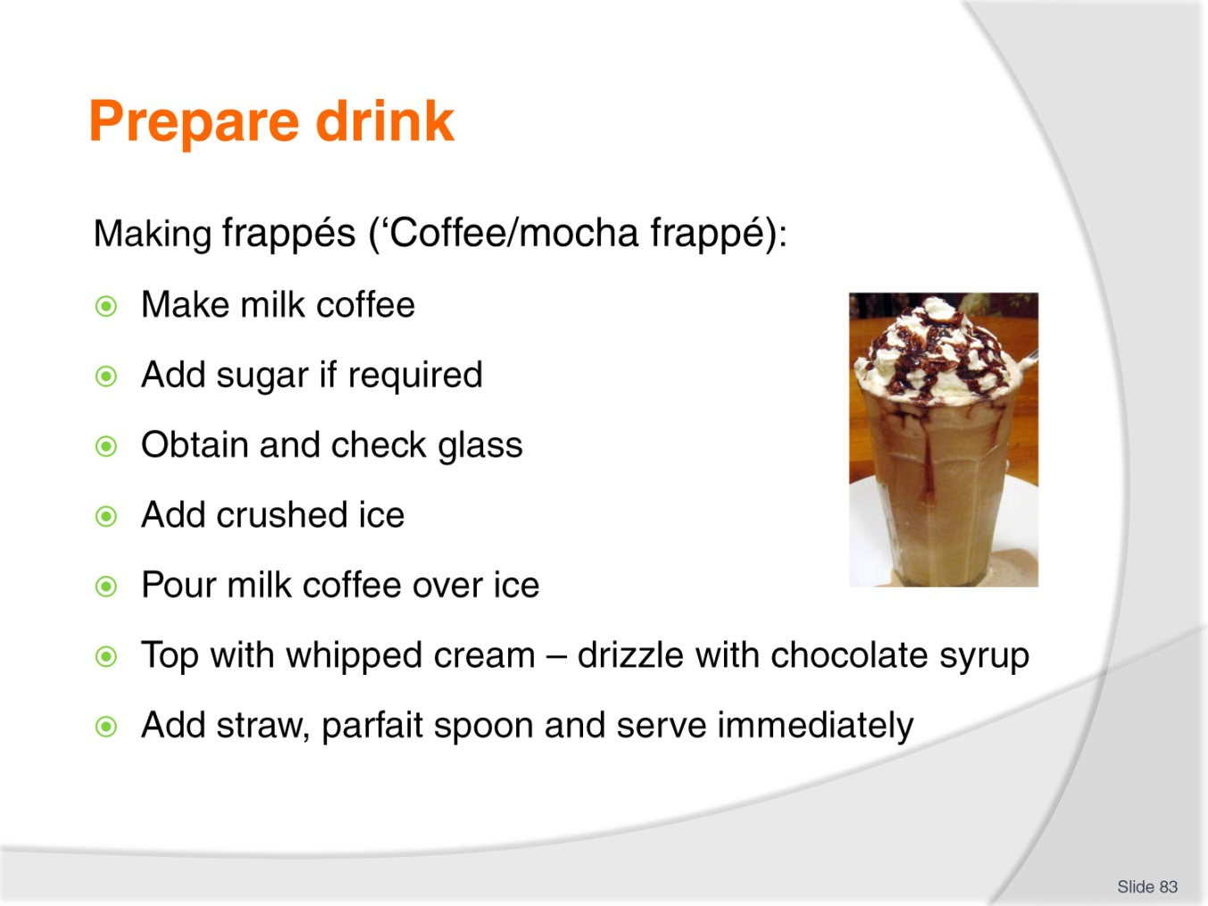
Slide No | Trainer Notes
Trainer discusses making and serving frappés:
Coffee/mocha frappé
Make a milk coffee using espresso – that is espresso coffee with iced milk
Add sugar to taste if required: use sugar syrup
Obtain and check glass
Add crushed ice to glass
Pour milk coffee over ice
Top with whipped cream
Drizzle coffee (or chocolate) syrup on whipped cream
Add straw and parfait spoon
Some venues use a blender to make frappes. They add the main ingredients to a blender, blend and then pour into a glass and decorate (whipped cream, shaved chocolate, syrup).
Class Activity 1 – Online Videos
Trainer has students view and discuss videos:
http://video.about.com/coffeetea/Mayan-Cherry-Frappe.htm
http://www.youtube.com/watch?v=Ylc5b3PmtSY.
Class Activity 2 – Demonstration and Practical
Trainer:
Demonstrates how to make and serve frappés:
- In-glass
- Using blender
Provides opportunity for students to practice making and serving frappés.

Slide
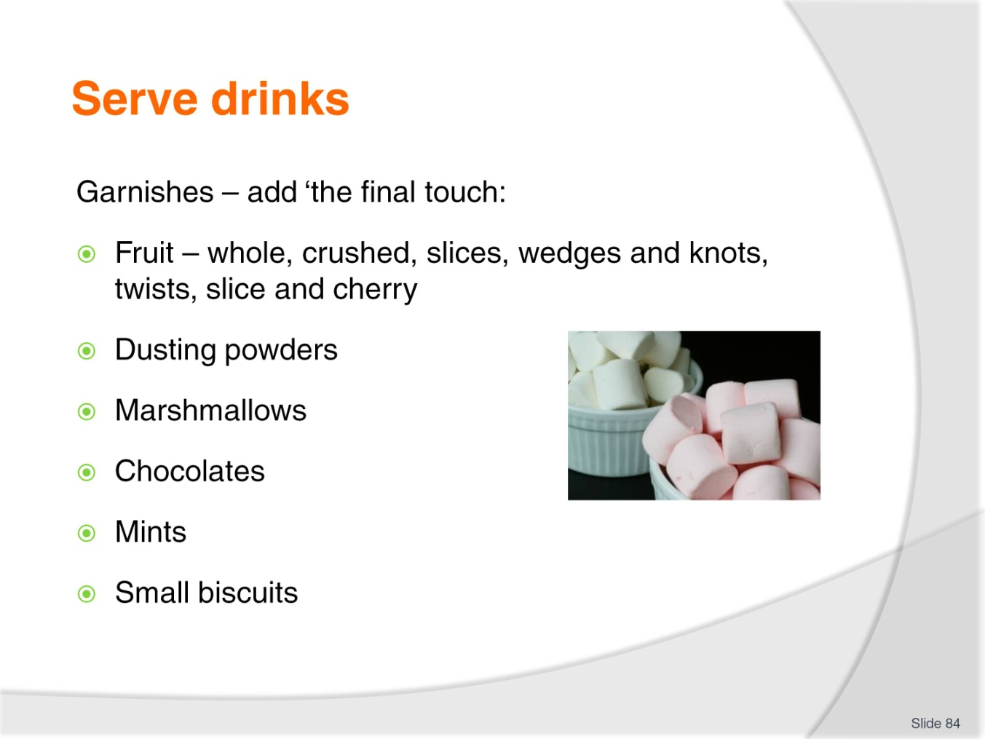
Slide No | Trainer Notes
Trainer stresses need for all drinks to be served in an attractive manner highlighting that the correct garnish adds the finishing touch, and helps to provide ‘the difference’ between a drink the customer might have at home, and the one they pay for at a venue.
Trainer presents typical garnishes easily used and relatively inexpensive to provide which include:
Fruit, such as:
- A whole strawberry – added to side of glass
- Crushed fruit
- Full, half and quarter slices of lemon and oranges
- Wedges and knots of lime, lemon or orange
- Twist of peel
- Slice and cherry – a slice of, for example, orange with a cherry attached by a toothpick. The slice is slightly bent to give the garnish a ‘sail’ effect
- Dusting powders – chocolate, cinnamon, cocoa, nutmeg
- Marshmallows – for hot chocolate
- Chocolates or mints
- Small biscuits.
Class Activity – Demonstration and Practical
Trainer:
Demonstrates how to prepare a range of garnishes
Provides opportunity for students to practice preparing drink garnishes.
Slide
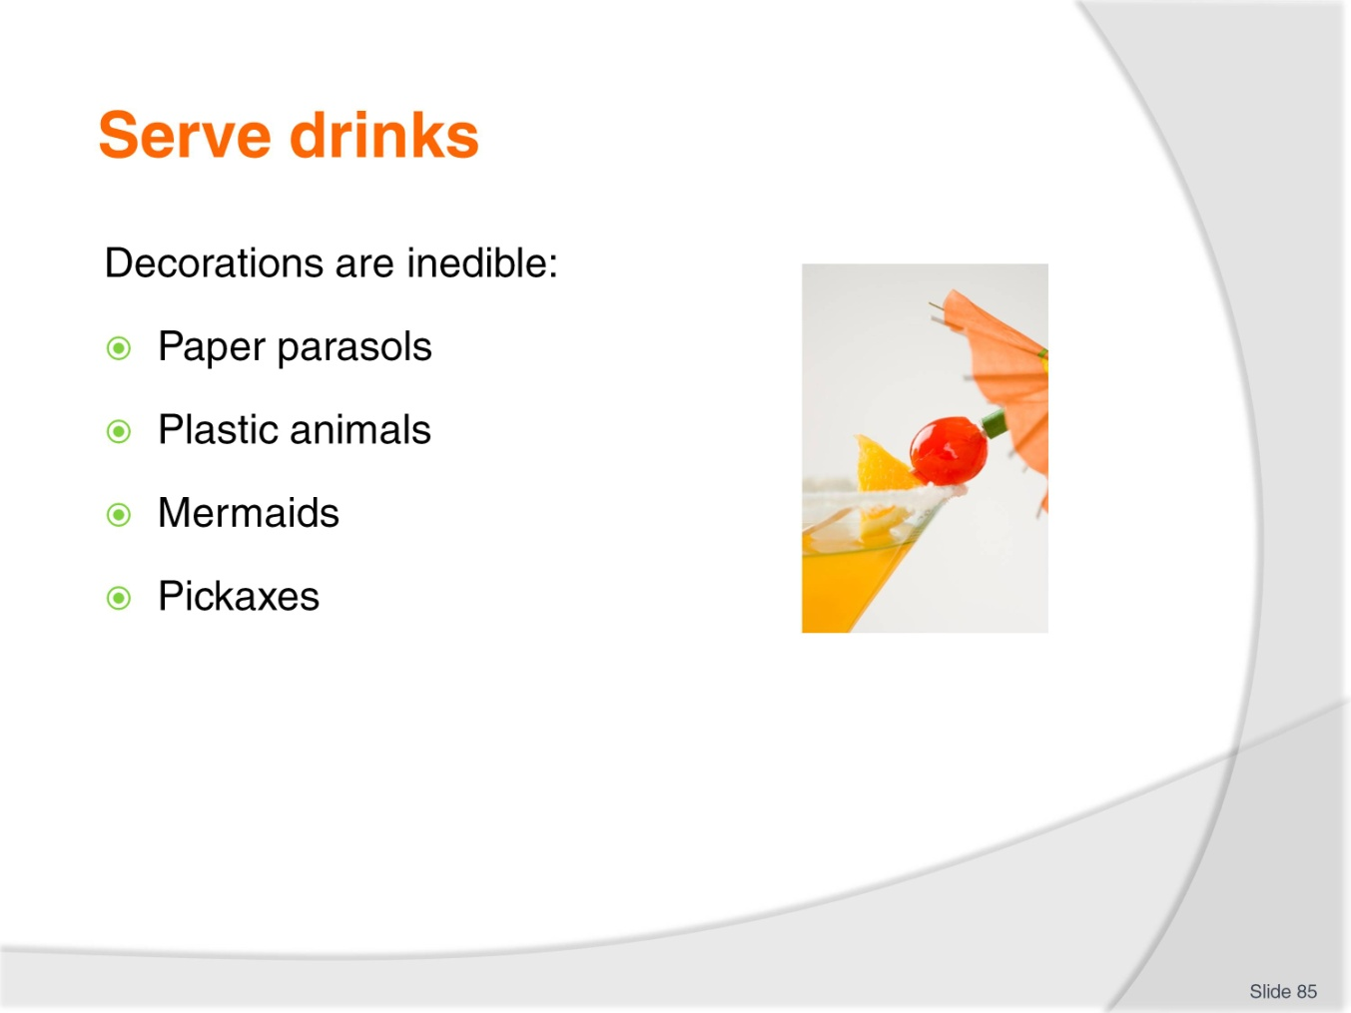
Slide No | Trainer Notes
Trainer explains garnishes are food-based as opposed to decorations which are made from paper, wood and/or plastic. Decorations are commercially prepared and cost money plus, as they are not food-based they are inedible and include:
Paper parasols – stuck into a wedge of fruit
Plastic animals – hung off the side of the glass: monkey, giraffe, dolphin, elephant
Mermaids – also hung from side of glass
Pickaxes – can be used to hang cherries on to side of glass.
The above are all commonly used with cocktails but have a role to play decorating non-alcoholic beverages too.
Class Activity 1 – Online Research
Trainer visits and discusses contents of following site of decorations available:
http://www.thepartypeople.com.au/party-supplies-cat/5582/cocktail-accessories.
Class Activity 2 – Demonstration
Trainer demonstrates how to use decorations when decorating non-alcoholic drinks.

Slide
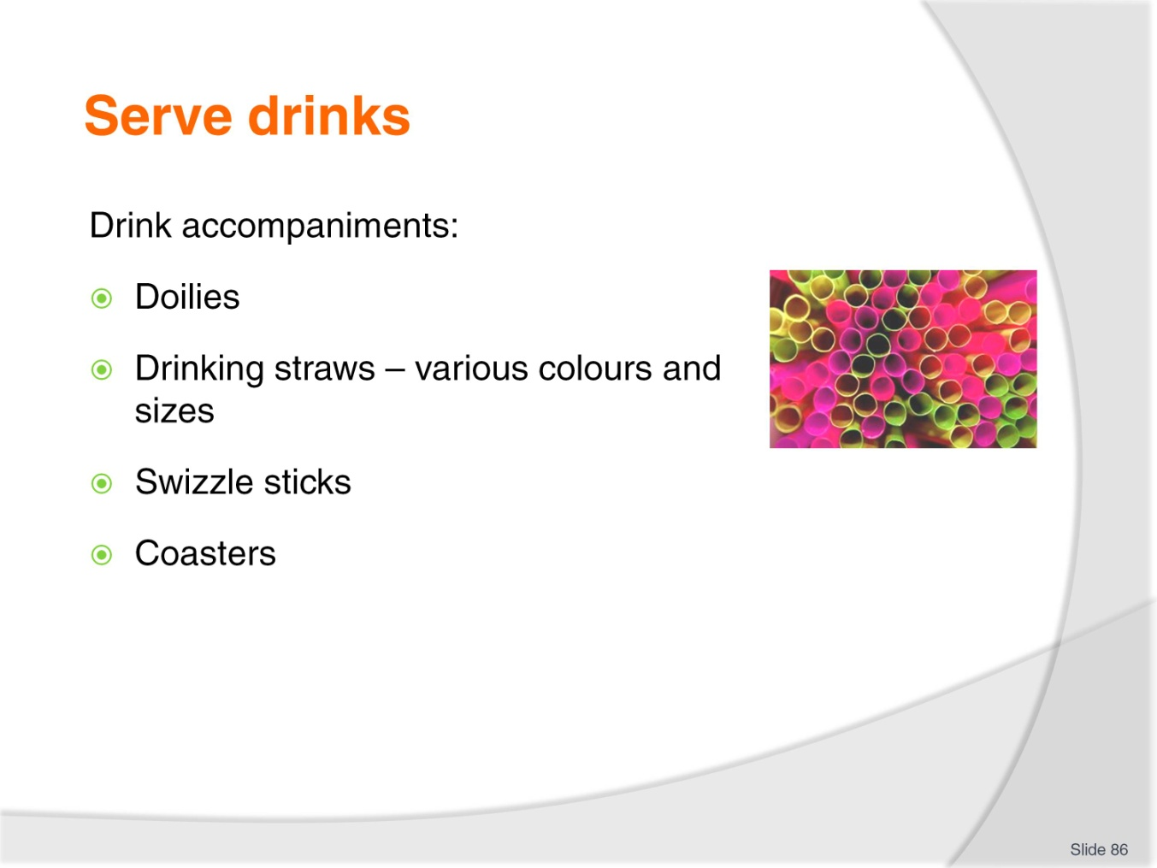
Slide No | Trainer Notes
Trainer introduces drink accompaniments stating traditional drink accompaniments used include:
Doilies – sometimes placed under drinks to enhance presentation
Drinking straws – usually placed into the drink but may be served in single-serve packaging. Make sure straws are the correct size for the glass. Flexible long straws are commonly used in tall glasses, and other alternatives include normal full-length straws, and half-straws
Swizzle sticks – placed into a drink for the customer to stir the drink if they choose
Coaster – placed under the drink to provide a resting place for the glass.
Class Activity – Product Samples
Trainer provides examples of accompaniments as identified on slide.

Slide
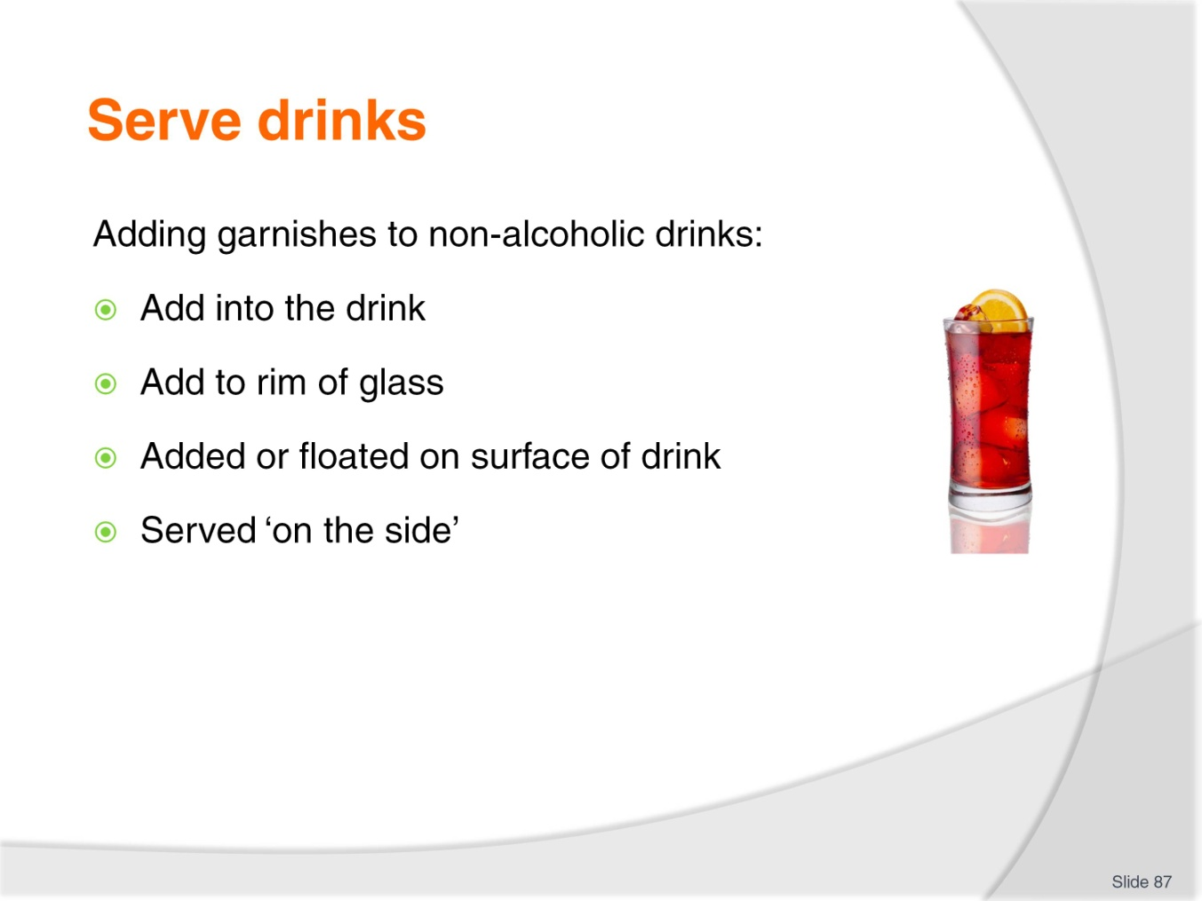
Slide No | Trainer Notes
Trainer states house recipes should guide the use of garnishes explaining they may be served:
In the drink – slices of orange and lemon can be placed directly into the drink: make sure to use tongs to handle the fruit
On the side of the glass using a cut in the slice to enable the slice to be fitted to the rim of the glass
On top of the drink – dusting powders and whipped cream are added on top of the finished beverage
Served on the side – on a plate (perhaps with a doily/napkin), or on the saucer the glass is served on.
Class Activity – Demonstration
Trainer demonstrates how to add garnishes to non-alcoholic drinks.

Slide
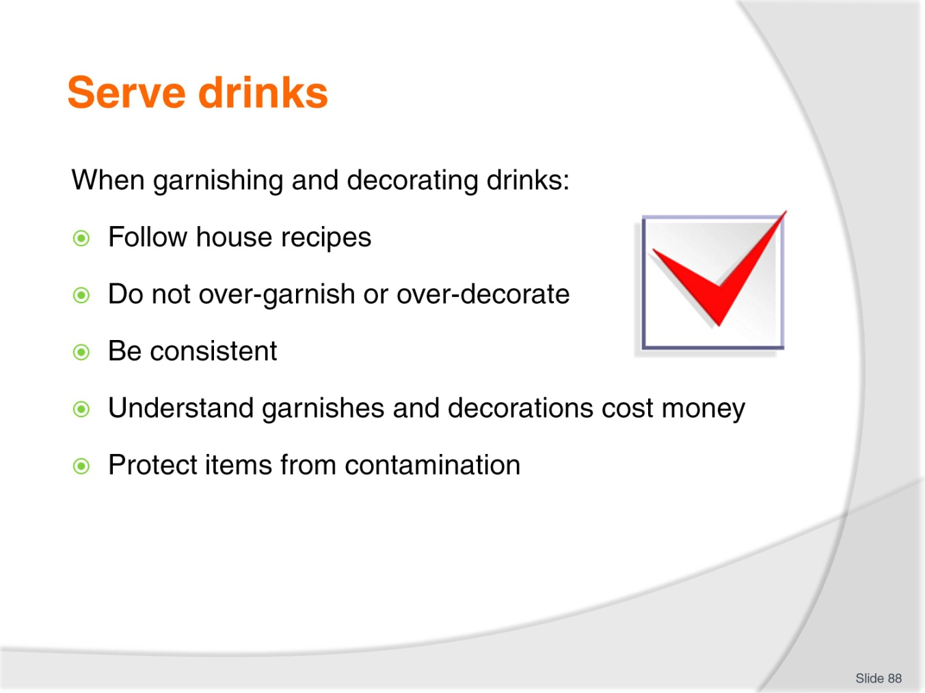
Slide No | Trainer Notes
Trainer presents points to note when garnishing and decorating drinks:
Follow house recipes
Use only the amount of garnish and decoration stipulated. Do not over-garnish or over-decorate
Strive for consistency – all drinks of the same type should be garnished and decorated to look the same
Realise garnishes and decorations cost money
Protect garnishes and decorations from contamination.

Slide
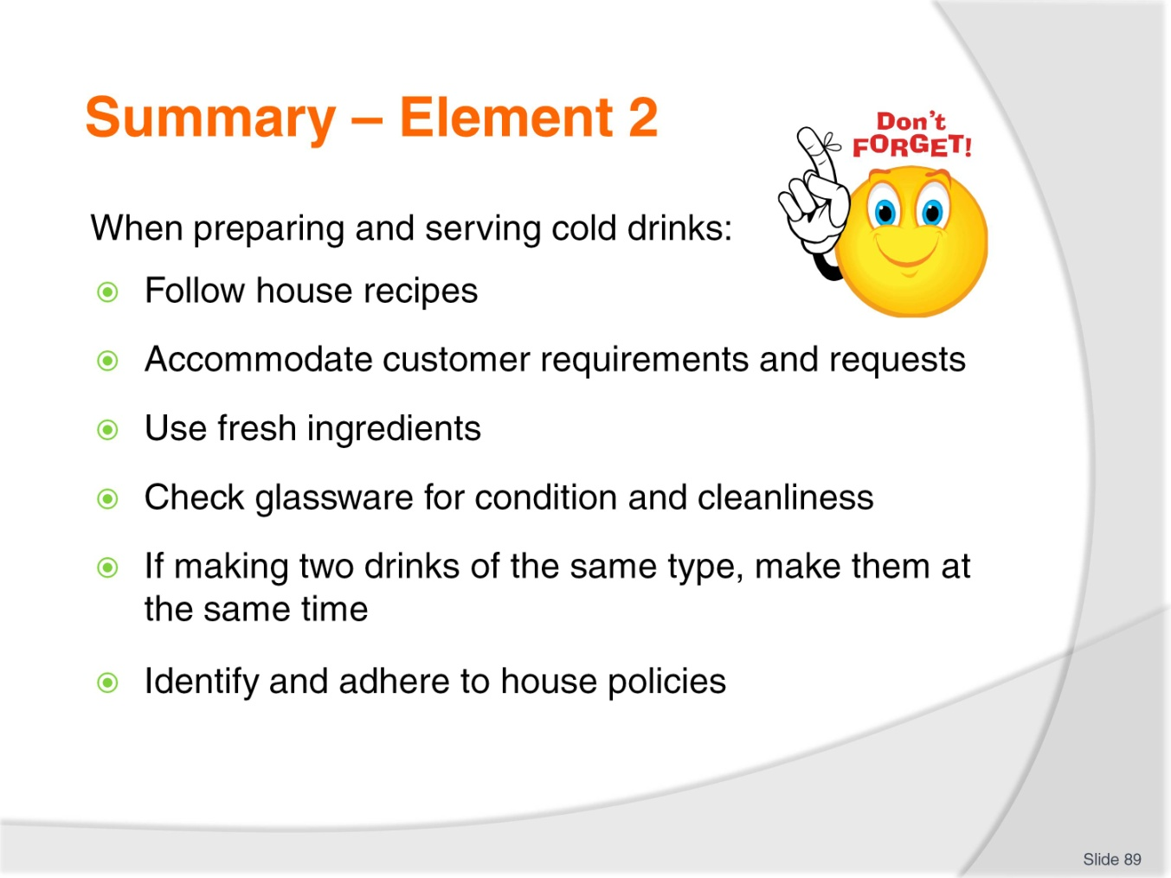
Slide No | Trainer Notes
 | Trainer provides a recap of the Element asking questions to check trainee understanding and responding to questions from trainees, as required.

Slide
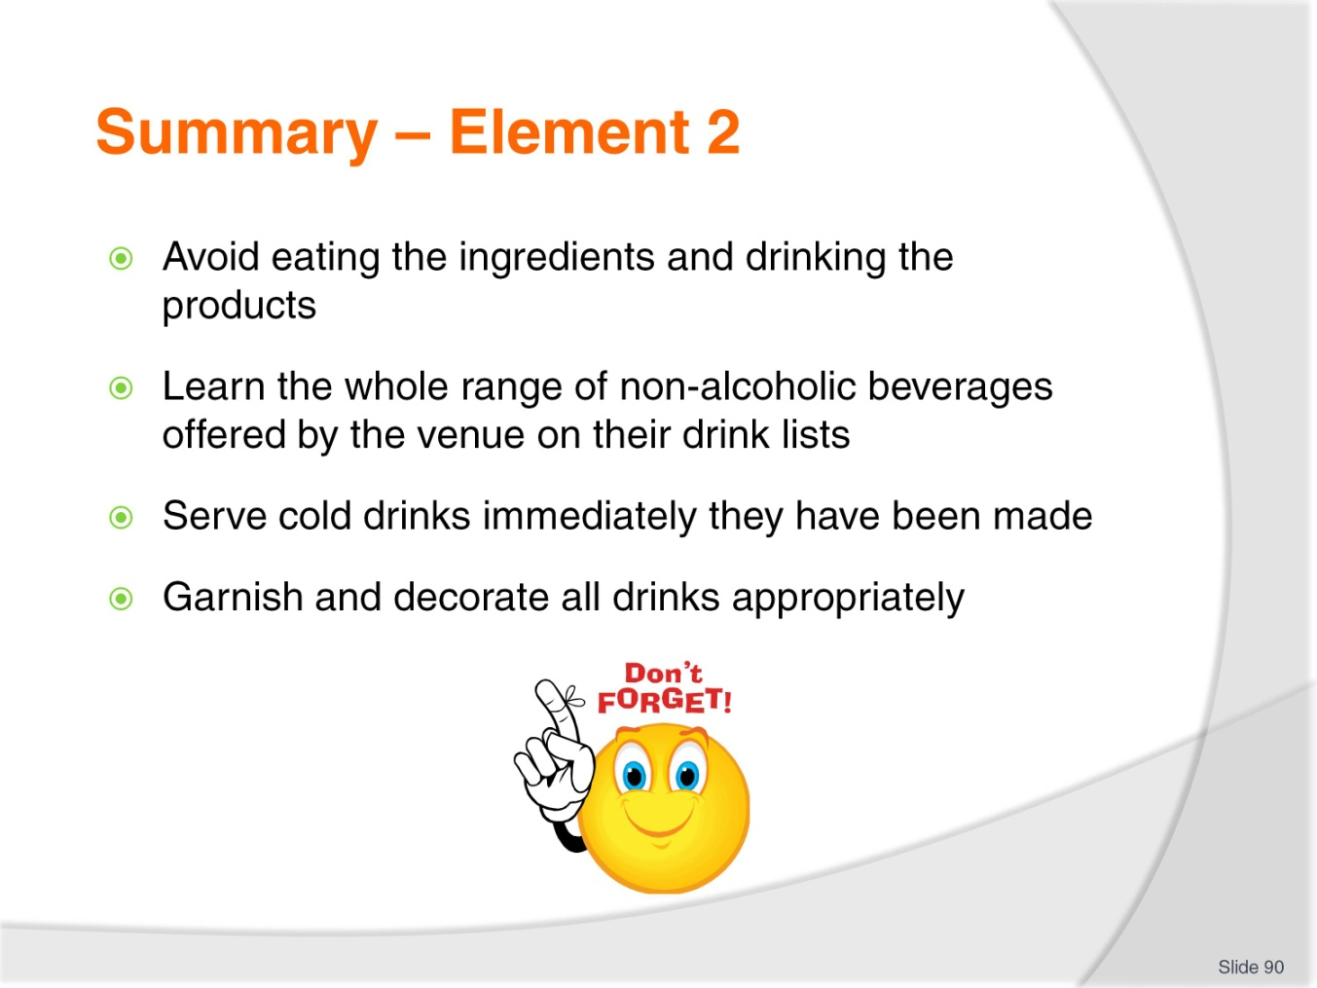
Slide No | Trainer Notes
 | Trainer provides a recap of the Element asking questions to check trainee understanding and responding to questions from trainees, as required.

Slide
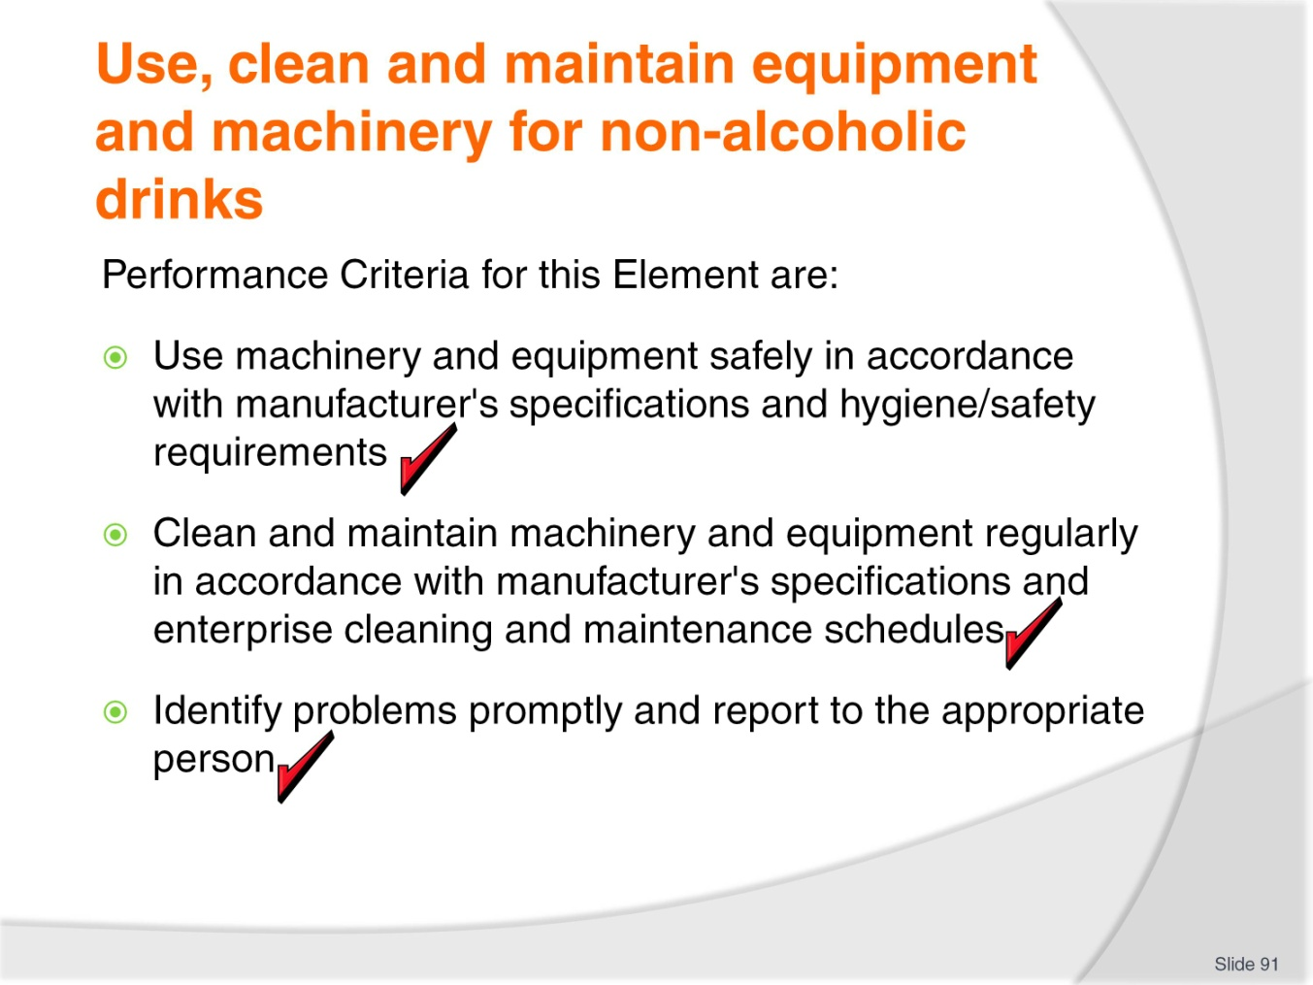
Slide No | Trainer Notes
Trainer identifies for trainees the Performance Criteria for this Element, as listed on the slide.
Class Activity – Discussion
Trainer asks trainees questions about using, cleaning and maintaining equipment and machinery by asking questions such as:
What do you think are the important points to consider when cleaning drink making equipment and machinery?
What do you think are the important points to consider when maintaining drink making equipment and machinery?
What items need to be cleaned and maintained?
Whose job might it be to clean and maintain such equipment and machinery?
Why is it important to keep this equipment and machinery clean?

Slide
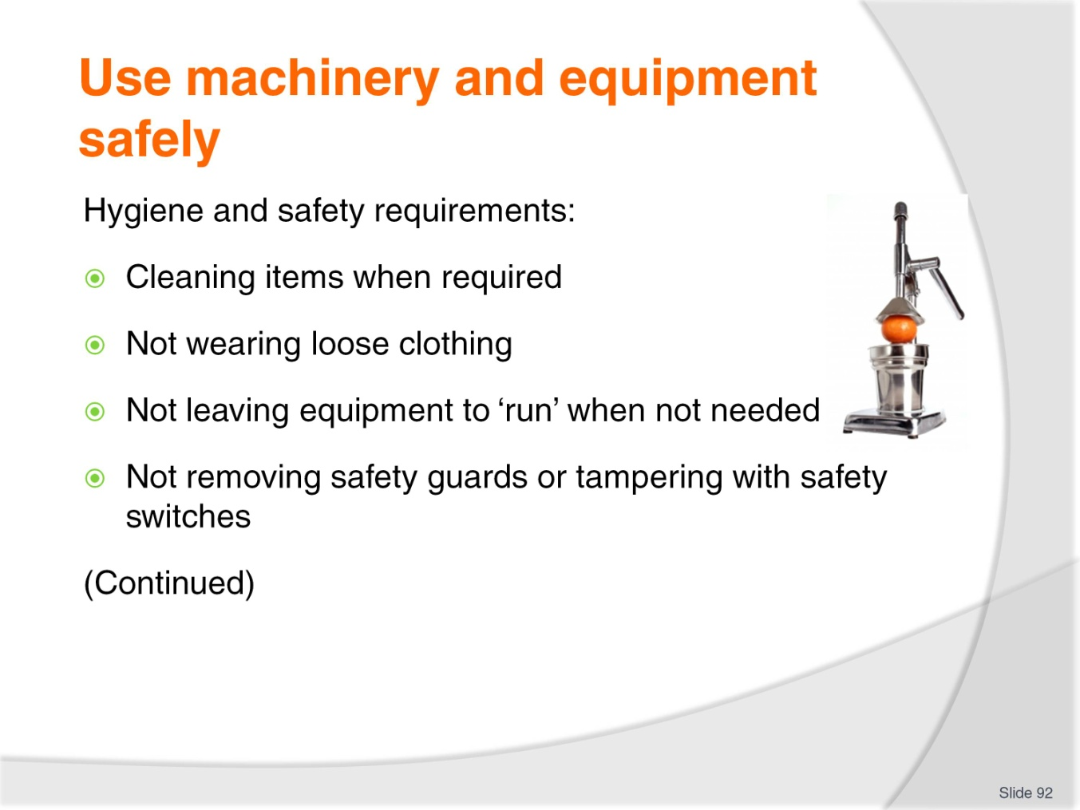
Slide No | Trainer Notes
Trainer highlights need to comply with hygiene and safety requirements when working explaining that these may include:
Thoroughly cleaning the equipment after each shift using the appropriate detergent and clean cloths as specified in house Food Safety Plans and/or cleaning schedules. Individual items used to produce drinks (such as blenders, milk shake machines) must be cleaned after every use
Not wearing loose clothing around the equipment – loose clothing can get into or on equipment and cause accident or injury
Wearing appropriate footwear around the equipment – shoes should be non-slip and other house requirements may also apply (such as steel-capped footwear)
Switching the equipment on and off at the appropriate times as opposed to leaving it running all the time
Never removing or modifying safety guards or safety switches fitted to equipment and machinery.

Slide
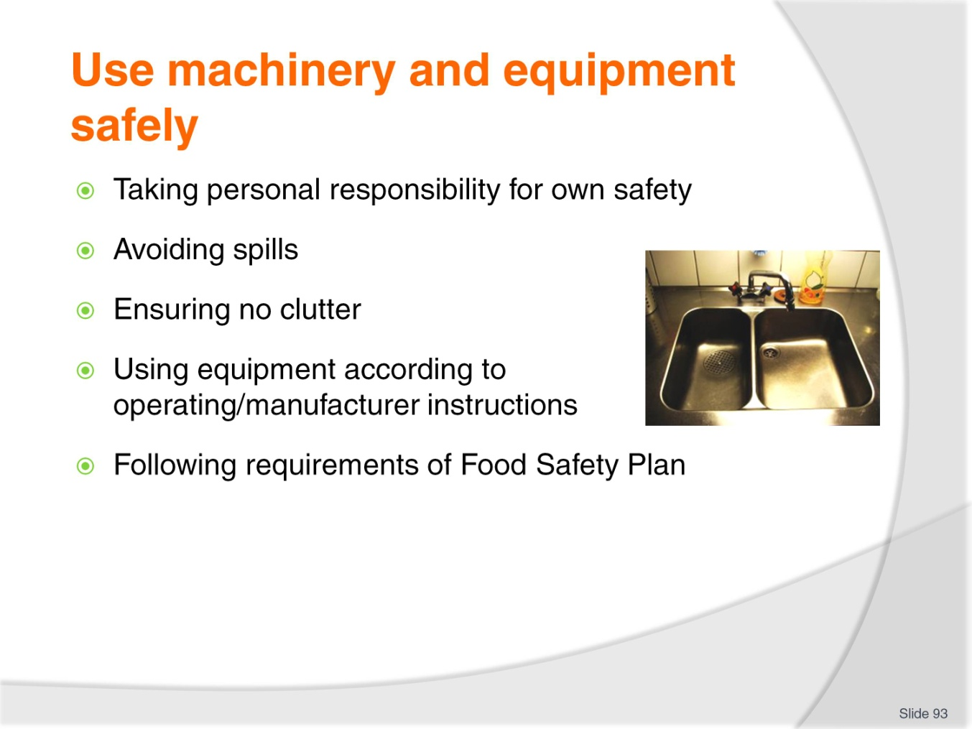
Slide No | Trainer Notes
Trainer continues discussing hygiene and safety requirements when working:
Taking responsibility for personal health and safety such as being careful not to scald, burn or otherwise injure yourself. You are under an obligation to work safely when at work
Trying not to spill liquid or foods on the floor and if it spilled making sure it is immediately cleaned up
Ensuring the area around the equipment is free from clutter. Clutter interferes with effective work performance and has proven to be a contributing factor in many accidents and in many spillages
Making sure all machinery and equipment is operated in accordance with the appropriate instruction manual
Following the requirements of any internal Food Safety Plan for the cleaning and maintenance of all items and areas in the preparation and service of beverages.

Slide
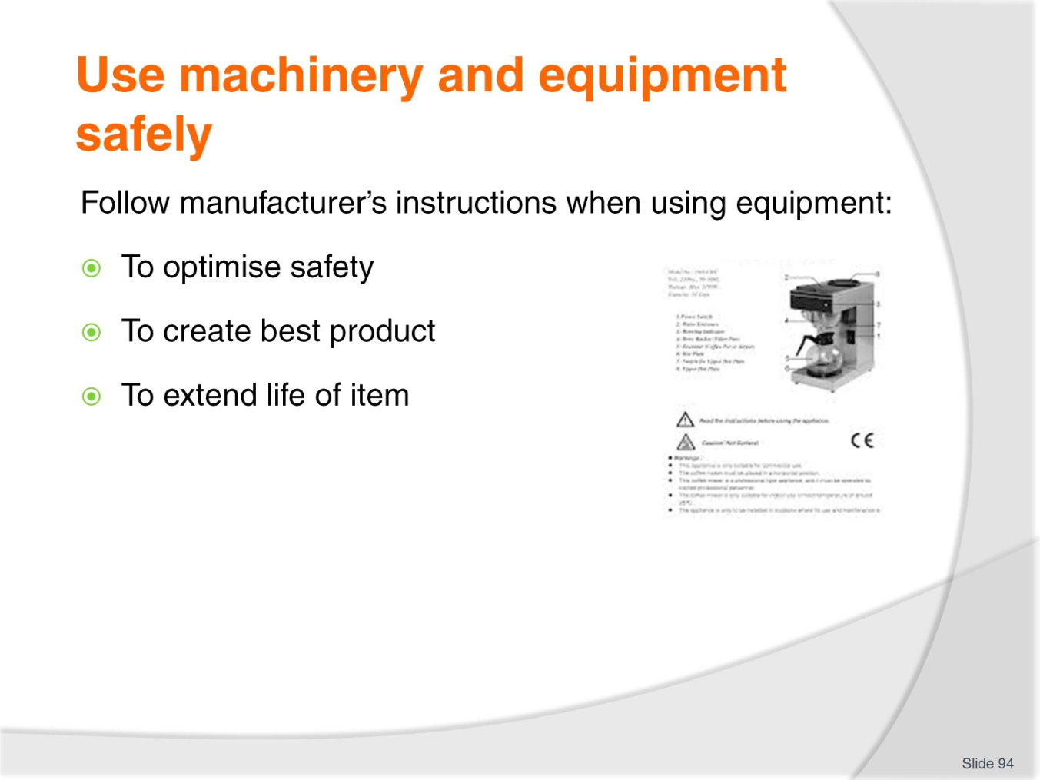
Slide No | Trainer Notes
Trainer stresses need to follow manufacturer’s instructions when using equipment explaining that there is a need to follow manufacturer’s instructions when using equipment because this will:
Optimise safety
Produce the best product
Extend the working life of the item.
Class Activity – Handouts/Online research
Trainer facilitates viewing of sample operations instructions by:
Distributing and discussing hard copies of manufacturer’s operating instructions
Viewing online examples such as those at:
- http://www.lovecoffeemachines.co.uk/downloads/cma_lisa_manual.pdf
- http://www.taylor-company.com/service/resources/op_man/0060op0.pdf.

Slide
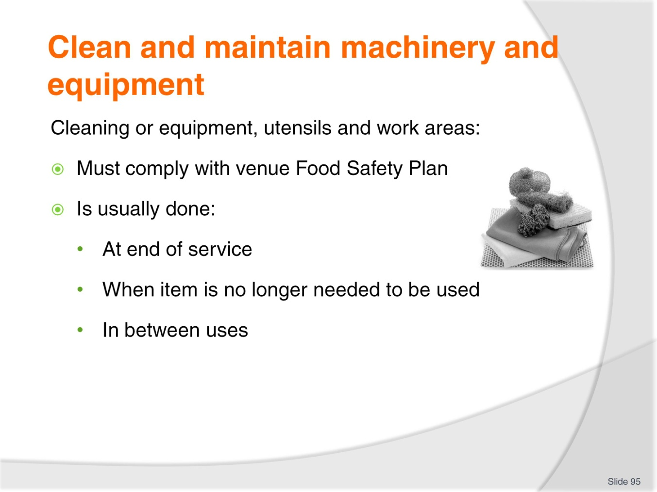
Slide No | Trainer Notes
Trainer explains all cleaning of equipment, utensils and work areas must comply with venue Food Safety Plan and that cleaning is usually done:
At the end of service as part of closing procedures
Once the item is no longer required for service such as when item has been used to produce a volume of product and will not be needed again until tomorrow
In between uses to prevent flavour (and colour) transfer.

Slide
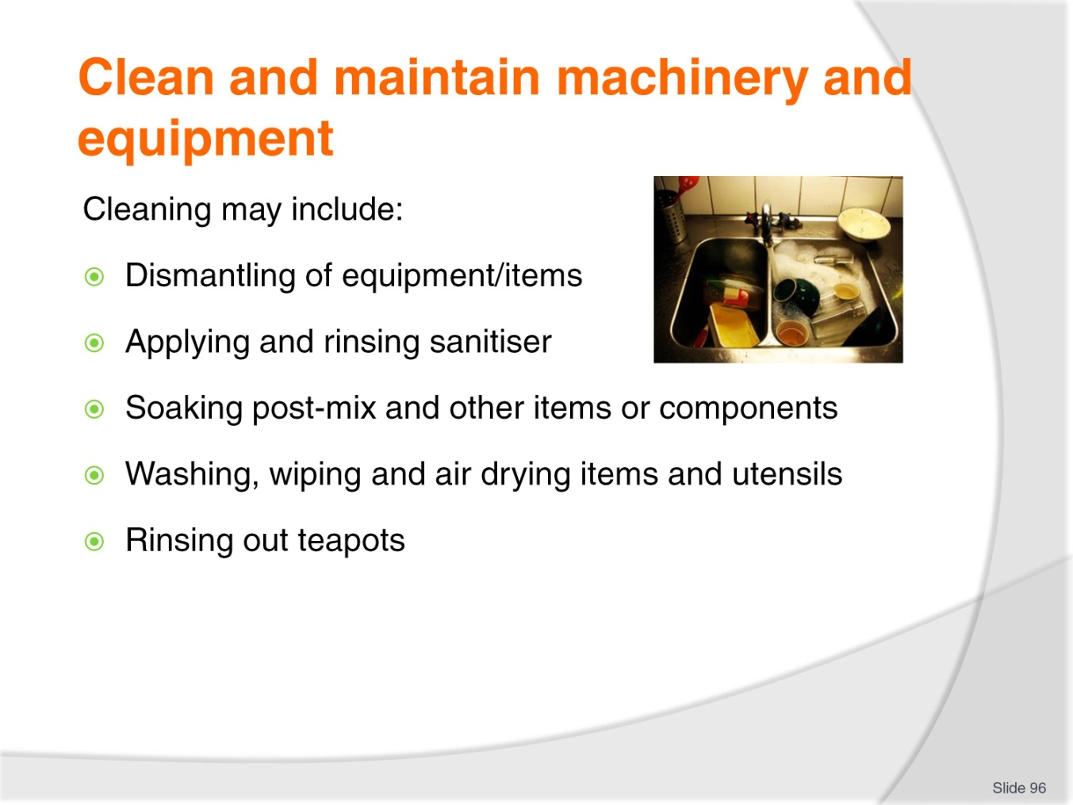
Slide No | Trainer Notes
Trainer identifies practices potentially involved in cleaning:
Dismantling and cleaning relevant equipment with hot soapy water and a clean cloth. Check first to ensure this cleaning method is in-keeping with manufacturer’s instructions
Applying and rinsing off a sanitiser
Soaking post-mix dispensers in soda water overnight as well as wiping parts with a warm cloth to remove sticky syrup
Washing and drying all plunger coffee jugs, steel holders and plungers
Cleaning and wiping down the dripolator machine and Cona jugs
Rinsing out and/or washing teapots
Removing and cleaning the dispensing nozzles and the gun for post-mix, including cleaning the gun holder regularly, because grime and slime can build up in it too. Clean gun holder with a brush and hot soapy water.
Class Activity – Demonstration
Trainer:
Cleaning activities
Provides opportunity for students to practice cleaning.

Slide
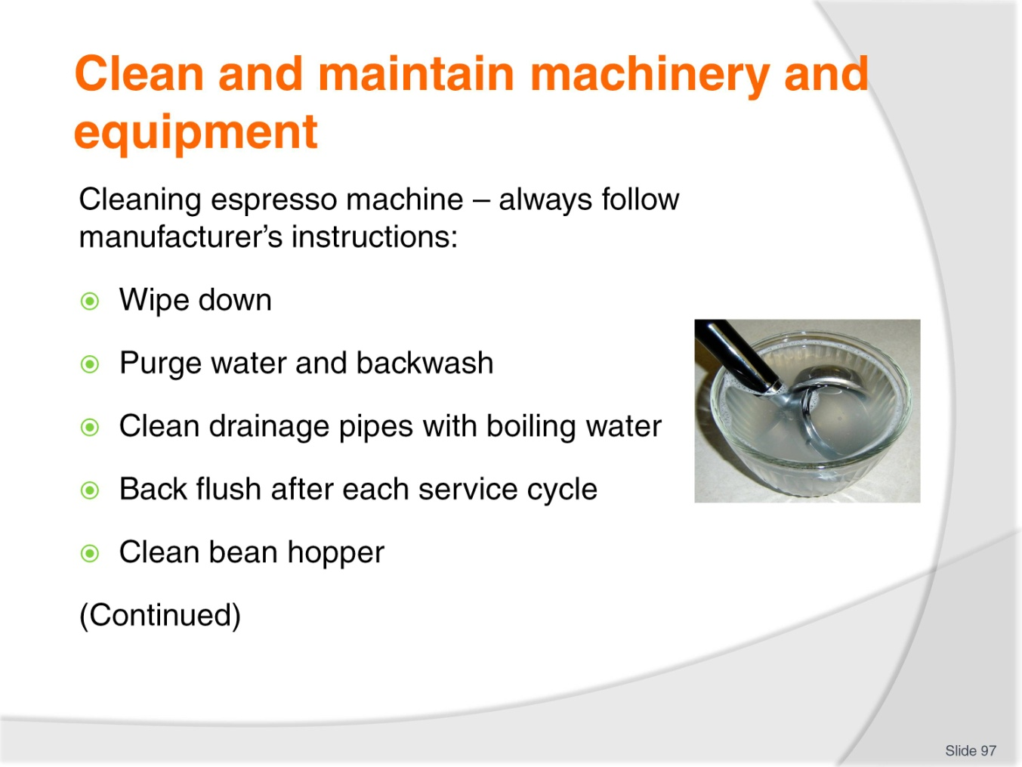
Slide No | Trainer Notes
Trainer describes cleaning for espresso machine highlighting need to follow instructions as appropriate to the machine being used:
Wiping down entire machine to ensure cleanliness and good appearance
Purging reservoir of hot water, releasing steam and backwashing the machine with an appropriate cleaning solution
Pouring boiling water to clean drainage pipes of equipment
Back flushing the machine at the end of a service cycle, using clean water to ensure no chemical or other residues are left
Cleaning the bean hopper using wet method and drying thoroughly before refilling and storing:
- Wet techniques – using warm water with detergent for soaking various parts and cleaning with a sponge, cloth or scourer (for group handle only)
- Dry techniques – using a damp cloth followed by a dry cloth.
Class Activity – Demonstration
Trainer demonstrates cleaning practices as identified on slide.

Slide
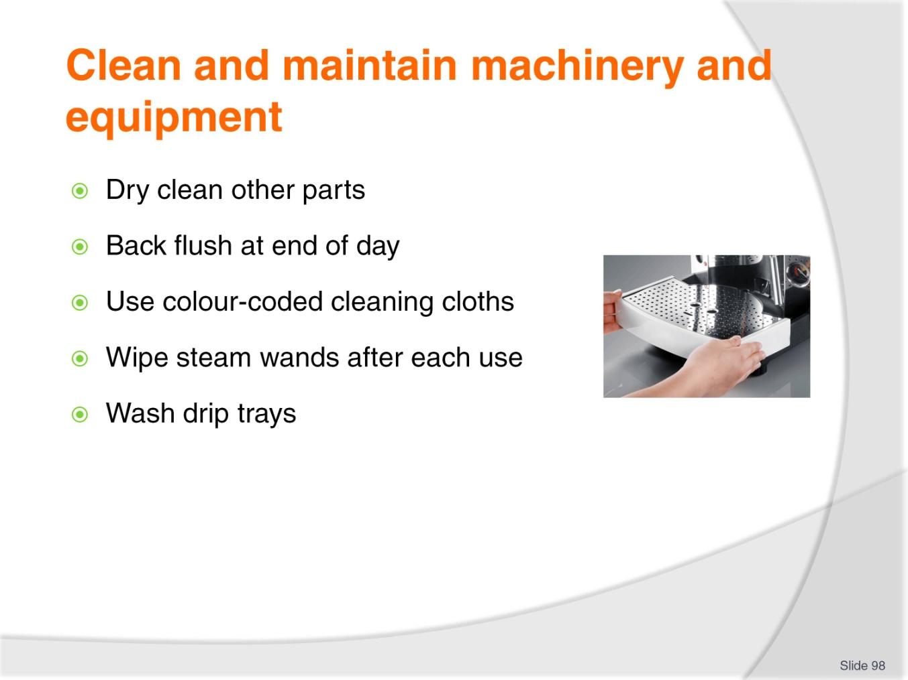
Slide No | Trainer Notes
Trainer continues describing cleaning of espresso machine:
Cleaning all remaining parts using dry cleaning method
Back flushing group heads according to recommended industry methods at end of day, using a blank filter and appropriate machine detergent
Using colour-coded cloths for cleaning such as blue for general cleaning and yellow for cleaning steam wands
Wiping steamer wands after each use to remove milk residue.
Class Activity – Demonstration
Trainer demonstrates cleaning practices as identified on slide.

Slide
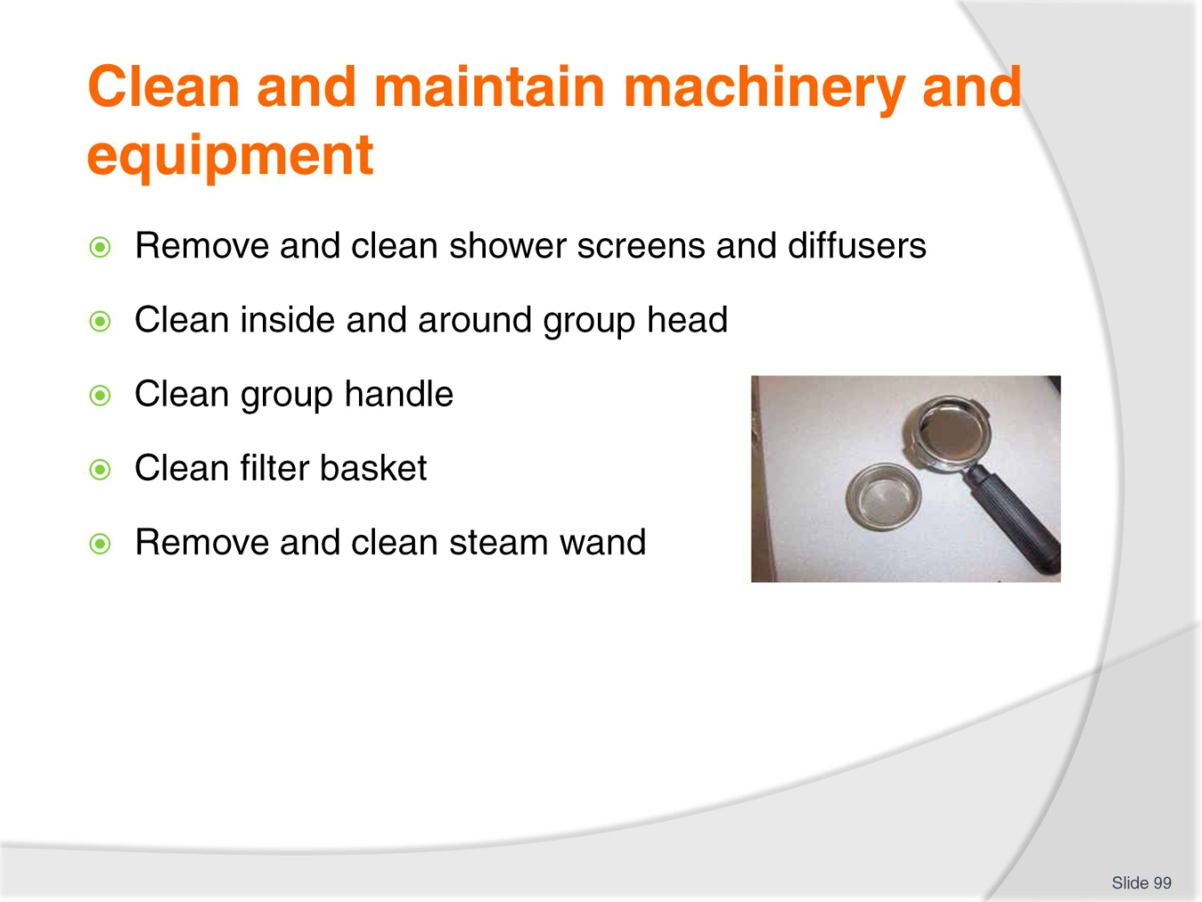
Slide No | Trainer Notes
Trainer continues describing cleaning of espresso machine:
Removing shower screens and diffusers if appropriate, cleaning using wet method and reassembling
Cleaning around the inside of the group head using an appropriate brush or cloth
Cleaning group handle and filter basket and steam arm spout after removing, using the wet method.
Class Activity – Demonstration
Trainer demonstrates cleaning practices as identified on slide.

Slide
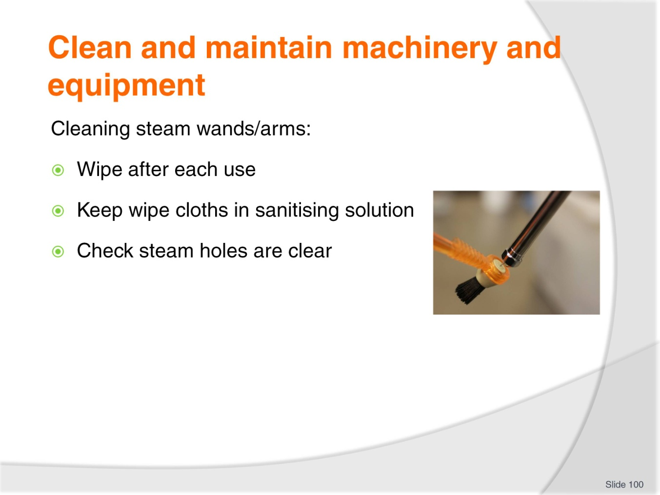
Slide No | Trainer Notes
Trainer presents daily/weekly cleaning for espresso machine:
Steam arms
Wipe down after foaming milk – after every use
Keep cloths in a soaking solution of mild bleach or sanitiser
Check steam holes are clear – use a paper clip to clear if necessary.
Class Activity – Demonstration
Trainer demonstrates cleaning as identified on slide.

Slide
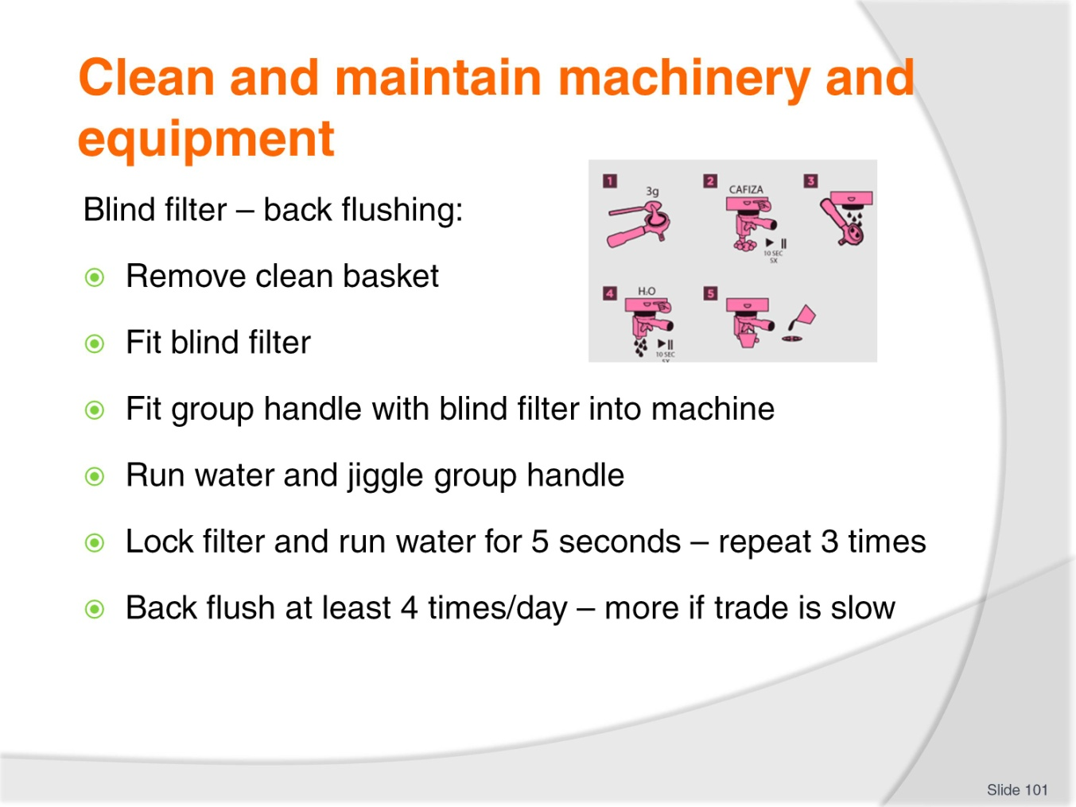
Slide No | Trainer Notes
Trainer continues to explain daily/weekly cleaning for espresso machine:
Blind filter – Back flushing
Take out filter basket and clean out using scouring pad
Fit blind filter
Loosely fit the group handle into the group and run water. Gently jiggle it left and right to dislodge coffee grounds until water runs clear
Lock in the filter holder and run water for five seconds. Turn water off and repeat three times
This should be done at least 4 times a day and at the end of the day. Back flush more when the machine is underutilised.
Class Activity – Demonstration
Trainer demonstrates cleaning as identified on slide.

Slide
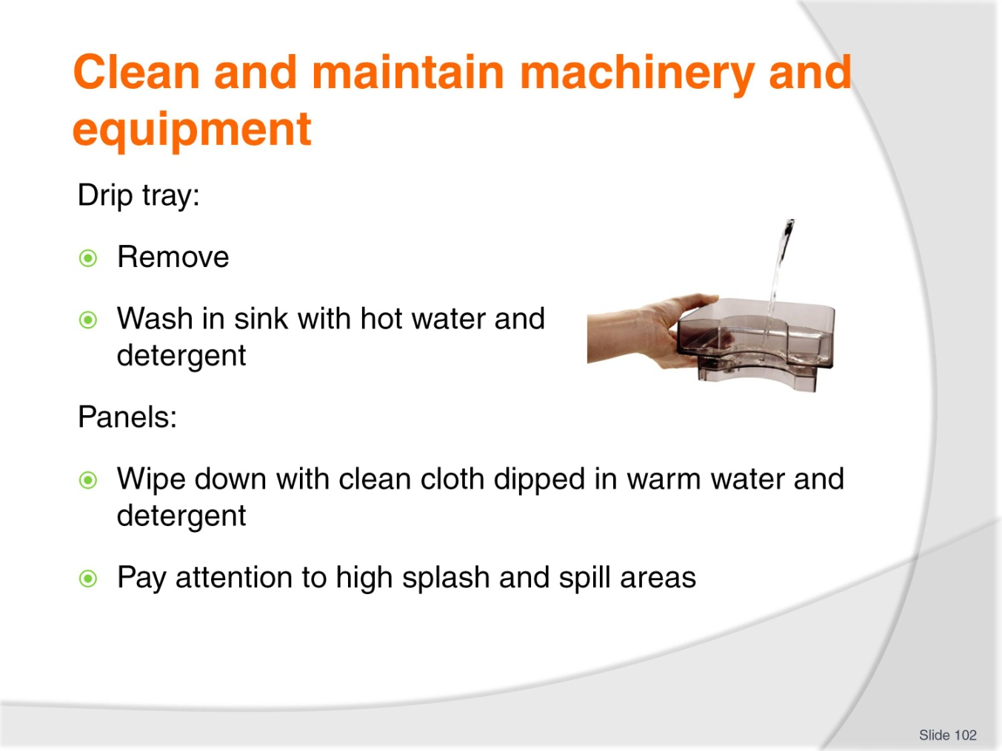
Slide No | Trainer Notes
Trainer continues to explain daily/weekly cleaning for espresso machine:
Drip tray
Remove the drip tray and wash with hot water and detergent
Follow requirements of the FSP.
Panels
Wipe down with a clean cloth soaked in warm water and detergent
Pay attention to the areas where milk is likely to have been splashed.
Class Activity – Demonstration
Trainer demonstrates cleaning as identified on slide.

Slide
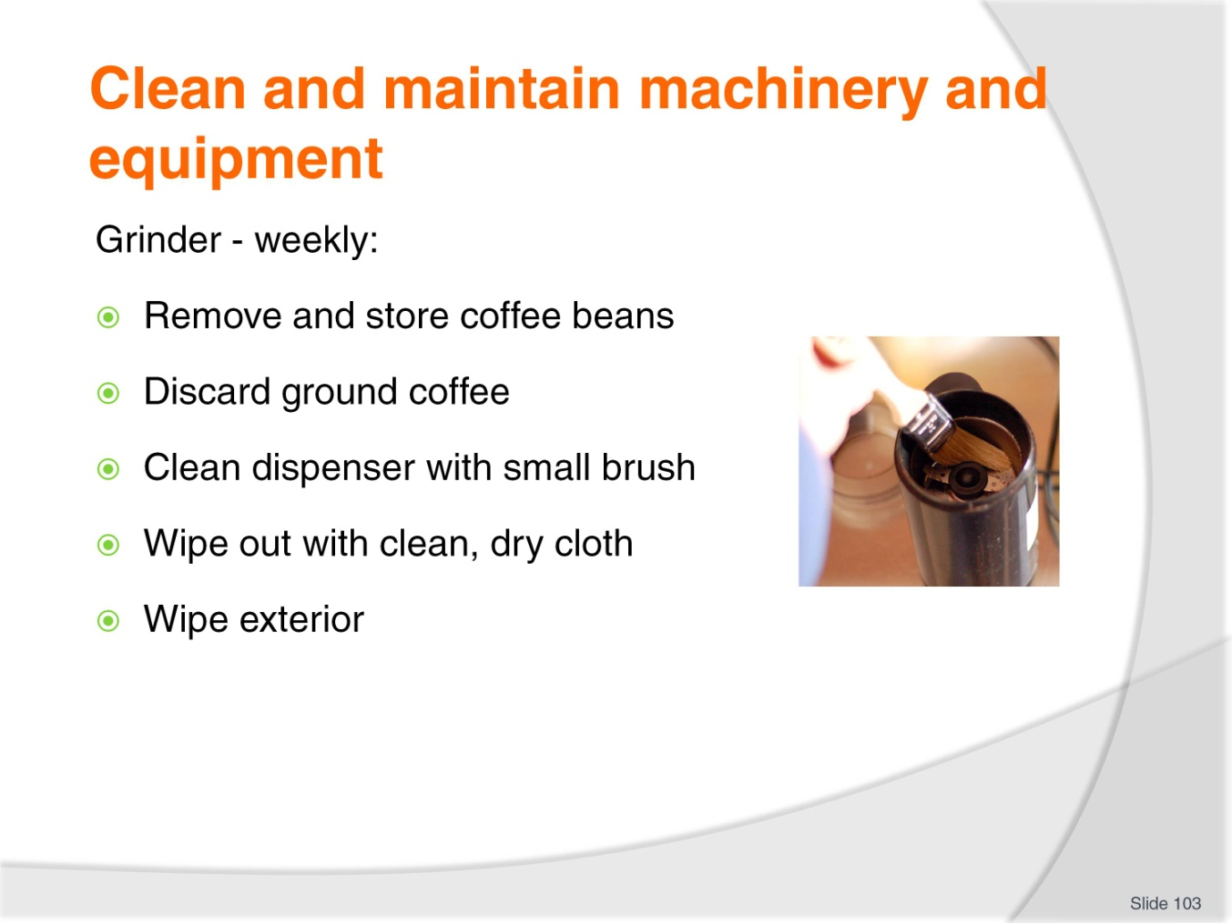
Slide No | Trainer Notes
Trainer continues to explain daily/weekly cleaning for espresso machine:
Grinder
Empty beans out of hopper at the end of the day and store in an airtight container in dark place but not in refrigerator
Wash hopper at least weekly in mild detergent and very hot water – do not put through the dishwasher: dry fully
Remove ground coffee from the dispenser and brush out with a small brush and wipe out with clean dry cloth. Removed coffee can be used for start-up the next day. Never use this coffee for customers as it is completely stale 24 hours after grinding
Wipe down exterior of the grinder.
Class Activity – Demonstration
Trainer demonstrates cleaning as identified on slide.

Slide
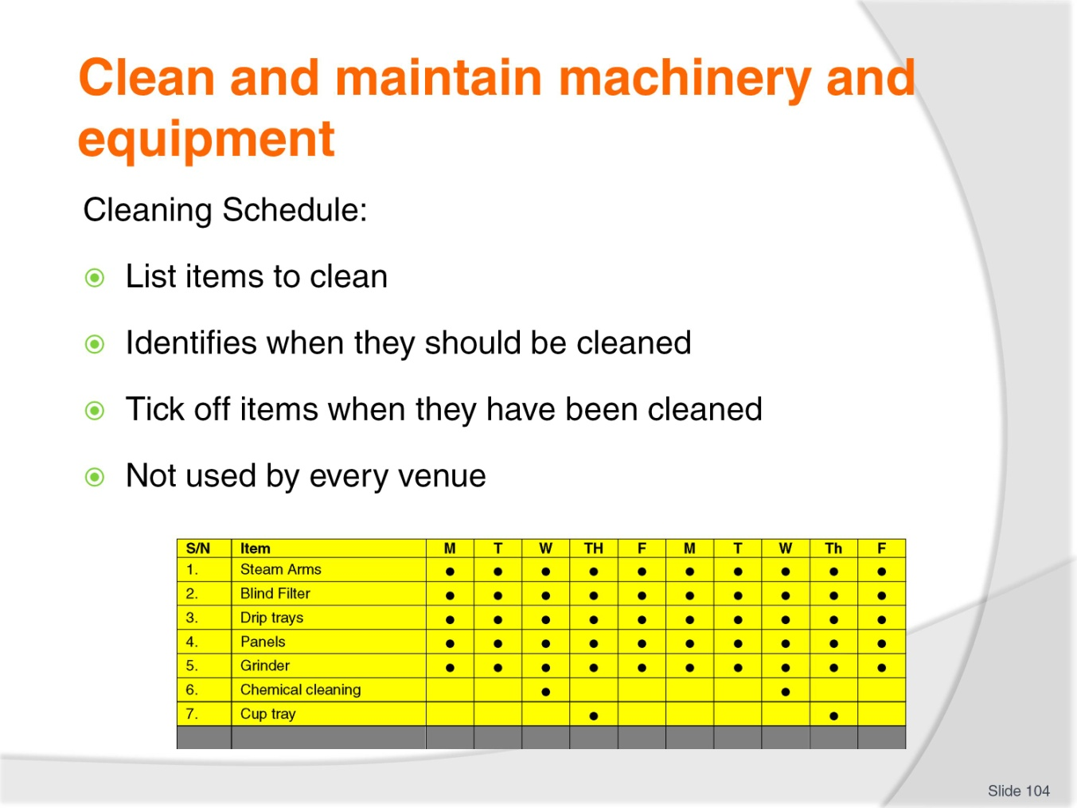
Slide No | Trainer Notes
Trainer identifies for students that cleaning should comply with ‘Cleaning Schedule’ explaining they:
List every item in the bar/service area to be cleaned
Identify the frequency with which items listed must be cleaned – some are daily and some are not
Need to be completed (signed off and/or ticked off) when items have been cleaned
Are not used by every venue but they are a good idea as they assist in ensuring all items are cleaned when they should be.
Class Activity 1 – Handout
Trainer distributes and discusses sample Cleaning Schedule.
Class Activity 2 – Online Videos
Trainer enables students to view and discuss videos on cleaning of espresso machines such as:
http://www.youtube.com/watch?v=ubtUlnntpjs
http://www.youtube.com/watch?v=pWyuMq5Ct8Y
http://www.youtube.com/watch?v=pefMLxN19K8
http://www.youtube.com/watch?v=ov8yoTpnpkY.

Slide
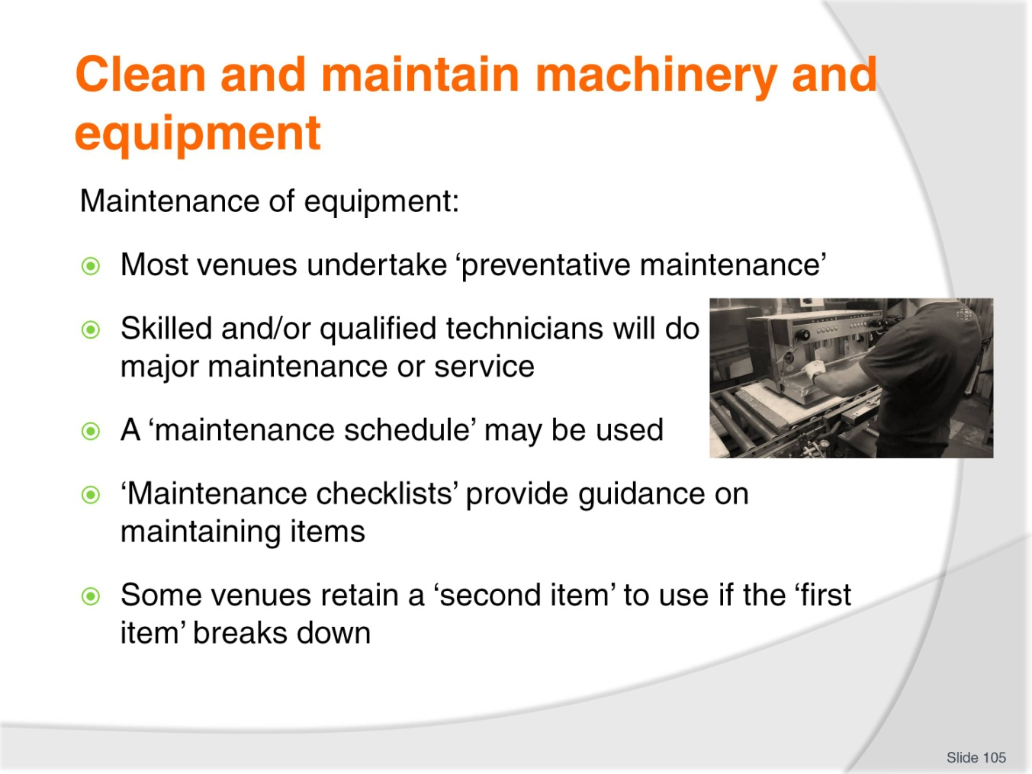
Slide No | Trainer Notes
Trainer introduces ‘maintenance of equipment’ stating:
All venues undertake ‘preventative maintenance’ in an effort to avoid breakdowns
You will only be required to undertake ‘basic maintenance’ tasks. Other maintenance will be done by qualified technicians
Some venues develop a ‘maintenance schedule’ to identify when maintenance needs to be provided to items listed on the schedule
Some venues use a ‘maintenance checklist’ to detail the exact nature of maintenance which needs to be provided to each item
Some venues retain a ‘second item’ to put into operation if a ‘first item’ breaks down.
Class Activity – Handouts
Trainer provides and discusses sample:
Maintenance schedule
Maintenance checklist.

Slide
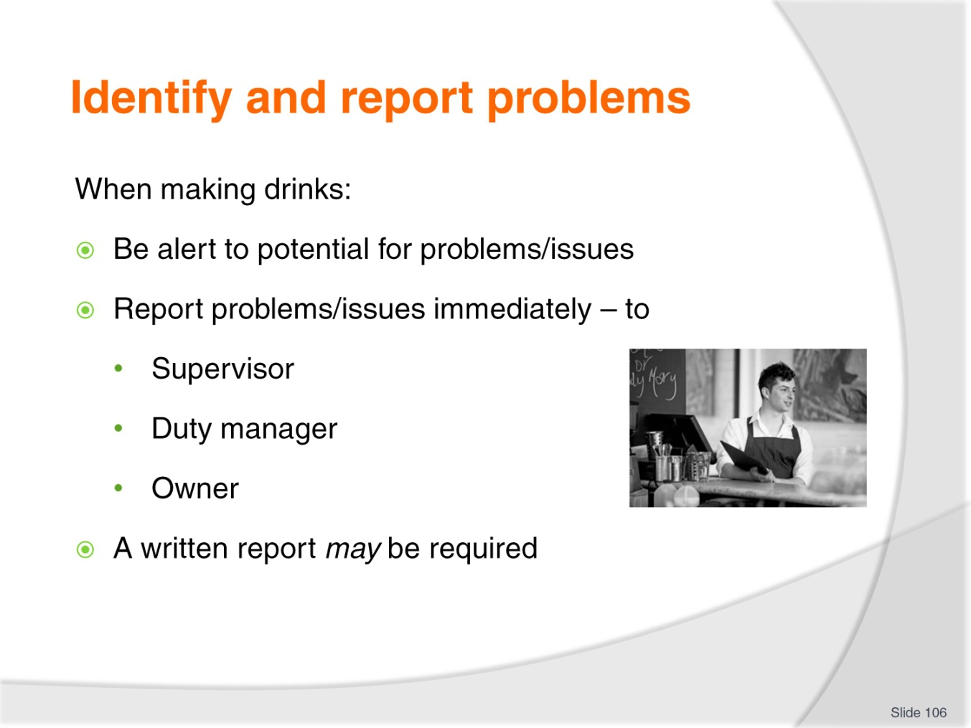
Slide No | Trainer Notes
Trainer states that as soon as students identify a problem when preparing and serving drinks they should report this matter to the ‘appropriate person’ so action can be taken to address the problem. This may be:
Your supervisor
Duty manager
Owner.
Check to see who the ‘appropriate person’ is where you work.
It is important that issues and problems are reported immediately so appropriate remedial action can be taken or arranged as soon as possible
A verbal report is usually sufficient but there may be a need to complete a form such as a Maintenance Request form.

Slide
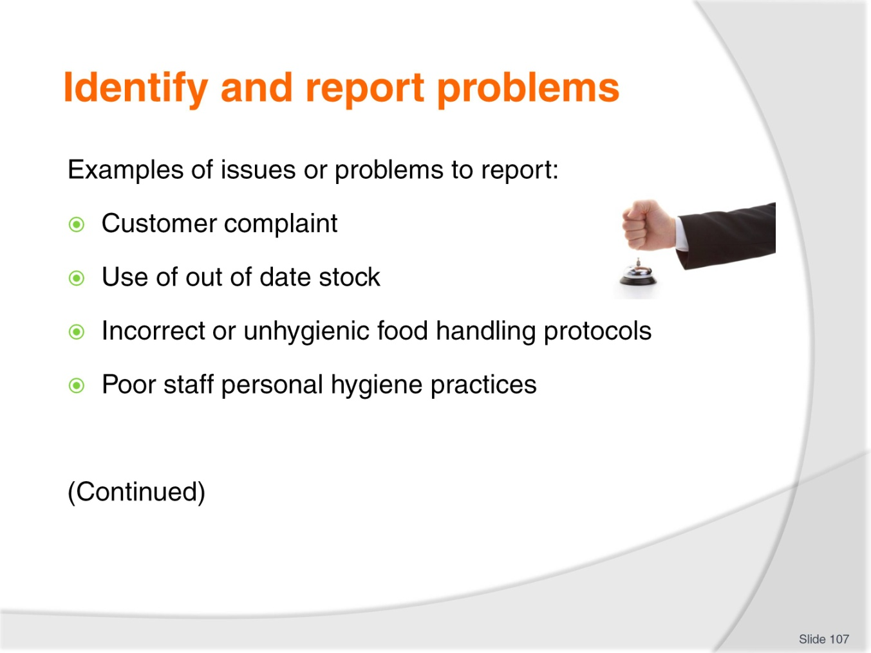
Slide No | Trainer Notes
Trainer provides examples of situations which need to be reported stressing the list is indicative and not all-inclusive:
Customer complaints – about anything: products served, other customers, comfort (noise, temperature)
Out of date stock is being used – stock rotation needs revising
Food not being handled, stored or processed in hygienic manner giving rise to possible food poisoning
Poor personal hygiene practices being used by staff.

Slide
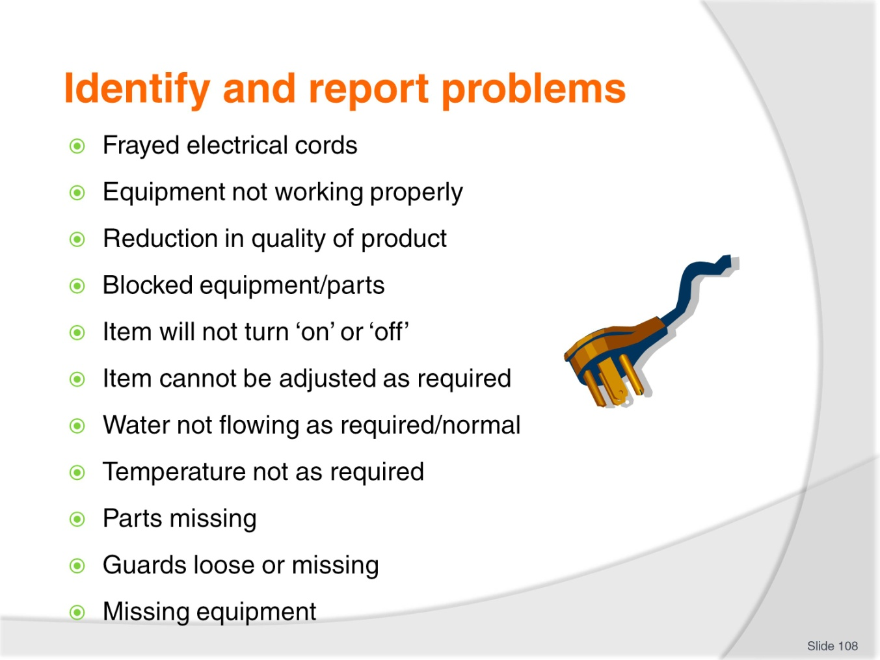
Slide No | Trainer Notes
Trainer continues to provide examples of situations which need to be reported:
Frayed electrical cords on equipment – a safety issue
Equipment not achieving or maintaining the required temperature/steam pressure
Quality of product has dropped. This is common in situations where there are problems associated with refrigerated and/or frozen storage, or where mechanical/electrical equipment is not processing ingredients as required
Equipment is blocked in some way due to over-use or improper regular cleaning
Item cannot be turned on or off
Item cannot be adjusted as required. Sometimes a piece of equipment will work but you may not be able to, for example, adjust speed, temperature or settings
Water not flowing into the machine
Temperature is not as required. This may include heating elements not heating up, or refrigeration units, freezers or ice cream machines (and similar) not achieving their required temperature for holding and/or processing drinks
Part of a machine is missing
Machine guards have loosened or fallen off
Missing equipment – the entire item has disappeared.

Slide
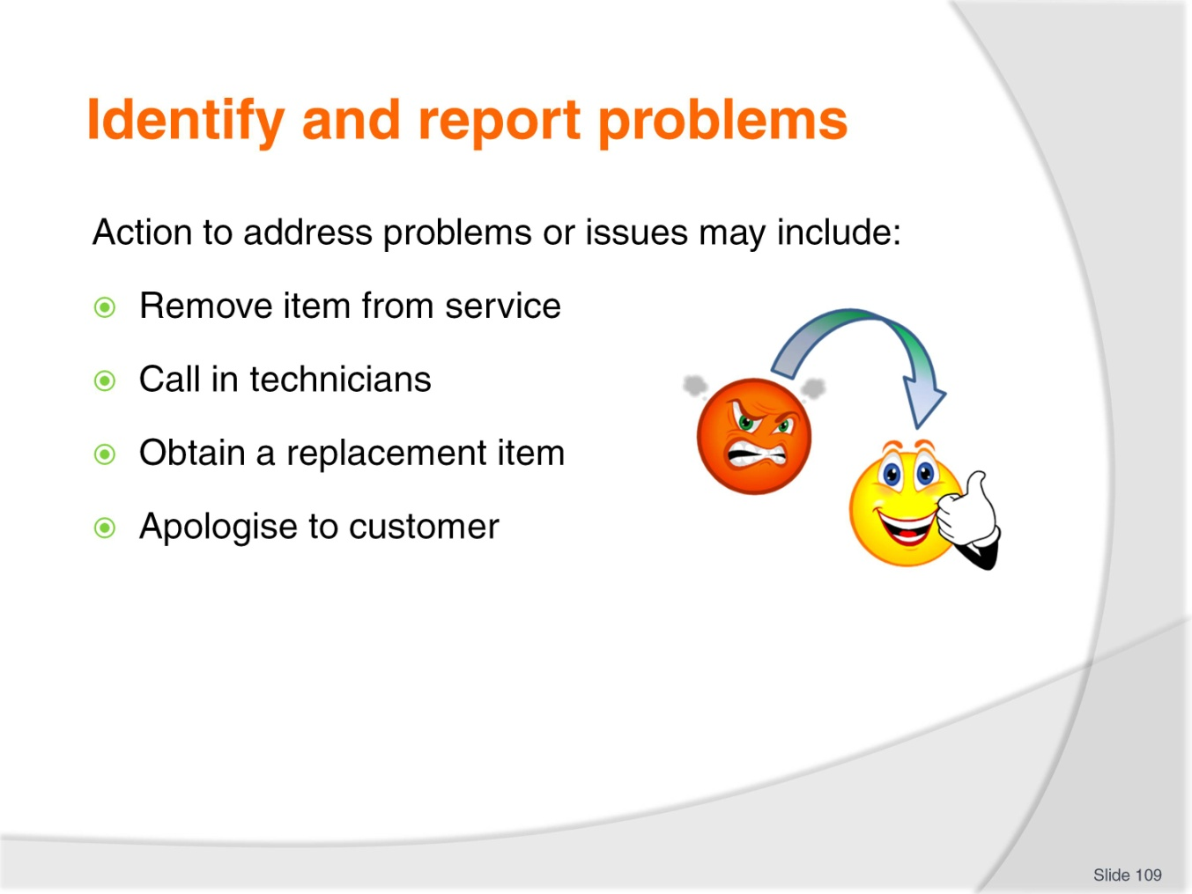
Slide No | Trainer Notes
Trainer states that, depending on the nature of the problem, the following action can be taken:
Removing the item from use where there is a health, hygiene or food related risk
Contacting service technicians to initiate a service call to fix the problem
Obtaining a replacement item for use in the immediate short-term
Acknowledging the item cannot be repaired and buying a new item
Apologise to customer/s where necessary – provision of a free product/drink may be appropriate.

Slide
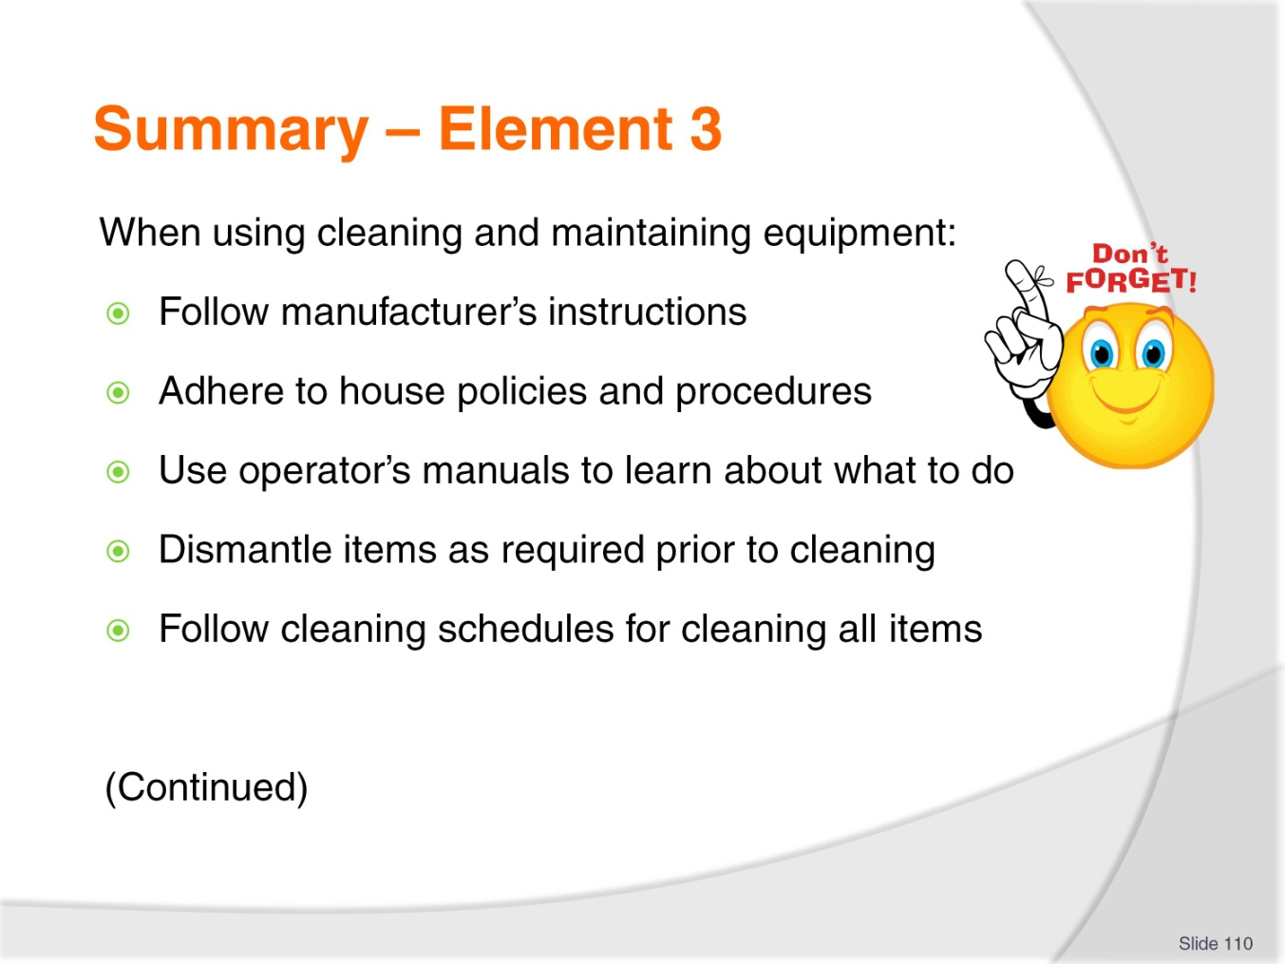
Slide No | Trainer Notes
 | Trainer provides a recap of the Element asking questions to check trainee understanding and responding to questions from trainees, as required.

Slide
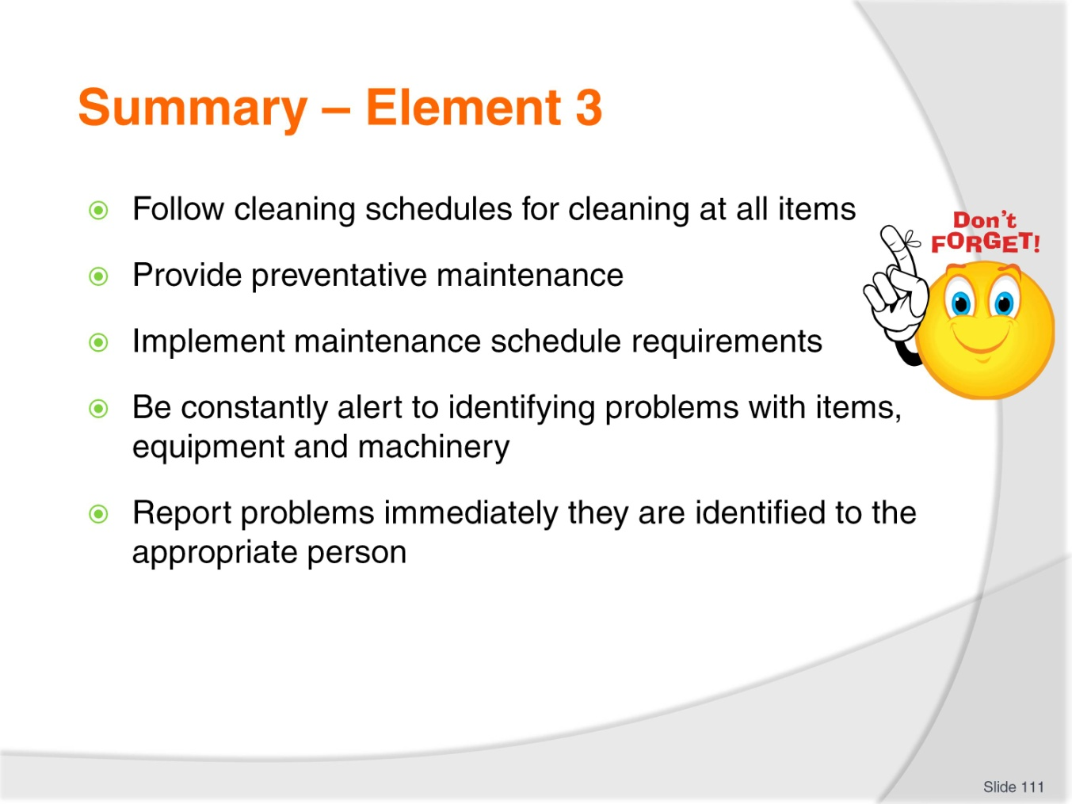
Slide No | Trainer Notes
Trainer provides a recap of the Element asking questions to check trainee understanding and responding to questions from trainees, as required.
Trainer thanks trainees for their attention and encourages them to apply course content as required in their workplace activities.

Recommended training equipment
Facility with standard bar/drink equipment such as glass washer, sinks, service counters, preparation areas, refrigeration units, ice machine, ice crusher.
Espresso machine, grinder, weighing scales, knock box, tamper, thermometer, metal jugs (for texturing milk)
Dripolator, Cona jugs, coffee plungers
Juicing machine
Boiling water source
Fresh water source
Microwave oven (for heating milk)
Milk shake machines and metal milk shake containers
Blenders
Soft serve ice cream machine
Plastic bottles – for syrups
Post-mix machine with base station and counter unit (towers and heads) complete with syrups
Crockery – cups and saucers (different sizes including demi-tasse), mugs, jugs, tea pots, tea infusers, hot water pots, tea strainers, tea bag squeezers, tea bag rests, bowls, side plates, silverware (for tea and coffee service), service trays, bottle openers, scoops, grater
Cutlery – knives and chopping boards, parfait spoons, bar spoons, tea spoons, coffee spoons, tongs
Glassware – variety of glassware such as Old fashioned glasses, Highball glasses, Pilsener glasses, Mugs, Milk shake glasses, Soda glasses, Cocktail glasses (variety – for mocktails)
Take-away drink containers
Drinking straws – various colours and sizes
Drink decorations – paper parasols, plastic animals, pickaxes, mermaids
Doilies, drink coasters and swizzle sticks
Cleaning items – detergent, sanitiser, descaler for espresso machine, cleaning cloths (including colour-coded cloths), scourers, sponges
Beverages – soft drinks (variety), fruit juices (variety), milk, cream, syrups (variety), cordials (variety), Angostura bitters

Food items – such as fruit and vegetables (for juicing and garnishes), powders (chocolate, malt, cinnamon), chocolate (for shaving/grating), milk and cream, yoghurt, honey, marshmallows, coffee beans, instant coffee, granulated coffee, tea leaves (variety), tea bags (variety), sugar, maraschino cherries, toothpicks, PC sachets (coffee, sugar, sugar substitutes), ice cream, sprinkles
Sample documentation – house recipes, cleaning checklist and schedule, maintenance checklist and schedule, drink lists, Food Safety Plans/Programmes, manufacturer’s instructions for equipment, operator instructions for equipment, Maintenance request forms
Computers with internet access/connection

Instructions for Trainers for using
PowerPoint – Presenter View
Connect your laptop or computer to your projector equipment as per manufacturers’ instructions.
In PowerPoint, on the Slide Show menu, click Set up Show.
Under Multiple monitors, select the Show Presenter View check box.
In the Display slide show on list, click the monitor you want the slide show presentation to appear on.
Source: http://office.microsoft.com
Note:
In Presenter View:
You see your notes and have full control of the presentation
Your trainees only see the slide projected on to the screen
More Information
You can obtain more information on how to use PowerPoint from the Microsoft Online Help Centre, available at: http://office.microsoft.com/training/training.aspx?AssetID=RC011298761033
Note Regarding Currency of URLs
Please note that where references have been made to URLs in these training resources trainers will need to verify that the resource or document referred to is still current on the internet. Trainers should endeavour, where possible, to source similar alternative examples of material where it is found that either the website or the document in question is no longer available online.

Appendix – ASEAN acronyms
AADCP | ASEAN – Australia Development Cooperation Program.
ACCSTP | ASEAN Common Competency Standards for Tourism Professionals.
AEC | ASEAN Economic Community.
AMS | ASEAN Member States.
ASEAN | Association of Southeast Asian Nations.
ASEC | ASEAN Secretariat.
ATM | ASEAN Tourism Ministers.
ATPMC | ASEAN Tourism Professionals Monitoring Committee.
ATPRS | ASEAN Tourism Professional Registration System.
ATFTMD | ASEAN Task Force on Tourism Manpower Development.
CATC | Common ASEAN Tourism Curriculum.
MRA | Mutual Recognition Arrangement.
MTCO | Mekong Tourism Coordinating office.
NTO | National Tourism Organisation.
NTPB | National Tourism Professional Board.
RQFSRS | Regional Qualifications Framework and Skills Recognition System.
TPCB | Tourism Professional Certification Board.







